**Blue Pathway**

|  |  |  |  |  |
| --- | --- | --- | --- | --- |
| **The Engagement Model** | **My Thinking** | **My Communication** | **My Body** | **My Play** |
| * Initiation - investigating to bring about a desired outcome * Persistence – sustain attention * Anticipation – predicting, expecting and making associations * Exploration – building on an initial reaction * Realisation – interacting and noticing something new | * Problem solving * Cause and effect * Investigative play * Following a sequence * Use of now/next * Experiencing number, shape and measure * Object permanence * Attention building – focusing on a task * Encountering and experiencing money exchange * Locating places and objects * Purposeful use of switches * Tracking objects and sounds * Visual skills | * Responsiveness * Intentional communication * Using switches * Use of PECs * Eye Gaze * Makaton signing * Engaging and understanding objects of reference * Gesture * Communicating a choice | * Following a sequence * Copying movements * Anticipating movements * Rhythm * Action and gesture * Social interaction * Appropriate movement * Fine motor development | * Shared attention * Motivating objects * Encountering and exploring objects * Interacting with peers and staff * Musical play * Parallel play |

Use all their senses in hands-on exploration of natural materials.

Begin to understand the need to respect and care for the natural environment and all living things.

|  |  |  |  |
| --- | --- | --- | --- |
|  | **Autumn** | **Spring** | **Summer** |
| **Year 1** |  | All around me | Africa |
| **Year 2** |  | How does your Garden Grow? | How do people Travel? |
| **Year 3** | All about me  Where I live, houses |  | UK Weather |
| **Year 4** |  | People who help us | India |
| **Year 5** |  | Holidays | The Four Seasons |

**Green Pathway – Primary**

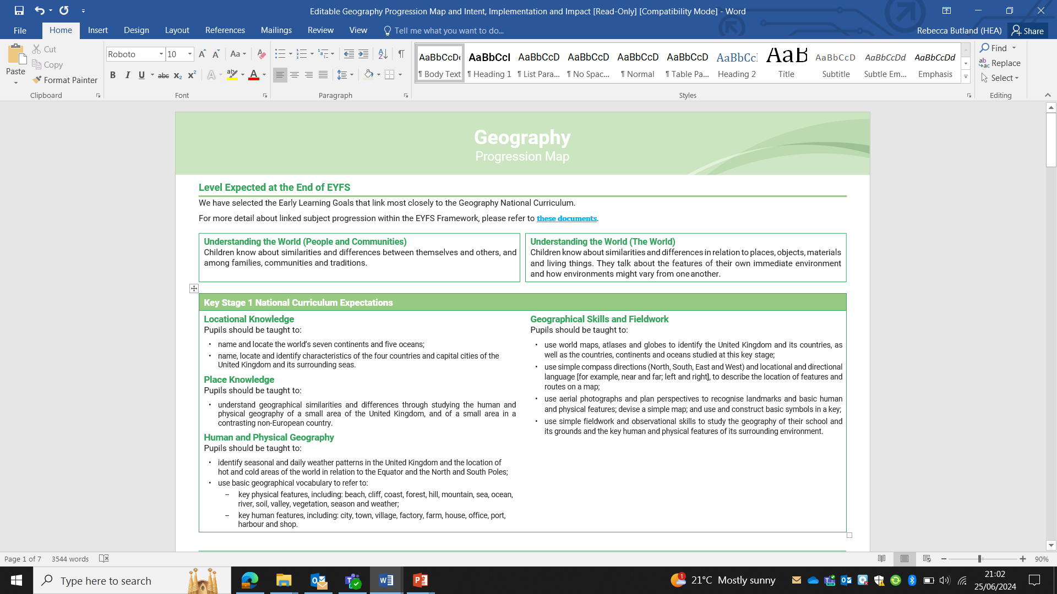

**Green Pathway – Secondary**

|  |  |  |  |
| --- | --- | --- | --- |
|  | **Autumn** | **Spring** | **Summer** |
| **Year 1** |  | My School and Local Communities | Exploring our Oceans |
| **Year 2** |  | The Jungle | The Coast |
| **Year 3** | The UK |  | Biomes |
| **Year 4** |  | Maps and Navigation | Australia |
| **Year 5** |  | Artic and Antarctica | Saving our Planet |



**Purple Pathway – Primary**

|  |  |  |  |
| --- | --- | --- | --- |
|  | **Autumn** | **Spring** | **Summer** |
| **Year 1** |  | All around me | Africa |
| **Year 2** |  | How does your Garden Grow? | How do people Travel? |
| **Year 3** | All about me  Where I live, houses |  | UK Weather |
| **Year 4** |  | People who help us | India |
| **Year 5** |  | Holidays | The Four Seasons |

**Purple Pathway – Secondary**

|  |  |  |  |
| --- | --- | --- | --- |
|  | **Autumn** | **Spring** | **Summer** |
| **Year 1** |  | My School and Local Communities | Exploring our Oceans |
| **Year 2** |  | The Jungle | The Coast |
| **Year 3** | The UK |  | Biomes |
| **Year 4** |  | Maps and Navigation | Australia |
| **Year 5** |  | Artic and Antarctica | Saving our Planet |

**Yellow Pathway – Secondary**

|  |  |  |  |
| --- | --- | --- | --- |
|  | **Autumn** | **Spring** | **Summer** |
| **Year 1** | Natural Disasters | The UK | China |
| **Year 2** | Mapping | Safari | Seaside |
| **Year 3** | Settlements | Water & The Weather | What’s it like in London? |

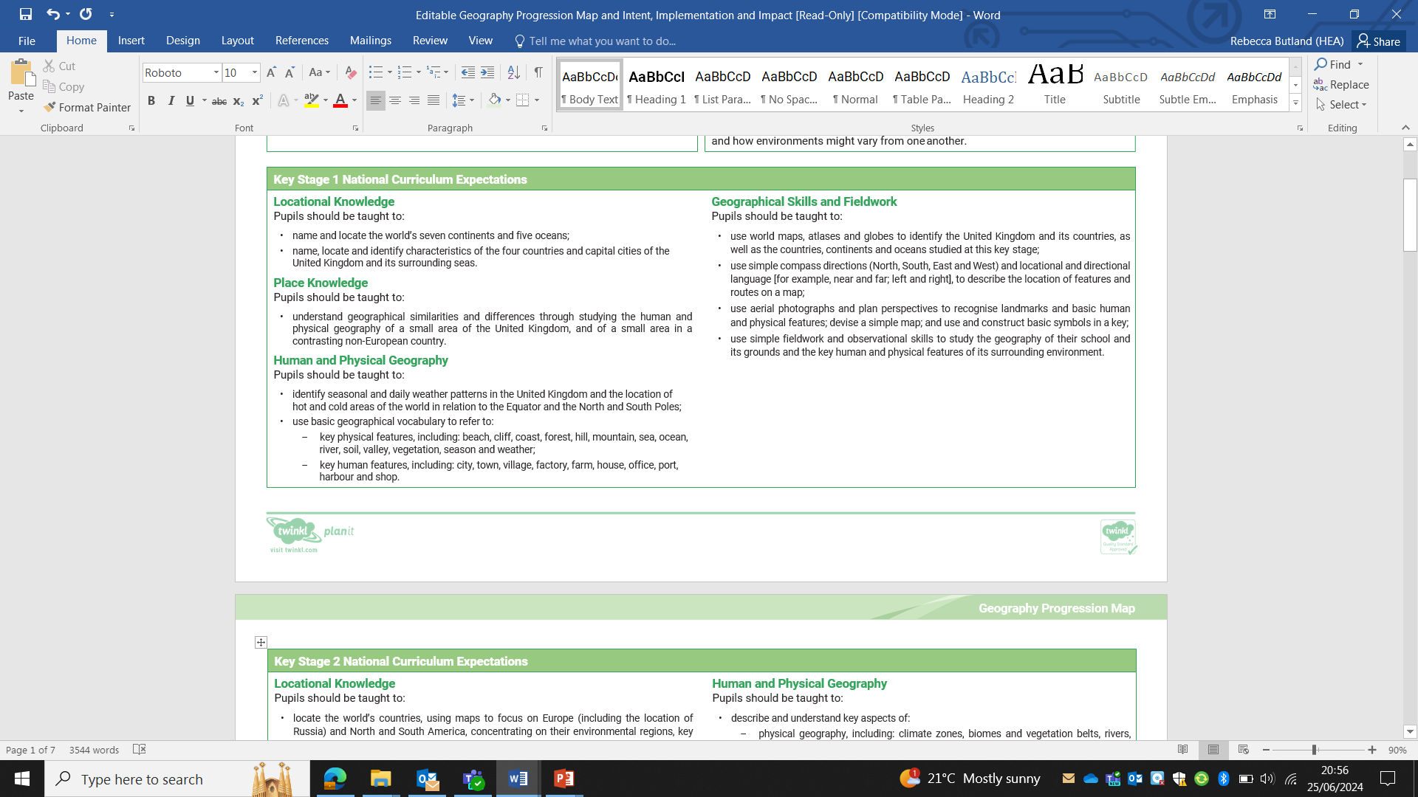

**Yellow Pathway – Uppers**

|  |  |  |  |
| --- | --- | --- | --- |
|  | **Autumn** | **Spring** | **Summer** |
| **Year 1** | The Americas | Trade | Rivers |
| **Year 2** | Mountains | Mapping | Eastern Europe |
| **Year 3** | Our Planet | Rainforest | Changing World |

