Geography Long term Plan (Updated Sept 2025)
Blue, Green and Purple Primary
In the Blue pathway each topic will have a sensory focus and will be integrated into the My World Framework, rather than being taught as stand-alone lessons.
 | Autumn | Spring | Summer
Year 1 |  | All around me | Africa
Year 2 |  | How does your Garden Grow? | How do people Travel?
Year 3 | All about me  Where I live, houses |  | UK Weather
Year 4 |  | People who help us | India
Year 5 |  | Holidays | The Four Seasons
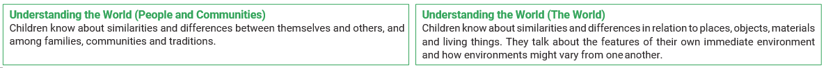

Blue, Green and Purple Secondary
In the Blue pathway each topic will have a sensory focus and will be integrated into the My World Framework, rather than being taught as stand-alone lessons.
 | Autumn | Spring | Summer
Year 1 |  | My School and Local Communities | Exploring our Oceans
Year 2 |  | The Jungle | The Coast
Year 3 | The UK |  | Biomes
Year 4 |  | Maps and Navigation | Australia
Year 5 |  | Artic and Antarctica | Saving our Planet

Yellow Secondary
 | Autumn | Spring | Summer
Year 1 | Natural Disasters | The UK | China
Year 2 | Mapping | Safari | Seaside
Year 3 | Settlements | Water & The Weather | What’s it like in London?

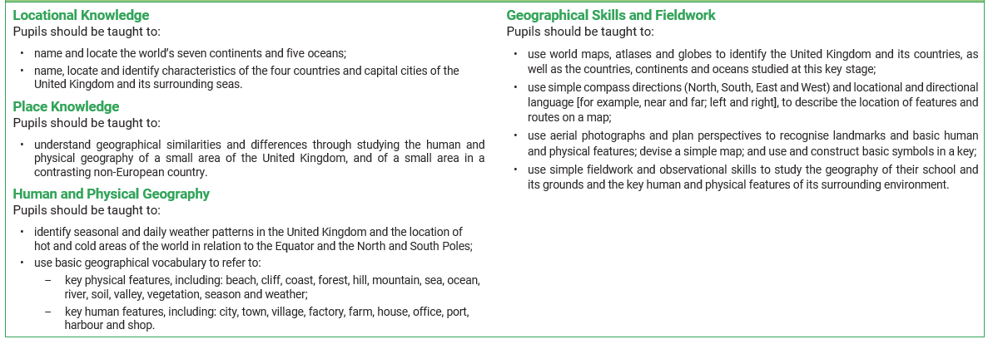
Yellow KS4
 | Autumn | Spring | Summer
Year 1 | The Americas | Trade | Rivers
Year 2 | Mountains | Mapping | Eastern Europe
Year 3 | Our Planet | Rainforest | Changing World
