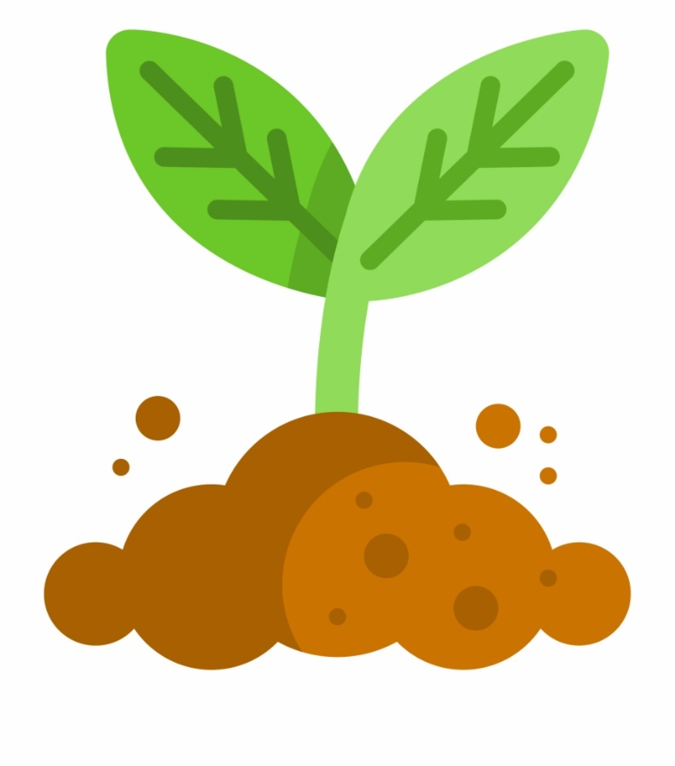

My world:

Observing and recording plant growth

Different global habitats and the plants that grow there

Rainforest/Desert exploration and comparison

Biomes around the world

Jobs and careers to do with growing

Life cycles and habitats

My body and well being

Mud Kitchen and other sensory play

Vegetable tasting

Growing your own veg

Digging, Cutting, Planting etc

Healthy Eating

Diet and exercise

Smells/Tastes

My communication:

Key texts:

Window

The Hungry Caterpillar

James and the Giant Peach

Jack and the Beanstalk

The Lost Words

WOW experiences:

Pond Dipping

Wicken Fen/Milton Country Park to observe Changes

Garden Centres

My thinking;

Sorting/Ordering plant stuffs

Measuring plants height, weight etc.

Observing and measuring change

Sequencing instructions to grow/farm foods

Counting fruit and veg

Shapes of Nature

Photos and Presentations on plant growth

Video of plant growth

Physical Problem solving using natural resources

Observing, measuring, recording mould and decay

Recycling

My play

Painting with fruit dye

Ant farm

Sta Monkey

Imaginary play – animals, cooking, farming

Fruit and veg printing

Sensory play – bark, sticks, fruit

Mud Kitchen

Play shops – green grocer

Dressing up

Being explorers

Home learning opportunities:

Outings with family – Wicken Fen etc

Observe changes in the home environment

Look after a house pant

Plant veg in the garden

Shopping with family

Garden Centre outing

Growing Cress

Interventions:

Forest School

Horse Riding

TEACCH

Attention Autism

My Independence

Garden Centres

Cooking with vegetables

Gardening

Shopping for fruit and veg

Outdoor TEACCH Tasks around gardening

Sorting and organising materials

Chopping Wood

My communication: literacy activities

Colourful semantics/PECS to comment on the stories

Narration and Dramatisation

Sensory Stories including sensory vocabulary

Character Profiling

Instructions for growing things

Word hunts outdoors or in sensory materials

Matching letter shapes

Sensory writing experiences

Shared reading about growing

**Green Fingers**