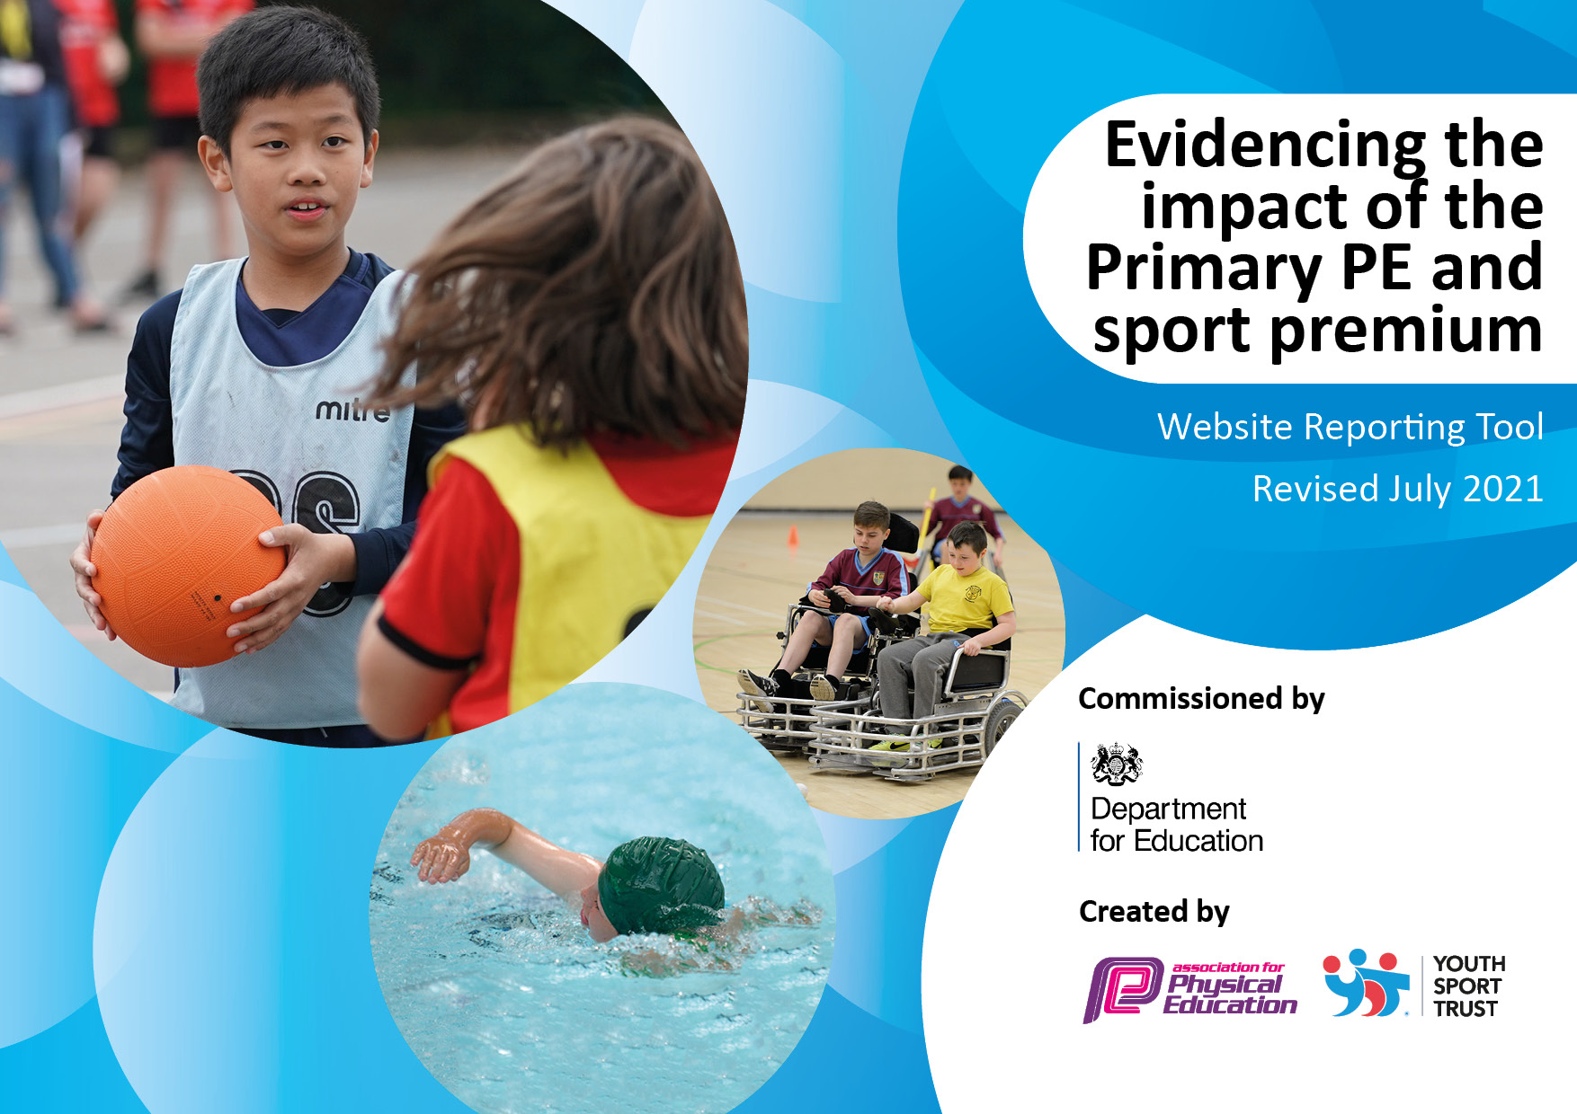
0.

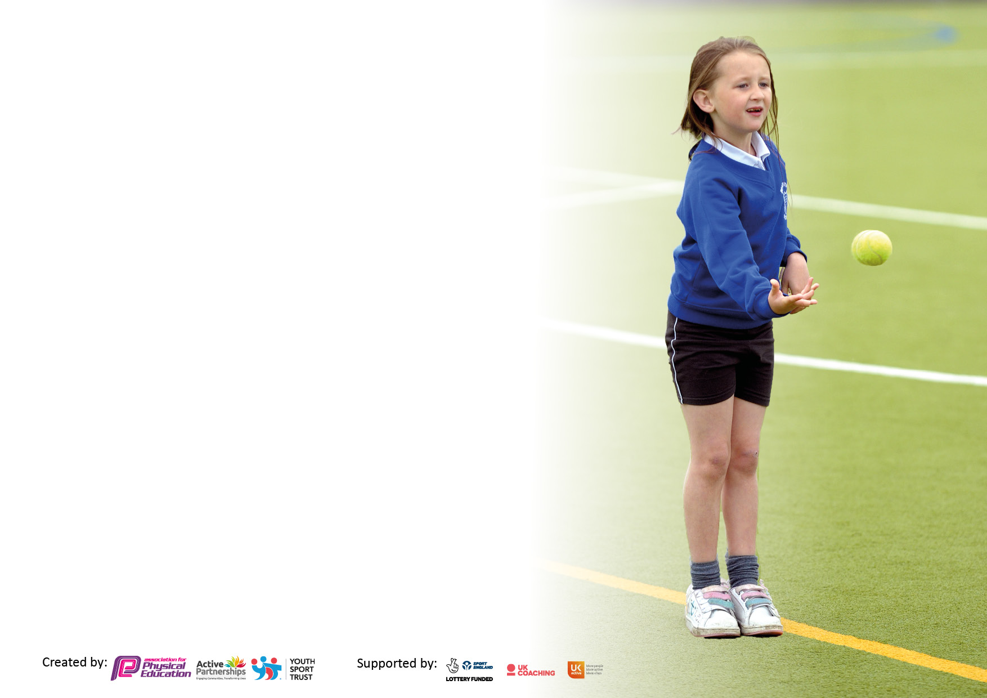

It is important that your grant is used effectively and based on school need. The Education Inspection Framework makes clear there will be a focus on ‘whether leaders and those responsible for governors all understand their respective roles and perform these in a way that enhances the effectiveness of the school’.

Under the Quality of Education Ofsted inspectors consider:
Intent - Curriculum design, coverage and appropriateness
Implementation - Curriculum delivery, Teaching (pedagogy) and Assessment
Impact - Attainment and progress

To assist schools with common transferable language this template has been developed to utilise the same three headings which should make your plans easily transferable between working documents.

Schools must use the funding to make additional and sustainable improvements to the quality of Physical Education, School Sport and Physical Activity (PESSPA) they offer. This means that you should use the Primary PE and sport premium to:

- Develop or add to the PESSPA activities that your school already offer
- Build capacity and capability within the school to ensure that improvements made now will benefit pupils joining the school in future years
- The Primary PE and sport premium should not be used to fund capital spend projects; the school’s budget should fund these.

Pleasevisitgov.ukfortherevisedDfEguidanceincludingthe5keyindicatorsacrosswhichschoolsshoulddemonstrate animprovement.Thisdocumentwillhelpyoutoreviewyourprovisionandtoreportyourspend.DfEencouragesschools to use this template as an effective way of meeting the reporting requirements of the Primary PE and sport premium.

We recommend you start by reflecting on the impact of current provision and reviewing the previous spend.

Schools are required to publish details of how they spend this funding, including any under-spend from 2019/2020, as well as on the impact it has on pupils’ PE and sport participation and attainment. All funding must be spent by 31st July 2023.

We recommend regularly updating the table and publishing it on your website throughout the year. This evidences your ongoing self-evaluation of how you are using the funding to secure maximum, sustainable impact. Final copy must be posted on your website by the end of the academic year and no later than the 31st July 2023. To see an example of how to complete the table please click HERE.

Details with regard to funding
Please complete the table below.

Total amount allocated for 2022/23 | £17708
Total amount of funding for 2022/23. To be spent and reported on by 31st July 2023. | £17708
Swimming Data
Please report on your Swimming Data below.

Meeting national curriculum requirements for swimming and water safety.

N.B. Complete this section to your best ability. For example you might have practised safe self-rescue techniques on dry land which you can then transfer to the pool when school swimming restarts.
Due to exceptional circumstances priority should be given to ensuring that pupils can perform safe self rescue even if they do not fully meet the first two requirements of the NC programme of study
What percentage of your current Year 6 cohort swim competently, confidently and proficiently over a distance of at least 25 metres?  N.B. Even though your pupils may swim in another year please report on their attainment on leaving primary school at the end of the summer term 2020.  Please see note above | 90%
What percentage of your current Year 6 cohort use a range of strokes effectively [for example, front crawl, backstroke and breaststroke]?  Please see note above | 84%
What percentage of your current Year 6 cohort perform safe self-rescue in different water-based situations? | 96%
Schools can choose to use the Primary PE and sport premium to provide additional provision for swimming but this must be for activity over and above the national curriculum requirements. Have you used it in this way? | Yes

Action Plan and Budget Tracking
Capture your intended annual spend against the 5 key indicators. Clarify the success criteria and evidence of impact that you intend to measure to evaluate for pupils today and for the future.

Academic Year: 2022/23 | Total fund allocated: | Date Updated: July 2023
Key indicator 1: The engagement of all pupils in regular physical activity – Chief Medical Officers guidelines recommend that primary school pupils undertake at least 30 minutes of physical activity a day in school |  |  |  | Percentage of total allocation:
 |  |  |  | 28%
Intent | Implementation |  | Impact
Your school focus should be clear what you want the pupils to know and be able to do and about  what they need to learn and to  consolidate through practice: | Make sure your actions to achieve are linked to your intentions: | Funding allocated: | Evidence of impact: what do pupils now know and what can they now do? What has changed?: | Sustainability and suggested next steps:
1.Identify pupils with low levels of participation. Offer alternative activities/sports  2.Taget all children to be able to swim 25m/use a variety of strokes  3. Playleader training (PE Consultant)  4. Sports Ambassador training (PE Consultant)  5. Daily activity programme for all using outdoor gym equipment  6. Effective maintenance programme essential | - After school clubs aimed at engaging most sedentary group  - Additional swimming sessions (1Hr) and swimming tuition Y5 and Y6  - KS2 Playleaders to engage KS1 pupils during lunchtime each day  - Sports Ambassadors to engage KS2 pupils daily  - Ensure outdoor gym equipment is used daily and effectively  - Transport and instruction provided for additional swimming for Y5/6  - Access to high quality well maintained PE equipment | £5000 | All active after school clubs we’re over-subscribed. All year groups were offered opportunities.  Participation was carefully monitored.  All KS2 classes had sessions at the pool with qualified instructors.  90% of pupils leaving Hill View could swim and were confident in safe self-rescue techniques. These lessons were completed at the pool and undertaken by qualified instructors.  Gym equipment is carefully maintained and used daily | Small-sided games during lunchtime  Mid-day assistant training  Play Leader training re-schedule for Autumn 2023 for new group of pupils
Key indicator 2: The profile of PESSPA being raised across the school as a tool for whole school improvement |  |  |  | Percentage of total allocation:
 |  |  |  | 11%
Intent | Implementation |  | Impact
Your school focus should be clear what you want the pupils to know and be able to do and about  what they need to learn and to  consolidate through practice: | Make sure your actions to achieve are linked to your intentions: | Funding allocated: | Evidence of impact: what do pupils now know and what can they now do? What has changed?: | Sustainability and suggested next steps:
1. Professional development, mentoring, training and resources to help teach PE and sport more effectively and embed physical activity across school  2. Share good practice and develop effective partnerships | 1.PE Consultant to provide all staff with high quality professional development in delivering fundamental skills  2.Subject Leader Network  3. Monitor effect on pupil mental health and wellbeing  4. Halton Games subscription | £2000 | Pupil interviews showed their enjoyment of PE in school, enjoyment of participating in competition, trying new sports eg Lacrosse and archery | Overall school improvement  PE Lead professional development

Key indicator 3: Increased confidence, knowledge and skills of all staff in teaching PE and sport |  |  |  | Percentage of total allocation:
 |  |  |  | 40%
Intent | Implementation |  | Impact
Your school focus should be clear | Make sure your actions to | Funding | Evidence of impact: what do | Sustainability and suggested
what you want the pupils to know | achieve are linked to your | allocated: | pupils now know and what | next steps:
and be able to do and about | intentions: |  | can they now do? What has
what they need to learn and to |  |  | changed?:
consolidate through practice:
All pupils to have active involvement  All teaching staff to work alongside specialists for CPD | Progressive Sports Cheshire work alongside class teachers to provide high quality PE one day per week for all classes  Progressive Sports provide after school clubs in alternative activity, such as dance, yoga, lacrosse | £7000 | Staff surveys showed confidence improving in providing opportunities for pupils through lessons | Access to alternative sports and physical activity
Key indicator 4: Broader experience of a range of sports and activities offered to all pupils |  |  |  | Percentage of total allocation:
 |  |  |  | 11%
Intent | Implementation |  | Impact
Your school focus should be clear | Make sure your actions to | Funding | Evidence of impact: what do | Sustainability and suggested
what you want the pupils to know | achieve are linked to your | allocated: | pupils now know and what | next steps:
and be able to do and about | intentions: |  | can they now do? What has
what they need to learn and to |  |  | changed?:
consolidate through practice:
Additional achievements:  Increased participation at an inter-school competitive level  Achievement of recognised awards | Pupils have had opportunities to access specialist provision in the following sports and activities throughout the year:  Dance, Gymnastics, Archery, Lacrosse, Rounders, Football, Netball, Yoga, Hockey and Cricket | £2000 | Pupils have attended inter-school competitions in football, cricket and dodgeball.  INSPIRE competitions have targeted those children less likely to participate in organised sport | Develop partnerships with sports clubs and other schools

Key indicator 5: Increased participation in competitive sport |  |  |  | Percentage of total allocation:
 |  |  |  | 6%
Intent | Implementation |  | Impact
Your school focus should be clear | Make sure your actions to | Funding | Evidence of impact: what do | Sustainability and suggested
what you want the pupils to know | achieve are linked to your | allocated: | pupils now know and what | next steps:
and be able to do and about | intentions: |  | can they now do? What has
what they need to learn and to |  |  | changed?:
consolidate through practice:
PE Lead to be up to date and informed of local appropriate competitions  Sports teams appropriately resourced and equipped. | Transport costs met in order to allow teams to be entered into local and regional competitions  All year groups represented in local competitions | £1700 |  | Intra School Competitions termly

Signed off by
Head Teacher: | Richard Jackson
Date: | 8/07/2023
Subject Leader: | Kerry Ritchie
Date: | July 2023
Governor: | Karl Ashton
Date: | 10/10/2023

