Health & Safety

COVID 19 Risk Assessment – March 2022 Onwards

School: | Hill View Primary School
Assessor: | RJ/CO
Date: | 28/03/2022
Review Date: | Ongoing

INTENTIONALLY LEFT BLANK

GENERAL NOTES TO BE AWARE OF

Covid has not gone away and as we learn to live with the virus, as we do with other respiratory illnesses, it is as important as ever that we do all we can to reduce the chain of transmission in order to protect ourselves and each other. Whilst undoubtedly a huge success in preventing deaths and serious illness the vaccine programme doesn’t provide 100% immunity to 100% of the population. However, in conjunction with appropriate and proportionate control measures we can try to reduce the risk of transmission and infection to an acceptable level… to a level we can learn to live with.

MAIN SYMPTOMS OF COVID

A new continuous cough, and / or

High temperature, and / or

A loss of, or change in, normal sense of taste or smell (anosmia)

HOW TO STOP THE SPREAD OF COVID

Vaccination - Anybody who is eligible should be encouraged, unless medically exempt, to take up the offer of a vaccination.

Ventilation - Ensure an adequate supply of fresh, not recirculated, air.

Face Coverings – Encourage the use of face coverings when in crowed spaces, especially when mixing with people you do not usually meet.

Hygiene – Maintain good handwashing and sanitisation protocols.

Isolate – Stay at home if you have symptoms or test positive.

Please be aware that giving negative answers to any of the questions on the following pages evidences a hazard(s).

Please transfer negative answers to the blank Risk Assessment Proforma (below) and put appropriate controls in place to remove the hazard and eliminate the risk or to control the hazard and reduce the risk to an acceptable level.

Risk Assessments MUST be reviewed a minimum of every 12 months unless circumstances dictate they be reviewed sooner.

A non-exhaustive list of circumstances which might necessitate a review before 12-months have passed might include; changes in legislation, new staff, accidents / incidents, changes in use of buildings / rooms, improvements in procedures / equipment / safety devices / technology etc.

- Entering and Leaving School | Yes / No / N/A | Describe the systems in place / or proposed to be put in place to manage the risk(s).
- Does effective communication take place with transport providers (bus / minibus operators, taxis, etc.) to ensure wearing of face coverings meets or exceeds current guidance with regard to wearing coverings when in a crowded space or mixing with others who you don’t usually come in to contact with? |  | When it comes to travel, the requirement to wear a face covering on public transport ended on 27 January, but after that date local advice on wearing a face covering may still apply. Where transport has been booked for trips and visits staff will be check with contractor if face masks are required for adults.
- Does effective communication take place with transport providers (bus / minibus operators, taxis, etc.) to ensure they provide vehicles which afford fresh air ventilation (not recirculated air)? |  | Added to coach risk assessment for all trips and visits
- Does effective communication take place with transport providers (bus / minibus operators, taxis, etc.) to ensure they have a robust risk assessment in place which affords effective disinfection of their vehicles before and after use?

- Does effective communication take place with transport providers (bus / minibus operators, taxis, etc.) to ensure a log is kept to record all journeys, passengers, issues etc.?

- Where practical, is the use of public transport strongly discouraged?

- Have ‘sneeze screens’ been installed in relevant areas i.e. reception, around cash registers / point-of-sale terminals etc. so as to protect staff?

- Where digital systems such as touch screens are in use, for example signing in / out at reception or biometric registration, are these regularly sanitised?

- Where pupils use biometric registration systems e.g. finger print scanners, are these regularly sanitised and is the use of hand sanitiser before using such systems encouraged?

- Are parents / carers who need to access reception areas / office staff still being offered a telephone appointment as an alternative to ad-hoc face-to-face meetings? |  | In line with the guidance from DfE, school will make it clear that if a parent or carer insists on attending school where they have a confirmed or suspected case of Covid-19 (or who live in the same household as someone who has tested positive for Covid-19), school will insist they stay away, to protect other pupils and staff from possible infection.
- Is there sufficient provision of hand sanitiser at entrances / exits and other appropriate places for staff, pupils, parents, contractors and unplanned visitors etc. who may wish to use it? |  | Monitored by Site Manager. We will continue to advise everyone to clean their hands thoroughly and frequently.
- With Government guidance being reviewed, updated and changed regularly do you have a robust system in place to ensure that any such changes are clearly communicated and in a timely manner to all staff, parents, pupils, contracting services and visitors? |  | The school will use all channels to communicate quickly and effectively using the website/twitter/school comms.
- Any there any other hazards to be controlled or actions to be taken?

Entering and leaving school will continue to be via classroom doors to avoid any unnecessary congestion amongst adults dropping off or collecting children.

- Hygiene | Yes / No / N/A | Describe the systems in place / or proposed to be put in place to manage the risk(s).
- Although the legal requirement has been removed are staff, pupils and parents regularly reminded of the importance of wearing face coverings in crowded areas especially where mixing with people they wouldn’t normally come in to contact with, e.g. areas outside of the setting, such as public transport? |  | Although face coverings are no longer recommended by the Government, we adopt an agile approach and respond appropriately and proportionately to spikes and outbreaks by reinstating the wearing of masks, for adults in school, as part of risk assessments and in response to local public health guidance.
- Is there sufficient provision of waste receptacles (bins) and tissues on site to encourage good respiratory hygiene, e.g. ‘Catch It, Bin It, Kill It’? Are staff and pupils made aware of what they should do if they don’t have a tissue(s) e.g. ‘Catch It, Bin It, Kill It’, i.e. sneeze / cough in to crook of elbow? |  | We continue to make sure everyone in school practises good respiratory hygiene, and promote the 'catch it, bin it, kill it' approach.
- Are there procedures in place for removing waste / emptying bins daily or when full (whichever comes first)? |  | All waste bins are emptied daily
- Are there procedures in place for dealing with suspected contaminated waste i.e. double bagging it and storing (in isolation) for 72-hours before disposing of it with normal waste?

- Is there a documented policy on handwashing that covers frequency and time spent (minimum 20 seconds)? Is there adequate access to handwashing facilities? Is this effectively communicated?

- Are younger children and children with complex or special educational needs assisted with maintaining good hand and respiratory hygiene?

- Has a review of all classroom risk assessments taken place giving consideration to issues such as provision of hand sanitiser, cleaning protocols, use of CO2 Monitors / air filtration etc.? Is it aligned with current Government guidance? |  | A continued focus on enhanced  hygiene and cleaning regimes,  particularly handwashing, is being maintained in the context ofCovid-19 and in preventing outbreaks of other infectious diseases.
- Are staff and pupils encouraged to maintain current handwashing and sanitisation protocols and to not touch their face or hair in order to reduce virus transmission? Do they understand why?

- Are there extra cleaning schedules in place for all areas? Have heavy use hot spots which may require enhanced and / or more regular cleaning / sanitisation been identified and are suitable protocols in place to ensure this happens? |  | A continued focus on enhanced  hygiene and cleaning regimes,  particularly handwashing, is being maintained in the context of Covid-19 and in preventing outbreaks of other infectious diseases.
- Do cleaning staff have access to sufficient stocks of cleaning products necessary to carry out relevant cleaning requirements?

- Are cleaning staff trained to use any new products that may have been implemented and are COSHH risk assessments reviewed to include new products? |  | COSHH risk assessments reviewed following update of cleaning regimes and new supplier. Safety data sheets reviewed for all products and stored in site manager office for reference.
- If required can a deep clean be actioned at short notice utilising correct protocols i.e. full PPE, appropriate cleaning materials?

- Are procedures in place if classroom resources are shared to ensure they are cleaned regularly or if appropriate removed from use for 72-hours?

- Have extra cleaning schedules been put in place for eating areas including dining halls, kitchens, staff rooms etc.? |  | Mid-day staff hours extended to incorporate extra cleaning required following lunch
- Are kitchen / serving staff wearing appropriate protective clothing (PPE) i.e. aprons, gloves, visors, hair nets etc.?

- Have staff been advised with regard to the correct use of PPE e.g. donning and doffing? Have staff been advised with regard to the correct disposal of PPE? |  | Posters remain on display
- Are sufficient stocks of PPE held for pupils whose care normally involves the use of PPE due to intimate care needs?

- Is PPE available and is it disposed of correctly along with soiled items?

- Where a risk assessment has identified a need for FFP3 masks have staff affected by the risk assessment been suitably face fit tested for the mask they are to use? |  | FFP2/3 masks made available  to staff who were previously classified  as clinically extremely vulnerable or  otherwise at significantly greater risk,  and any member of staff who is anxious  about their situation.
- If hand sanitiser is used is there sufficient supervision for safe use particularly for younger pupils / children taking into consideration recent safety alerts? Consider skin friendly cleaning wipes as an alternative?

- Are toilets cleaned regularly?

- Are handwashing areas regularly checked to ensure plentiful supplies of necessary soaps etc.?

- Are pupils encouraged to wash hands before and after breaks / lunches?

- Are pupil handwashing areas supervised? Is hand sanitiser required?

- Have shared water fountains been taken out of use?

- Is physical contact discouraged e.g. shaking hands? Are simple verbal greetings to be used instead e.g. good morning? Is this message effectively communicated to all?

- Are staff / pupils advised to cover any cuts or wounds?

- Any there any other hazards to be controlled or actions to be taken?

- Equipment | Yes / No / N/A | Describe the systems in place / or proposed to be put in place to manage the risk(s).
- If I.T. suites are in use are appropriate cleaning measures in place?

- Are there cleaning schedules in place for all I.T. equipment before and after use? |  | Wipes available on all computer trolleys for use following computing work
- Are tablets, iPads cleaned before and after use?

- Is there a process in place to ensure effective sanitisation of toys, teaching aids, sports equipment on a regular basis? |  | Equipment used on rota basis and left unused for 72 hours where appropriate
- Have non washable toys / items been removed? |  | As of March 2020
- Are children instructed to not bring items from home to school or take items home from school i.e. toys etc.? Are they encouraged to only bring in essential items i.e. lunch box, bag etc.?

- Are desks regularly cleaned? |  | Daily cleaning as part of enhanced routine
- Are children instructed to only use their own equipment i.e. pens, pencils etc. and to share such items under any circumstances?

- Where touch terminals are in use in dining areas, are there appropriate cleaning regimes in place?

- Do cash machines in Secondary Schools have appropriate cleaning regimes in place?

- Are extra cleaning procedures in place for dining hall furniture before and after use? |  | Mid-day staff working enhanced hours to accommodate extra cleaning.
- Are changing beds / facilities cleaned before and after use?

- Are correct procedures followed for extra support, nappy or pad changing etc.? Are handwashing facilities available?

- Any there any other hazards to be controlled or actions to be taken?

- Ventilation | Yes / No / N/A | Describe the systems in place / or proposed to be put in place to manage the risk(s).
- Can you ensure an adequate supply of fresh air intake and circulation within your classroom / setting, either by opening a window or via mechanical ventilation? |  | All occupied spaces are kept well ventilated
- Are air conditioning systems set to bring in fresh air and not just re-circulate? |  | Only one in school in conference room, set to fresh air
- Has a need for air filtration been identified, if so has appropriate advice / guidance been received with regard to type, placement, use and maintenance?

- Are CO² monitors in use? Has appropriate advice been received with regard to type, placement, use and maintenance? |  | All classrooms and occupied areas have access to Government-provided CO2 monitors. Ventilation measures aim to keep CO2 below 800ppm in all occupied classrooms.  The CO2 monitoring are continually monitored by staff and Site manager. If the levels are consistently above 800ppm ventilation is improved.  Where ventilation cannot be improved,  naturally or mechanically, then options  available include reducing the number  of people in the room, reducing the  length of time groups spend in the  room, or temporarily vacating the room.
- Have staff / pupils been instructed not to interfere with any such equipment and is an agreed action plan in place if readings exceed the permitted level?

- Has appropriate training / guidance been received with regard to interpreting readings, what permitted levels are and what to do if readings fall outside of permitted levels? |  | See above
- If free standing or desk fans are in use are they positioned near to open windows to encourage circulation of fresh air?

- Any there any other hazards to be controlled or actions to be taken?

Improving ventilation must remain a focus for the long term, to reduce the risk of transmission of other airborne viruses, to aid concentration in the classroom.

- Fire, Emergency Incidents and Building Issues | Yes / No / N/A | Describe the systems in place / or proposed to be put in place to manage the risk(s).
- Has the full site fire risk assessment been reviewed?

- Have fire evacuation plans been reviewed to reflect any areas change of use?

- Has the reviewed fire evacuation plan been put into practice? Are incident controllers / fire marshals aware of new procedures? |  | Termly fire evacuation drills highlight any changes
- Have Bomb / Lockdown plans been reviewed to reflect any areas which may be subject to a change of use? |  | Reviewed by Governors 7th March 2022
- Has the reviewed Bomb / Lockdown plan been put into practice?

- Have Business Continuity / Recovery plans been reviewed to reflect any changes?

- Have staff, pupils, contractors and any allowable visitors been updated with any reviewed fire / bomb / lockdown arrangements?

- If internal fire doors are pinned open are they done so using either by a hardwired maglock device interlinked to the fire alarm system or using Dor Gard type products? If so both will automatically close on activation of the fire alarm. Internal fire doors should never be wedged open i.e. by using fire extinguishers, cardboard / wooden / other wedges etc. |  | KDE certificate showing internal mag-locked doors release on operation of fire alarm
- Are normal fire checks continuing i.e. alarm tests, emergency lighting test etc.? Completion of weekly, monthly, 6-monthly, annual requirements?

- Where applicable has consideration been given to asbestos management? |  | Action Plan updated 17th March 2022
- Are water management tests continuing as per normal? |  | Monthly checks by site manager
- Have any other systems or equipment which are usually subject to periodic testing or come under a planned, preventative maintenance (PPM) schedule and which may have been affected to the pandemic been appropriately tested / serviced / maintained?

- Any there any other hazards to be controlled or actions to be taken?

- General | Yes / No / N/A | Describe the systems in place / or proposed to be put in place to manage the risk(s).
- Have Occupational Risk Assessments for staff been reviewed to reflect current guidance? Have they been communicated to and shared with staff? |  | Joint Union advice followed:  Practical steps to reduce the risk  of Covid-19 disruption in schools  and other education settings –  Spring/Summer 2022  Individual Risk Assessments updated where necessary
- Have Environmental Risk Assessments been reviewed and communicated to staff?

Have you considered (non-exhaustive list);

- Access / egress?
- Movement around school / setting?
- Break times / lunch times / lesson changes?
- Toileting?
- Location of hand sanitisers?
- Signage?
- First Aid rooms?
- Sensory rooms?
- Intimate care rooms?
- COVID isolation room and associated bathroom facilities?
- Kitchens?
- Dining hall?
- Halls / gyms?
- Science and DT area?
- LFD testing areas?

- Are all risk assessments and individual plans for vulnerable children and children with additional needs in place and up to date? |  | Reviewed and discussed with parents 21st March
- Are staff regularly briefed, daily, twice weekly etc. regarding ever changing circumstances and their responsibilities? |  | Weekly briefing
- Has your staff handbook / induction process been reviewed to reflect the current situation and latest guidance / procedures etc.?

- Are site managers conducting their regular building checks i.e. site inspection checklists, temperature testing, fire alarm checks etc.?

- Have Head Teachers / Site Managers liaised with contractors to seek assurances that any contractor attending site must be in good health, must adhere to the schools / early years settings rules and procedures, good handwashing procedures must be adhered to, possible use of separate entrances and abide by site rules in general to manage COVID 19?

- Are there sufficient first aiders on site?

- If outdoor play equipment is in use are stringent rules adhered to and are appropriate before / after cleaning measures in place?

- Has the deliveries section of the ‘Driving in Schools Grounds Risk Assessment’ been reviewed to reflect your site procedures regarding COVID 19 and receiving deliveries? Alternatively, have you produced a separate risk assessment / safe system of work for accepting deliveries, ensuring deliveries are contactless and not signed for?

- Are appropriate procedures in place to receive and send postal items whether by royal mail, courier etc. and if required is there an appropriate isolation protocol for postal items?

- When participating in ‘out of school activities’ have venue risk assessments been deemed suitable and sufficient by the Head teacher and are COVID protocols in place? |  | We carry out full and thorough risk assessments for all visits and refer to any public health advice, such as on hygiene and ventilation, as part of the risk assessments.  Discussions are held with visit provider or insurance provider to find out the level of protection available prior to departure.  All visits are approved via Evolve system  Residential visits have to receive LA approval prior to departure.
- During open days, live performances and any other large gatherings that include mass visitors are risk assessments in place, suitable and sufficient with full COVID protocols?

- Are governing bodies / trusts / executive boards continuing to meet regularly via online platforms or in safe surroundings to prevent transmission? Are relevant communication strategies in place to keep governors informed? |  | Hybrid working model for meetings supported
- Any there any other hazards to be controlled or actions to be taken?

- Transmission, Testing, Isolation and Local Outbreaks | Yes / No / N/A | Describe the systems in place / or proposed to be put in place to manage the risk(s).
- Do you have in place an outbreak management procedure / plan, including appropriate stepping up / stepping down protocols?

- Do you have an established and effective open line of communication with your local Public Health team in order to receive the most current advice with regard to infection prevention and control, either as they issue it or as you seek it? |  | Spreadsheet completed when school gets notified of each new case to Public Health (Covid).  Any advice followed
- Are records kept of all visitors / contractors to site?

- When there is an operational need are all staff, and if appropriate, pupils encouraged to take part in LFD and PCR testing? When an operational need for such testing has been identified please consider controls for those staff who won’t / can’t test. |  | This will continue until testing becomes unavailable.  We recommend asymptomatic testing for as  long as tests remain freely available.
- Have all staff, pupils, parents, visitors, contractors and any other persons attending the school received clear communications informing them of the school’s policies and approach to managing COVID 19 within their setting and what is expected of them in terms of helping the school achieve their aims? |  | Staff who live with someone who has Covid-19 will be permitted to work from home where possible.
- Have all staff, pupils, parents, visitors, contractors and any other persons attending the school been instructed to inform the school if a suspected case is confirmed as COVID 19?

- Whilst the legal requirement to do the same may have been removed is it made clear in the school’s policies and procedures that anyone – all staff, pupils, parents, visitors, contractors and any other persons attending the school - who is ill or otherwise showing symptoms or who has had a positive test must stay at home for at least 5x days and not return until they have had 2x negative tests on consecutive days? |  | As long as tests remain freely available.
- Have areas been identified, with adequate ventilation, to enable separation of staff / pupils (if safe to do so) in the event of developing symptoms until able to go home? Is there a suitable deep clean protocol in place for sanitising the area once the suspected case has left the area?

- Are procedures in place for staff and pupils to immediately action appropriate hygiene procedures, e.g. handwashing, sanitisation etc. if thought to have been in contact with a suspected case within school and for any contaminated areas to be immediately closed until cleaned appropriately?

- Is sufficient PPE available when persons are displaying COVID 19 symptoms if effective social distancing cannot be adhered to i.e. face mask, eye protection, gloves, and aprons? |  | Personal protective equipment (PPE) will continue to be provided for staff administering first aid, medical care or personal care activities.
- Have staff been instructed in the proper disposal of PPE suspected to be contaminated e.g. double-bag it, safely store it for 72-hours then dispose of it in the regular waste stream? Is current government guidance regarding using / wearing PPE understood by staff?

- If any person, with due regard to safeguarding, is in isolation whilst waiting to go home and requires the use of a bathroom is there provision for use of a separate facility and are there cleaning regimes in place for after use?

- For individuals or groups of pupils are there remote education plans in place if needed?

- If the local PH team advise the school to temporarily close due to an outbreak is there a contingency plan in place?

- Has the contents of this risk assessment been shared with your staff? Have they been involved in the preparation process and made aware of any new variants?

- Any there any other hazards to be controlled or actions to be taken?

- Welfare | Yes / No / N/A | Describe the systems in place / or proposed to be put in place to manage the risk(s).
- Are pregnant and vulnerable (especially when clinically so) staff and pupils taking extra precautions to protect themselves? Are they receiving appropriate advice and / or guidance with regard to appropriate measures they can take? Have specific risk assessments been done for any such staff member or pupil and does it take in to account their specific needs and / or vulnerabilities with regard to COVID-19. Current government guidance states that any extra risk posed to pregnant employees increases from 28-weeks in those who are unvaccinated. |  | The position of the most vulnerable staff, and those who are pregnant, will continue to be addressed through individual risk assessments.
- For staff / pupils continuing to work from home due to vulnerabilities is regular contact made with a focus on wellbeing?

- Are you aware prolonged working from home can adversely affect mental health? Do you have strategies in place to assist staff / pupils who may need further support?

- Is there support in place for pupils returning to school who may have suffered bereavement, anxiety etc.? |  | Therapeutic support is available to any member of school, staff or pupil where required
- Are controls in place to keep staff anxieties at a minimal level? Are there procedures in place to ensure regular communication surrounding testing and vaccinations? Keep staff well informed.

- Any there any other hazards to be controlled or actions to be taken?

Please be aware that giving negative answers to any of the questions on the previous pages evidences a hazard(s).

Please transfer negative answers to the blank Risk Assessment Proforma (below) and put appropriate controls in place to remove the hazard and eliminate the risk or to control the hazard and reduce the risk to an acceptable level.

Risk Assessments MUST be reviewed a minimum of every 12 months unless circumstances dictate they be reviewed sooner.

A non-exhaustive list of circumstances which might necessitate a review before 12-months have passed might include; changes in legislation, new staff, accidents / incidents, changes in use of buildings / rooms, improvements in procedures / equipment / safety devices / technology etc.

Risk Assessment Proforma

School: Hill View Primary School |  |  |  | Assessor: RJ
Assessment Date: 28/03/2022 |  |  |  | Review Date: September 2022
Hazards | No. at Risk | Existing Controls | Risk Level | Action(s) Required | Date Due | Signed Off  (by and date)
Some areas, such as the hall at lunchtime, ventilation is poor and there may be a need for air filtration | All pupils/midday staff | Fire exit doors can be opened, although these need constant supervision as access is out onto the car park and not the secure area of school | Medium | Where CO2 is consistently above 800ppm equipment is required to  to supplement ventilation. Extractor fans are currently inoperable and need replacement. This will take place during the electrical re-fit during the summer of 2022.  Alternatively a HEPA filtration unit. The Department for Education (DfE) rolled out a very limited number of these units, but most schools were not able to benefit from this scheme. | Sept 2022 | RJ (March 2022)

Staff Record of Receipt and Understanding:

By signing and dating below you are acknowledging your receipt and understanding of the:
“COVID-19 Risk Assessment Mar-22”
You further acknowledge that if there is anything you don’t understand in the risk assessment, or if you have any other concerns or queries in respect of the risk assessment you will inform your manager immediately.
Name | Date

Risk Level = Likelihood Rating x Severity Rating

Likelihood Rating Severity Rating

Unlikely = 1 Minor Injury = 1

Possible = 2 Serious Injury = 2
(Lost Time)

Likely = 3 Fatality = 3

Multiplying your likelihood rating against your severity rating will give you an overall Risk Level Rating (see following table) which can be used to determine the level of control measures and mitigations you need to put in place in order to bring the risk level down to tolerable level (see Actions Required Based on Risk Level on next page).

Risk Level

 |  | Severity
 |  | Minor  (1) | Serious Injury  (2) | Fatality  (3) |  | Risk Level
Likelihood | Unlikely  (1) | 1 | 2 | 3 |  | Low | 1 – 3
 | Possible  (2) | 2 | 4 | 6 |  | Medium | 4 - 6
 | Likely  (3) | 3 | 6 | 9 |  | High | 6 - 9

Actions Required Based on Risk Level

Score | Risk Level | Actions Required
1 | Low | No action required and no records needed.
2 or 3 | Low | No additional controls required. Consideration may be given to a more cost-effective solution of improvement that imposes no additional cost. Monitor to ensure control measures are maintained.
4 | Medium | Efforts should be made to reduce risks with costs taken into consideration. Give a time period and identify a person responsible for resolving.
6 | Medium | Activities should not be started until the risk has been reduced. If the work is in progress, urgent action should be taken.
6  (If Fatal) | High | Activities should not be started or continued.
9 | High | Activities should not be started or continued.

Version Control

Version | Date | Amendment | Officer
1 | Jul-20 | Document created. | LPR
2 | Jan-21 | Document reviewed. September removed from title and footer, now 2020 2021, before September references removed and changes to present time, deep clean prior to opening changed to as required, addition of ‘if floor signage is damaged – regular review and replacement required, all September adjustments in bold now removed, inclusion of face coverings to be worn where appropriate as per government guidance, training included for cleaners around new products and review of COSHH risk assessments, implementation of bubbles changed to maintaining bubbles, advice to open / close windows during winter months in 15 minutes slots, assemblies advice included re new variant and lockdown, pinning open of internal fire doors updated to only include mag locks or doors guards as per fire service advice, no door wedges or other, pre-opening water testing management changed to ongoing, new variant to be included in occupational risk assessment, BAME risk assessment requirement now included, exclusion of vulnerable staff, pregnant and BAME from hold LFD testing roles, 28 week advice included re pregnancy, rows split to ensure one question per row, welfare if isolating section added. | LPR
3 | Jun-21 | Section included ref non-testing and non-vaccination staff. | LPR
4 | Jul-21 | Reviewed in line with step 4 of government guidance and lifting of restrictions. Statements and wording changed to include ‘if preferred’, ‘expected and recommended’, ‘subject to change’, ‘where possible’ etc. ‘COVID 19 stay at home guidance’ changed to ‘Coronavirus, how to stay safe and help prevent the spread’. BAME now VPEM. | LPR
5 | Aug-21 | Document updated in line with changes from 16th August onwards, all dependent upon local changes or re-implemented restrictions for case number levels. | LPR
6 | Jan-22 | Document updated.  Face coverings – current guidance updated regarding when and where they should be worn.  Use, monitoring and recording of CO2 monitors and air filtration units included,  Procedures for dealing with high readings.  Use of FFP3 masks and required face fit testing. | LPR
7 | Mar-22 | Minor changes to formatting throughout.  Changes to wording and grammar throughout.  Changes made in relation to Government “Living With Covid” guidance and changes which came in to force 24-02-22.  Appendices added ‘useful graphics’. | PVG

Appendix ‘A’

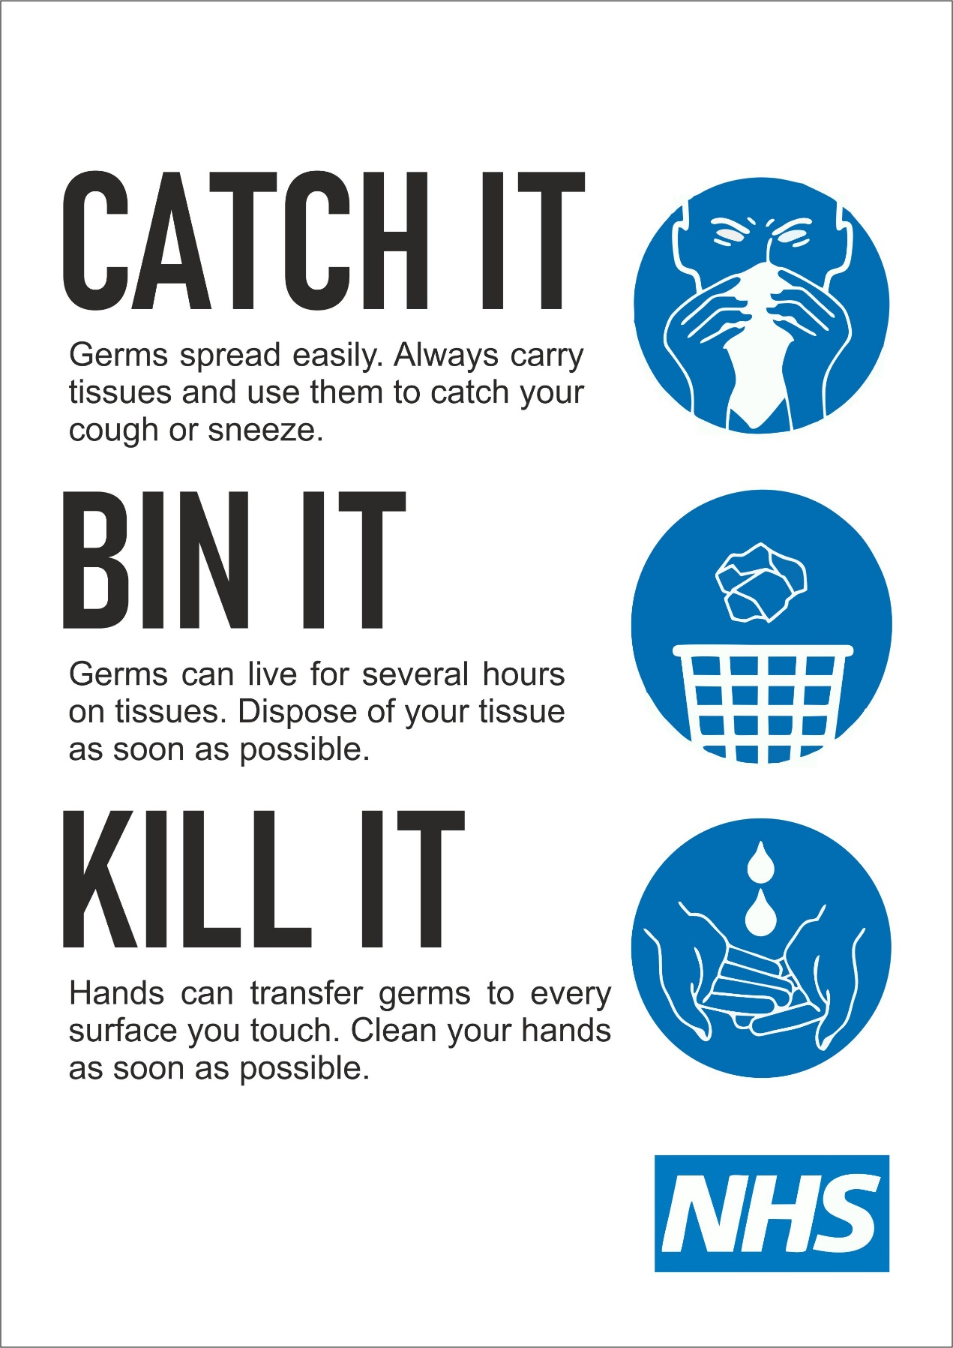
Appendix ‘B’ (Encouraged)

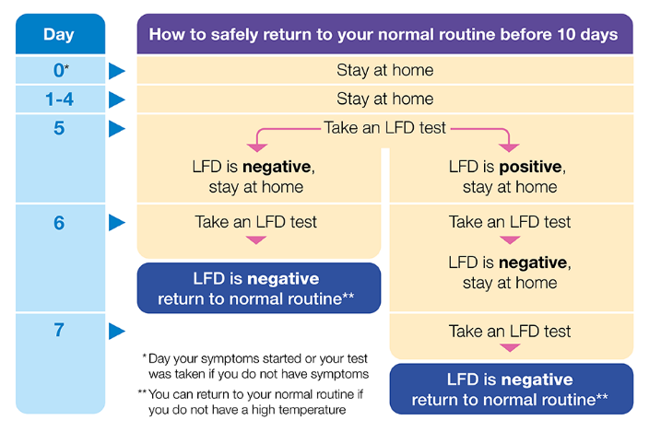

Appendix ‘C’

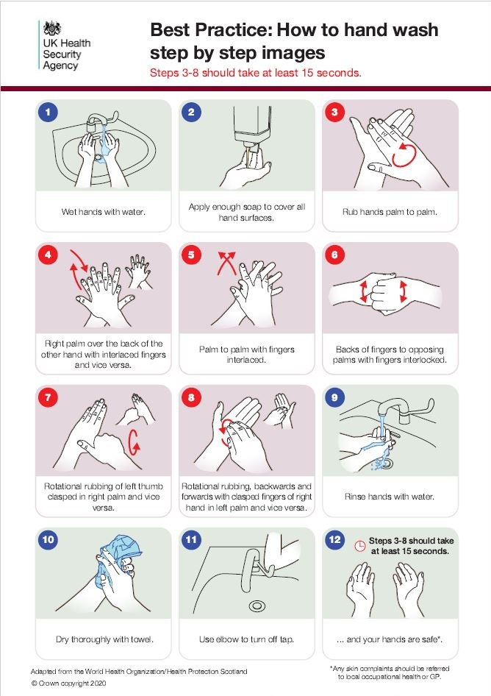

Appendix ‘D’

