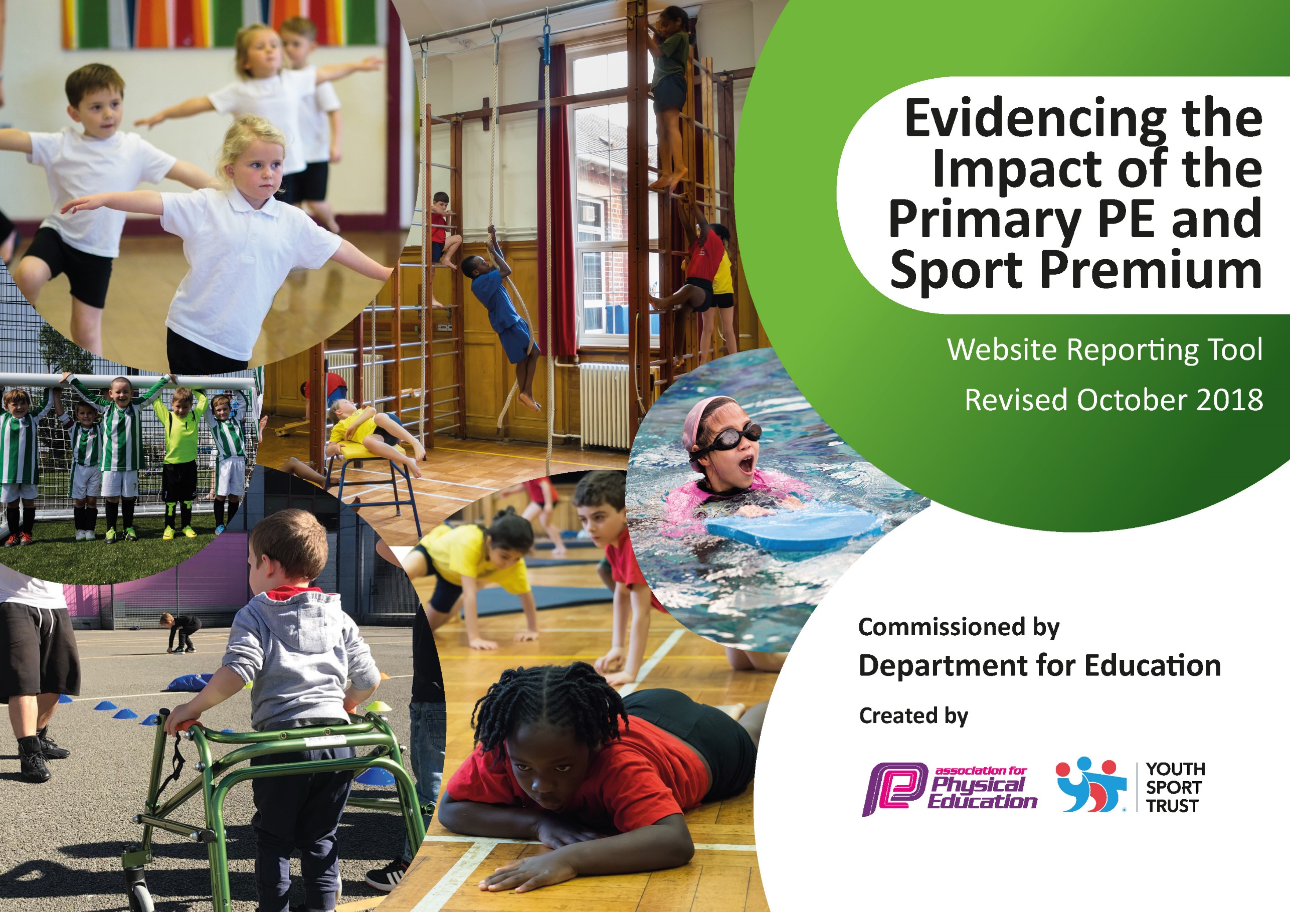
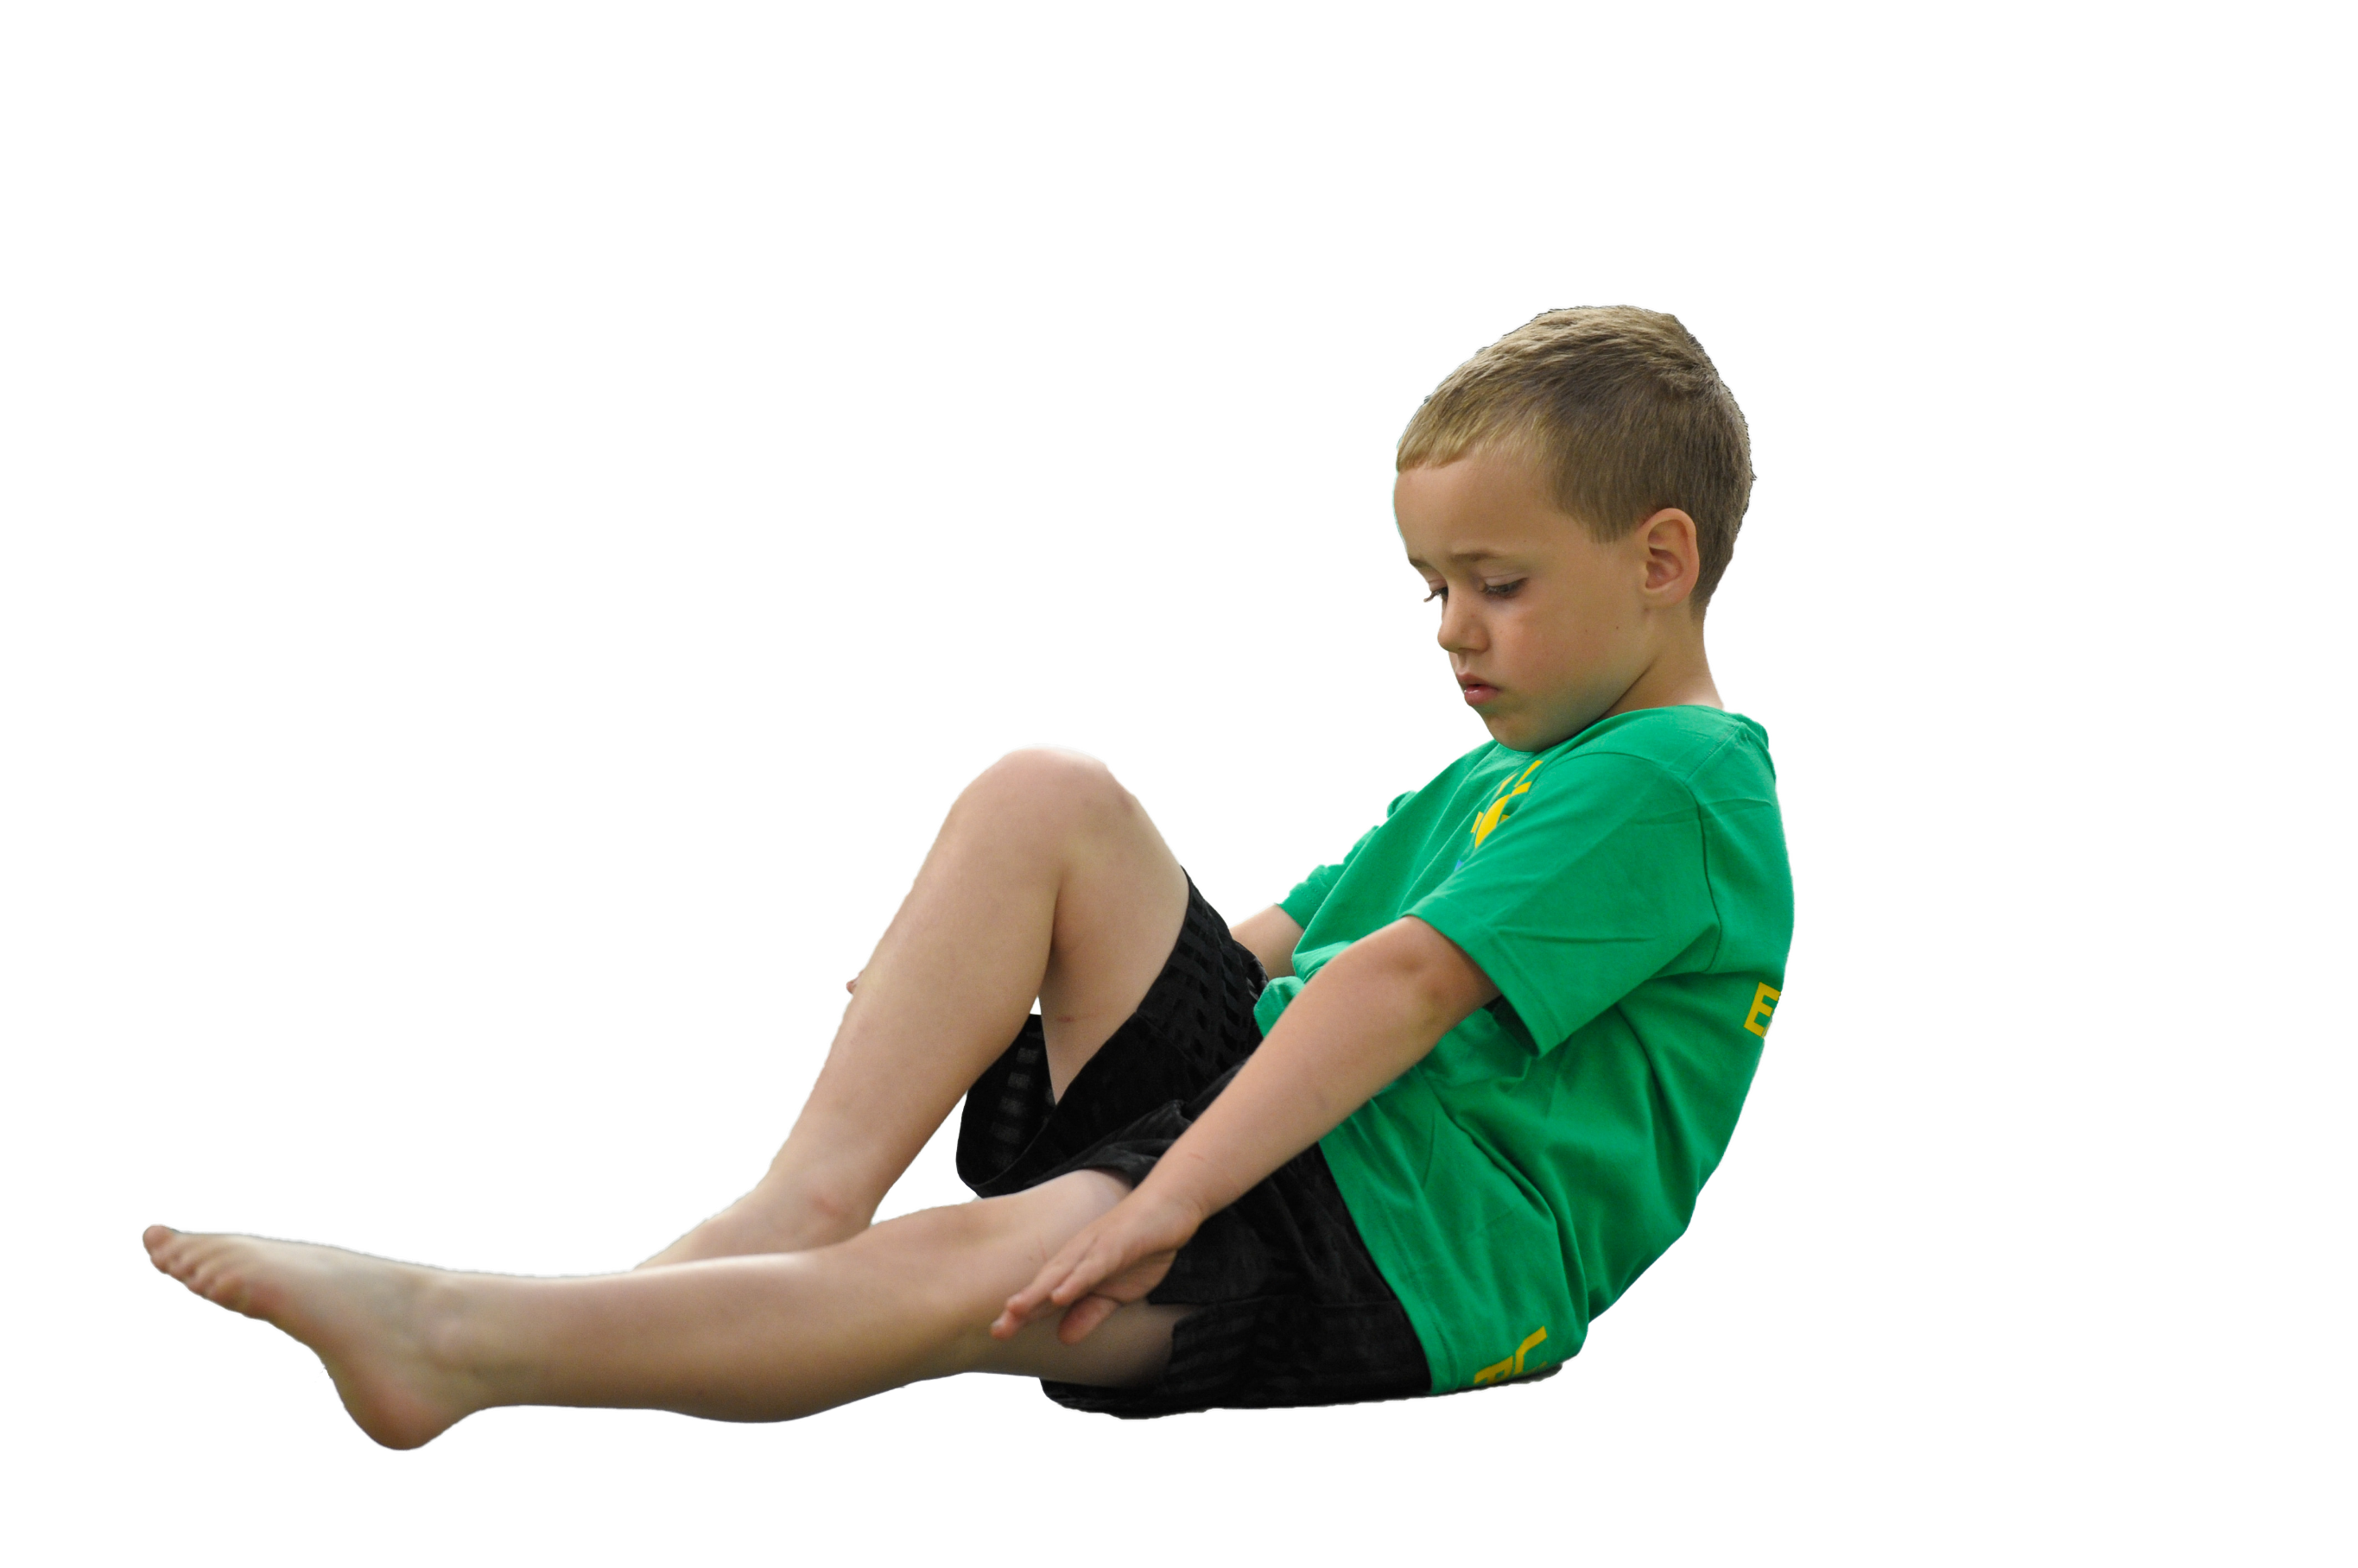
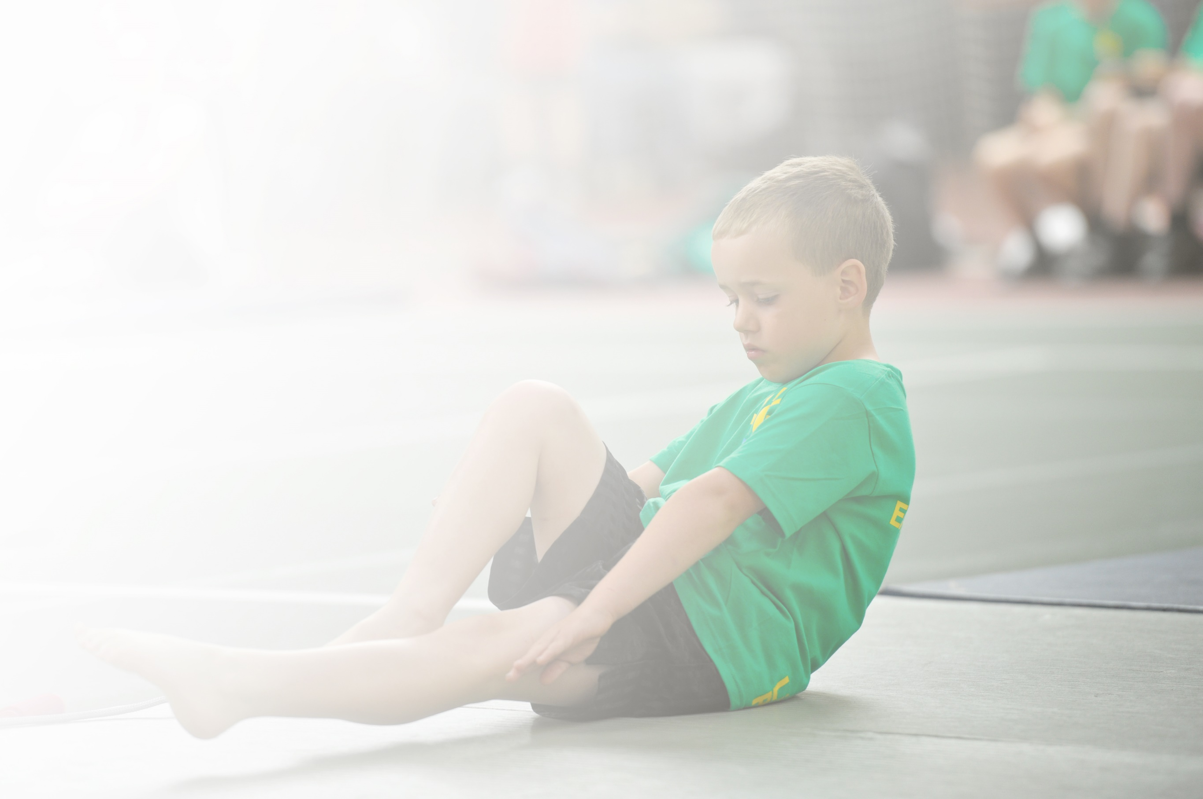
Schools must use the funding to make additional and sustainable improvements to the quality of Physical Education, Sport and Physical Activity (PESPA) they offer. This means that you should use the Primary PE and Sport Premium to:

- Develop or add to the PESPA activities that your school already offer
- Build capacity and capability within the school to ensure that improvements made now will benefit pupils joining the school in future years

Please visit gov.uk for the revised DfE guidance including the 5 key indicators across which schools should demonstrate an improvement. This document will help you to review your provision and to report
your spend. DfE encourages schools to use this template as an effective way of meeting the reporting requirements of the Primary PE and Sport Premium.

We recommend you start by reflecting on the impact of current provision and reviewing the previous
spend. Under the Ofsted Schools Inspection Framework, inspectors will assess how effectively leaders use the Primary PE and Sport Premium and measure its impact on outcomes for pupils, and how effectively governors hold them to account for this.

Schools are required to publish details of how they spend this funding as well as on the impact it has on pupils’ PE and sport participation and attainment by the end of the summer term or by 31 July 2019 at the
latest.
We recommend regularly updating the table and publishing it
on your website throughout the year, as evidence of your
ongoing review into how you are using the money to
secure maximum, sustainable impact. To see an
example of how to complete the table please
click HERE.

Support for review and reflection - considering the 5 key indicators from DfE, what development needs are a priority for your setting and your students now and why? Use the space below to reflect on previous spend, identify current need and priorities for the future.

Key achievements to date: | Areas for further improvement and baseline evidence of need:
Pupils at Hill View continue to have access to high quality PE and Sports provision. This is achieved through a well-planned, well-resourced progressive curriculum, extra-curricular activities and specialist coaching from external providers. There is a strong commitment to participation in team sports. Several of our age level teams have been successful in local tournaments and gone on to represent the borough of Halton in regional finals in both football and hockey. The number of children playing competitive sport has increased and the opportunities to participate non-competitively in activities such as yoga and dance have been provided for all children. Fitness equipment has been provided for daily  Hill View has been awarded the School Games Silver Award. | - Develop appropriate and systematic approach to assessment in all year groups  - Develop a system of monitoring and recording to show intent, implementation and impact  - Progress teaching to focus on achievement  - Develop partnerships with clubs and other schools

Meeting national curriculum requirements for swimming and water safety | Please complete all of the below:
What percentage of your current Year 6 cohort swim competently, confidently and proficiently over a distance of at least 25 metres?  N.B. Even though your children may swim in another year please report on their attainment on leaving  primary school. | 97%
What percentage of your current Year 6 cohort use a range of strokes effectively [for example, front crawl, backstroke and breaststroke]? | 84%
What percentage of your current Year 6 cohort perform safe self-rescue in different water-based situations? | 97%
Schools can choose to use the Primary PE and Sport Premium to provide additional provision for swimming but this must be for activity over and above the national curriculum requirements. Have you used it in this way? | Yes. The national curriculum requirements are met in Years 3 and 4. Years 5 and 6 continue with lessons over the summer term.

Action Plan and Budget Tracking
Capture your intended annual spend against the 5 key indicators. Clarify the success criteria and evidence of impact that you intend to measure to evaluate for students today and for the future.

Academic Year: 2019/20 | Total fund allocated: £17,630 | Date Updated: July 2019
Key indicator 1: The engagement of all pupils in regular physical activity – Chief Medical Officer guidelines recommend that primary school children undertake at least 30 minutes of physical activity a day in school |  |  |  | Percentage of total allocation:
 |  |  |  | 12%
School focus with clarity on intended impact on pupils: | Actions to achieve: | Funding allocated: | Evidence and impact: | Sustainability and suggested next steps:
- After school clubs aimed at engaging most sedentary group  - Additional swimming sessions (1Hr) and swimming tuition  - KS2 Playleaders to engage KS1 pupils during lunchtime each day  - Sports Ambassadors to engage KS2 pupils daily  - Ensure outdoor gym equipment is used daily  - Transport and instruction provided for additional swimming for Y5/6 | 1.Identify pupils with low levels of participation. Offer alternative activities/sports  2.Taget all children to be able to swim 25m/use a variety of strokes  3. Playleader training (PE Consultant)  4. Sports Ambassador training (PE Consultant)  5. Effective maintenance programme essential | £2000 | 1. Registers  2. Swimming assessments end of KS2  3. Independent learners and effective leaders | Small sided games during lunchtime  Mid-day assistant training
Key indicator 2: The profile of PESSPA being raised across the school as a tool for whole school improvement |  |  |  | Percentage of total allocation:
 |  |  |  | 35%
School focus with clarity on intended impact on pupils: | Actions to achieve: | Funding allocated: | Evidence and impact: | Sustainability and suggested next steps:
- PE Consultant to provide all staff with high quality professional development in delivering fundamental skills  - Subject Leader Network  - Effect on pupil mental health and wellbeing | 1. Professional development, mentoring, training and resources to help teach PE and sport more effectively and embed physical activity across school  2. Share good practice and develop effective partnerships | £6000 | PE Assessments  PE Lead to monitor impact  Teaching for achievement (Pupils attending outside clubs)  Indications of development of character and resilience | Overall school improvement  PE Lead professional development

Key indicator 3: Increased confidence, knowledge and skills of all staff in teaching PE and sport |  |  |  | Percentage of total allocation:
 |  |  |  | 35%%
School focus with clarity on intended  impact on pupils: | Actions to achieve: | Funding  allocated: | Evidence and impact: | Sustainability and suggested  next steps:
Progressive Sports Cheshire work alongside class teachers to provide high quality PE one day per week for all classes  Progressive Sports provide after school clubs in alternative activity, such as dance, yoga, lacrosse | All pupils to have active involvement  All teaching staff to work alongside specialists for CPD | £6000 | Increased pupil confidence in fundamental skills evidenced through lesson observations  Improvement in teaching for achievement evidenced through monitoring | Access to alternative sports and physical activity
Key indicator 4: Broader experience of a range of sports and activities offered to all pupils |  |  |  | Percentage of total allocation:
 |  |  |  | 9%
School focus with clarity on intended  impact on pupils: | Actions to achieve: | Funding  allocated: | Evidence and impact: | Sustainability and suggested  next steps:
Additional achievements:  Pupils have had opportunities to access specialist provision in the following sports and activities throughout the year:  Dance, Gymnastics, Archery, Lacrosse, Rounders, Football, Netball, Yoga, Hockey and Cricket | Participation at an inter-school competitive level | £1500 | PE Assessments  Increased participation | Develop partnerships with sports clubs and other schools
Key indicator 5: Increased participation in competitive sport |  |  |  | Percentage of total allocation:
 |  |  |  | 9%
School focus with clarity on intended  impact on pupils: | Actions to achieve: | Funding  allocated: | Evidence and impact: | Sustainability and suggested  next steps:
Transport costs met in order to allow teams to be entered into local and regional competitions  All year groups represented in local competitions  Two teams entered for hockey | PE Lead to be up to date and informed of local appropriate competitions  Sports teams appropriately resourced and equipped. | £1500 | School Sports Award | Intra School Competitions termly

