Learning to spell:

Using LOOK, SAY, COVER,WRITE, CHECK

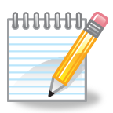
Look carefully at the word.
Can you see any words within this word?
Can you see a pattern of letters that you know?
Which part do you really need to focus on?
Say the letter names.
Repeat the letter names in a rhythm.
because

Cover
Write
Cover up the word, try to remember what the word looked like.
Check
Have a go at spelling the word.
Think about the way it looks, is it right?
Look
Say
Compare your word to the correct one. How much did you get right? Which bit do you need to learn next.

