LITERACY
To segment and write the sounds in words
To blend sounds together to read words containing the sounds I know
To know by sight the tricky words – I, the, is, put, pull, as, full.
To retell a familiar story – Dear Zoo, Oi Cat and Elmer stories

UNDERSTANDING THE WORLD
To know the names of different animals and know where we would find them- water, land and air
To know which animals we might see as pets, farm animals, zoo animals and begin to talk about wild animals

EXPRESSIVE ARTS AND DESIGN
To know how to use scissors so that I can cut paper for a purpose

To know how to make orange, green and purple by colour mixing and name the primary colours
To know how to join boxes using tape so that I can make a model

PSED
To play alongside and engage with others working on the same activity
To be able to take turns and know what is fair
To consider how actions affect others both positive and negative

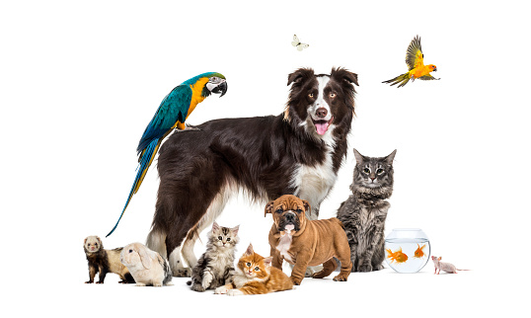

MATHS
To use the language more and fewer to describe sets of objects
To recognise arrangements of up to 4 objects without needing to count them (subitising)
To recognise if amounts are equal or not equal when sharing objects between two
To begin to add two sets of objects
Physical Development
To know how to form letters correctly with the correct pencil grip
To know how to turn my clothes the right way when getting changed
To know how to use a knife and fork to cut up my lunch

Pets knowledge organiser
Pet
Stay Play and Learn Together session Thurs 27^{h} Nov 2.15pm
Come into class and create an animal college with your child.
Useful website: www.phonicsplay.co.uk
Key vocabulary
pet
habitat
groom
vet
subitise
wings
fins
addition
animal
COMMUNICATION AND LANGUAGE
To follow the carpet rules to develop speaking and listening skills
To respond to one another to continue a conversation by asking a question.
To explain their thoughts and reasoning using I know this because… as a sentence starter

ROLE PLAY…
pet shop/ vet/ home corner

