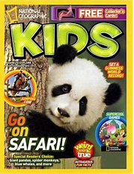

Foxes Class Reading Bingo.

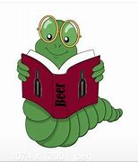
Choose a different activity each day. Have fun!
Read on a Saturday | Read before breakfast | Read outside | Read aloud to someone else in your household | Read twice in a day
Read whilst snuggling | Read to someone on the phone | Read a book in bed | Read a book you wouldn’t normally choose | Read to a stuffed toy or pet
Read for longer than usual | Read without being asked | Free choice | Read aloud as if you were presenting the CBeebies bedtime story | Read an award winning book
Read a book that has an animal featured on the cover | Read a book you have chosen because of the front cover | Read a book you have chosen because of the blurb | Read your favourite book again | Read with a torch
Read after dinner | Make yourself a den and read inside it | Read on a rainy day | Read a non -fiction book | 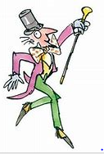  Read a magazine
Read a fairy or folk tale | Read a biography | Free choice | Retell a story in your own words | Read in a whisper

