Re: Sacrament of Confirmation
Dear Parent/Guardian
I am writing to invite our young people in year 8 (and above) to celebrate the Sacrament of Confirmation in summer 2026. In this sacrament, we receive the gift of the Holy Spirit to complete Christian Initiation which began at baptism and making our young people full members of the Church. Confirmation strengthens the Christian life and sends our young people out to be witnesses of Jesus Christ in today's world.
I hope that this sacrament will nurture or revitalise a life of prayer, be a time of further preparation in the Catholic faith, and inspire our young people to witness to Jesus Christ through love, service and faith in action.
I hope that you will support our young people in their journey of faith. Confirmation is also a sacrament for adults who have not received it at an earlier time; please speak to your parish priest if you are interested in preparing or receiving this sacrament if you missed out as a younger person.
Be assured of my prayers
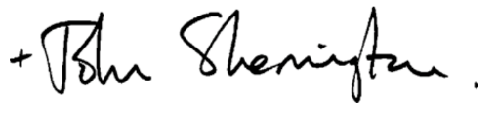
Archbishop John Sherrington
Archbishop of Liverpool

The Archdiocese of Liverpool is inviting young people in year 8 (and above) to receive the sacrament of confirmation.

Confirmation is a sacrament through which we receive the Holy Spirit to make us stronger and more perfect Christians and true witnesses of Jesus Christ.

The preparation for the sacrament will have begun in school in year 7 when pupils will have studied the sacrament in RE classes.

Preparation continues with either a visit to the school from Animate, the archdiocesan youth ministry team; or your child may instead watch short introductory videos. If you would like to watch the videos at home they can be accessed by going to YouTube - @Animate Youth – Playlists – Confirmation ‘Called…’

As year 8 pupils will already have studied the sacrament of confirmation in RE classes in year 7 they should already have some understanding of the sacrament. In Year 8 they will have short reminder sessions of what the sacrament is, and why it is important in the life of a maturing Christian.

If your child would like to receive the sacrament of confirmation this year it is essential they register online at:

https://liverpoolcalled.co.uk/

Registration must take place before the 13th February

Please complete the simple online form that can be accessed through clicking the button at the top right-hand side of the webpage (‘Register for Confirmation’). If you are unable to do this at home, please inform the school chaplain who will be able to help.

When the website has closed on the 13th February, your child will be contacted by your local parish / deanery confirmation co-ordinator who will take you through the next steps of the preparation process in your own area.

Please note that you will not be contacted before the 13th February – when the website closes. Many parishes may only contact individuals after Easter.

More details about the preparation scheme can be found on the liverpoolcalled.co.uk website or at animateyouth.org

Parishes will run their preparation at different times and in different ways so you should speak to your own parish priest if you have questions about meeting dates and venues.

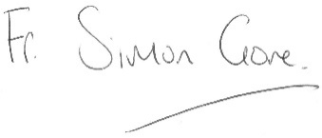

Fr Simon Gore
Director of Youth Ministry

