HOLY FAMILY CATHOLIC HIGH SCHOOL AND SIXTH FORM COLLEGE
Sixth Form Transition Pack

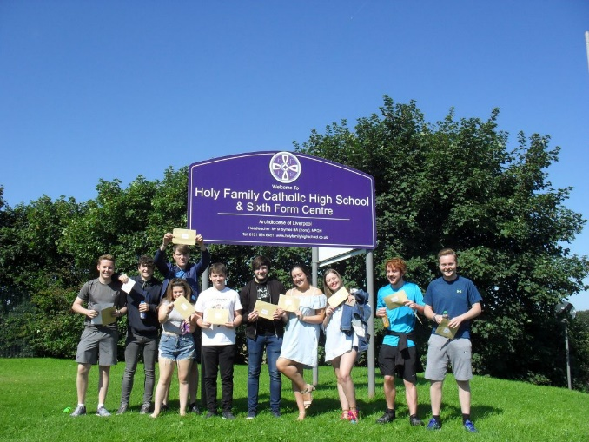
Essential Skills for Sixth Form Study – The VESPA system
This booklet will provide you with an introduction to the essential skills you will need in Holy Family Sixth Form. Regardless of your prior attainment at GCSE, each of you will now need to acquire and then further develop a different and new set of skills in order to achieve success at level 3.
These skills are broadly grouped into three areas and are grounded in LOTS of academic research and scientific studies.
1) Developing and implementing habits and routines.
2) Having the right attitude
3) Securing a successful approach to studying.
You and your teaching staff may have heard of three eminent theorists in these areas (they do cross over) – look them up!
1) Clough (Manchester Met University) - Research on mental toughness and confidence.
2) Carol Dweck – Knowing you can improve with hard work.
3) Duckworth - The benefits of perseverance and motivation
We will aim to teach you about these skills through lessons, assemblies, tutor time and activities and give you real and manageable ways to improve your ability to study and perform in your examinations. The system we will use is VESPA
From the very outset, you need to understand that Sixth Form life, although undoubtedly the very best part of school, is challenging, and requires commitment and hard work. There are no shortcuts.
“You’ll never change your life until you change something you do daily. The secret of your success is found in your daily routine.” - John C. Maxwell
“We are what we repeatedly do. Excellence, therefore, is not an act, but a habit.” – Aristotle
VESPA and the A Level Mindset (Oakes and Griffin) In order to be successful in Sixth Form you must have all of these qualities:
Vision – know what you want to achieve
Effort – put in many hours of independent study
Systems – organise your learning, resources and time
Practice – again and again and develop your skills
Attitude – respond constructively when setbacks happen
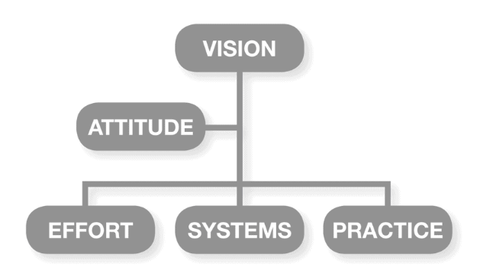
Your lessons, activities and assemblies will raise awareness about each of these five qualities and encourage you to reflect on whether each is a strength, or an area for development. You’ll then be shown how to strengthen these areas.
TASK 1 - VISION QUESTIONNAIRE
You have to have a goal otherwise you WILL hit a ceiling and underperform by ONE whole grade. The new linear A levels require long term stamina and a clear goal.
- Have a goal
- Set an actionable plan
- Stick at the goal
Your goal has to be a “pull goal”, not a push one (like your Mum wants you to be a doctor when you leave school, or your teachers have pushed you to get even better grades at GCSE and you have just gone along with.) It has to be the thing that inspires you and that you will work towards whatever the price.
Whatever goal you have you then need to capture and highlight steps. Our early sessions start with goal setting and we will be relentless at making sure that for every goal you have you will be given actionable tasks. For example, you want to be an actor? Join a new drama group; ask for bursary support to go to the theatre; watch 10 of the best actors in films from the last ten years and discuss what makes them so great. You want to study optometry? You need to organise some work experience. Can you talk about how optometry can change lives? Have you read a medical book on the eye? Can you show that you have outstanding interpersonal skills and the ability to communicate well?
Expect to be challenged and expect to step outside your comfort zone and not be allowed to just “fall into a path that is not your own.”
Work through the 20 QUESTIONS at the back of the work book. Take them seriously and bring your answers back on enrolment day.
TASK 2 - EFFORT
Effortless success is a MYTH. There are parents, teachers (bad ones) and students who believe that “you’ve either got it or you haven’t”. This is simply not true.
“Effort is a function of the intensity, direction and duration of one’s exertions towards a goal” (Duckworth et al).
Bloom’s study of world class performers in many areas (music, sport, and academia) noted that discipline and willingness to put in great amounts of time and effort were the SIGNIFICANT factors of success.
We will measure effort based on the hours of independent study you do every week. Independent study is homework, research, wider reading, consolidating your learning, revision, preparing for tests.
Two types of independent study:
Reactive: These are tasks set by teachers with a deadline – called homework. You will have only had reactive study at GCSE.
Proactive: This is the work that YOU set yourself. If this feels bewildering, it is because it is a new skill. It will look different in Maths than it will in English.
Chances are, you are not used to this and this independent study will require some effort. Your teachers have compiled a list of proactive independent study ideas. Look at them and tick them off if you do them.
You MUST do them and you will find (if your goal is right) you will enjoy doing them and will benefit from them. Research from many students says that the best students/ those achieving the best grades were undertaking 20 hours per week of independent study. The students who performed poorest were undertaking just 3 hrs per week. TOP PERFOMERS DO TWENTY HOURS per week of independent study.
Complete the Transition Activities in your three chosen subjects. Take them seriously.
TASK 3 -SYSTEMS
There is a direct link between your level of organisation and your final grade. Organisation helps you to see patterns, create connections and make sense of information. Research shows: If you are organised you will be less stressed, sleep better and be happier with your studies
Two types of system we want from you.
- A system to organise your learning
- A system to organise your time so that you can complete tasks to deadlines.
The first system (organising your learning) is about collecting and capturing. You will need a file for each of your subjects, with dividers and wallets. You will make notes in your lessons/ add to sheets that your teacher gives you and you will number or date every piece of work.
The second system is so you are able to manage your time effectively and prioritise work. You need to determine the amount of time your work will take and then schedule the appropriate time to do this work. You will need to make use of Class Charts and your diary to record homework and deadlines. Both of these systems will be checked regularly.
Complete the System Activity at the end of this in your workbook. Take them seriously and bring your work in on enrolment day.
TASK 4 – PRACTICE
The best practice brings deep learning. Apply effort and time across these three areas and you will know you are applying perfect practice.
- Content: Learn the content taught and then master it by reviewing and consolidating. Check and make sure you understand it.
- Skills: Put your knowledge into practice. Practise exam questions. Time yourself doing them. Make sure you try the tough questions.
- Feedback: Seek out expert feedback and learn from it.
Many students do not get past number 1. They continually review content but do not test themselves against the relatively high stakes of a test. Your teachers will give you lots of exam questions. Do them. And then do some more.
Your teachers will also give you skills lists. This is not the content you need to learn, but the skills you will need to have and apply to undertake examinations. When you know what you need to be able to do, you can apply this knowledge to practice tests. Your teachers will also give you drills to practise these skills. At its simplest level there will be mechanical practice e.g. learning by rote or practising short answers. When you have mastered these, you can then undertake flexible practice.
Teachers will always feedback on your practice questions by linking to the grade boundaries e.g. “that’s a B grade because you are using the skills from the mark scheme in the B grade”. “In order to achieve an A you need to use the A grade skills”.
You will be given model answers – analyse them for skills and mark them with the syllabi. Now do the question again and see if you can achieve an A. As a learner you should be able to chart the difference between a grade C skill and a grade A.
Complete the Practice Activity at the end of the workbook. Take them seriously. They will show you how to do the above really well.
TASK 5 – ATTITUDE
Attitude means
- Believing you can improve (having a growth mindset)
- Your buoyancy and positivity and having a strong response when faced with challenge or difficulty
- Your resilience and grit (getting back up when you get knocked down and your ability to “dig in”)
We will measure your attitude at the start of Year 12 via a questionnaire. These are the things we are looking for:
A growth mindset - Students who have a fixed mindset will be unable to thrive in challenging situations. They will use stories to explain why they can’t do something. These stories will be believable and strong, but ultimately indicate that a student needs to make a change to be successful.
Buoyancy - When you get a disappointing grade or miss out on something, it’s the way you handle it and remain positive and enthusiastic or determined to do better next time.
Resilience and Grit - The ability to deal with stress. Having emotional control, particularly around anxiety and exams. Worrying a little can be a positive thing – a little stress can support performance and can be a call to action.
These ideas will be reiterated through everything we do: assemblies, our interactions with you and our expectations of you. We want young people who are equipped for their examinations and their futures.
Complete the Attitude Activity at the end of this workbook, but remember this section should permeate all that you do.

ACTIVITY LIST.
VISION ACTIVITY 1 – Complete the questionnaire on page 7.
EFFORT ACTIVITY 2 –
- Complete 4 subject specific bridging work / transition packs. They will be uploaded onto the school website under the Sixth Form area – Year 11 Transition to Sixth Form.
- Make sure you understand the difference between Pro-active and Reactive effort.
SYSTEMS ACTIVITY 3 –
- Read a full newspaper article from April 2020 and summarise your opinion.
- Watch at least one YouTube video about how to make Cornell notes.
- Listen to a Podcast from this list and make Cornell notes.
PRACTICE ACTIVITY 4 –
Watch four videos on some of the most popular ways to practice effectively. Once you have watched each video summarise using your Cornell note taking technique.
The Leitner System / Box
https://youtu.be/uvF1XuseZFE
Mind mapping
https://youtu.be/-Y1HJMuqAPY
Graphic Organisers
https://youtu.be/DNFk1HvlCho
Overviews
https://youtu.be/CPxSzxylRCI
ATTITUDE ACTIVITIY 5 –
The work of Amy Cuddy on power posing has gained a big following, particularly after her very successful TED talk. Cuddy’s research focuses on how a change in posture can increase feelings of confidence and self-esteem and reduce feelings of fear. This is particularly important when tacking examinations and making a start to your new sixth form career.
Watch her TED talk and use her ideas.
https://www.ted.com/talks/amy_cuddy_your_body_language_may_shape_who_you_are?language=en

PLEASE BRING YOUR COMPLETED WORK AND QUESTIONNAIRE INTO SIXTH FORM ON ENROLMENT DAY.

VISION QUESTIONNAIRE
- If you could only take one subject what would it be and why?
……………………………………………………………………………………………………………………………………………….

- What elements of study do you find easy?
……………………………………………………………………………………………………………………………………………….
……………………………………………………………………………………………………………………………………………….

- What do you do in your spare time?
……………………………………………………………………………………………………………………………………………….
……………………………………………………………………………………………………………………………………………….
……………………………………………………………………………………………………………………………………………….

- Describe the most interesting lesson you have had and why (if you can remember).
……………………………………………………………………………………………………………………………………………….
……………………………………………………………………………………………………………………………………………….
……………………………………………………………………………………………………………………………………………….
……………………………………………………………………………………………………………………………………………….

- What jobs do you avoid doing and why?
……………………………………………………………………………………………………………………………………………….
……………………………………………………………………………………………………………………………………………….
……………………………………………………………………………………………………………………………………………….

- When does time fly? What are you doing?
……………………………………………………………………………………………………………………………………………….
……………………………………………………………………………………………………………………………………………….
……………………………………………………………………………………………………………………………………………….
……………………………………………………………………………………………………………………………………………….

- What job would you do for free and why?
……………………………………………………………………………………………………………………………………………….
……………………………………………………………………………………………………………………………………………….
……………………………………………………………………………………………………………………………………………….
……………………………………………………………………………………………………………………………………………….

- Who do you look up to?
……………………………………………………………………………………………………………………………………………….
……………………………………………………………………………………………………………………………………………….

- What would you try if you knew you couldn’t fail?
……………………………………………………………………………………………………………………………………………….
……………………………………………………………………………………………………………………………………………….
……………………………………………………………………………………………………………………………………………….

- If you have a lot of homework, what subject do you do first and why?
……………………………………………………………………………………………………………………………………………….
……………………………………………………………………………………………………………………………………………….
……………………………………………………………………………………………………………………………………………….
……………………………………………………………………………………………………………………………………………….

- What do you get stressed about?
……………………………………………………………………………………………………………………………………………….
……………………………………………………………………………………………………………………………………………….
……………………………………………………………………………………………………………………………………………….
……………………………………………………………………………………………………………………………………………….

- If you are with friends, what do you like to talk about?
……………………………………………………………………………………………………………………………………………….
……………………………………………………………………………………………………………………………………………….
……………………………………………………………………………………………………………………………………………….

- If you were given a small amount of money to start a company, what would it be?
……………………………………………………………………………………………………………………………………………….
……………………………………………………………………………………………………………………………………………….
……………………………………………………………………………………………………………………………………………….

- List five words you associate with happiness.
……………………………………………………………………………………………………………………………………………….
……………………………………………………………………………………………………………………………………………….

- When you had setbacks at school, what did you do to overcome them?
……………………………………………………………………………………………………………………………………………….
……………………………………………………………………………………………………………………………………………….

- What has been the best thing about being in ‘lockdown’?
……………………………………………………………………………………………………………………………………………….
……………………………………………………………………………………………………………………………………………….

- What has been the hardest thing about being in ‘lockdown’?
……………………………………………………………………………………………………………………………………………….
……………………………………………………………………………………………………………………………………………….

- What are you most looking forward to when starting 6th form or college?
……………………………………………………………………………………………………………………………………………….
……………………………………………………………………………………………………………………………………………….

- What concerns or worries you about starting 6th form or college?
……………………………………………………………………………………………………………………………………………….
……………………………………………………………………………………………………………………………………………….

- Where do you see yourself on your 21st birthday?
……………………………………………………………………………………………………………………………………………….
……………………………………………………………………………………………………………………………………………….
……………………………………………………………………………………………………………………………………………….
……………………………………………………………………………………………………………………………………………….

