

CCTV POLICY

Blessed Edward Bamber Catholic Multi Academy Trust


VERSION: 2.0
ADOPTED: AUTUMN TERM 25
NEXT REVISION: AUTUMN TERM 27

Corinthians 4:2

Now it is required that those who have been given a trust must prove faithful.

Version Control

Date of last review | AUTUMN TERM 2025
Date of next review | AUTUMN TERM 2027
Review period | EVERY 2 YEARS
Policy Status
Owner | HOLY FAMILY CATHOLIC PRIMARY SCHOOL
Approver | BEBCMAT/SHARD
Version | 2.0

Previous versions

Version | Author | Date | Changes
2.0 |  | Autumn 25 | Section on ‘access to CCTV footage’ and ‘covert surveillance’ added. References to Surveillance Camera Code of Practice and other legislations added. Updated terminology from ‘Privacy Impact Assessment’ to ‘Data Protection Impact Assessment.’
This is a Trust-Wide Policy which applies to all academies within the Trust

Contents
Introduction 4
Objectives 4
Operation 4
Storage and Retention 4
Security 5
Access to CCTV footage 5
Data Protection Impact Assessment 5
Covert Recording 6
Complaints and requests 6
Appendices to CCTV Policy 7
7
Appendix 1 – CCTV Signage 7
Appendix 2 – CCTV Log Sheet Example 8
Appendix 3 – CCTV Camera Location Log 9

Introduction
The purpose of this policy is to regulate and manage the use of the surveillance and CCTV (Closed Circuit Television) system at sites managed by BEBCMAT (Blessed Edward Bamber Catholic Multi Academy Trust). Cameras are used to monitor and record activities on Trust sites for the purpose of ensuring the safety of the building, staff, students, visitors and to prevent and identify any criminal activity. This policy is in line with principles set out in the Surveillance Camera Code of Practice 2021 and all personal data stored as part of the CCTV system is held in line with UK General Data Protection Regulations and the Data Protection Act 2018.

The system comprises of one fixed camera with PTZ (Pan Tilt Zoom) functionality located strategically in the junior playground. This is monitored and controlled by authorised personnel only.

The surveillance system will be registered with the ICO (Information Commissioner’s Office) in line with legislation. The CCTV system is owned by the trust.

Objectives
The objectives of the application of CCTV at trust sites is to:
- Protect trust buildings and property
- Ensure a safe working environment
- Maintain the welfare of pupils, staff and visitors
- Support Police by offering a form of deterrent to criminal activity and to support any enquiries
- Assist in the prevention of crime and assist law enforcement

Operation
The CCTV on site at Holy Family Catholic Primary School, Blackpool, will be operated outside of school hours (between 6.20pm – 7am daily) and outside of term time as a form of premises security.

Warning signs must be placed in suitable locations as required by the Code of Practice of the Information Commissioner (See Appendix A).

CCTV operators must not direct cameras outside of the school site, an individual, their property or a specific group of individuals. An exception for this may be for directed surveillance to take place, as set out in the Regulation of Investigatory Power Act 2000.

The CCTV system has been designed to cover a key point on our trust site, however, the trust cannot guarantee that a system will cover or detect all incidents.

Regular checks must be carried out of system functionality, this must include live view, recordings and storage capabilities.

Storage and Retention
Recorded data will not be retained for longer than necessary. Any retained data will be stored securely.

Recordings are kept for no longer than 30 days. Any specific recordings that are kept for a longer period will be logged and noted in the CCTV log sheet.

Access to recordings are restricted as set out in section 5.

Any footage that is required to be retained must be downloaded from the system at the very earliest opportunity to prevent any loss of data.

Security
Access to the CCTV, software and all data will be strictly controlled and limited to authorised staff.
The authorised system operators are:
- Senior Leadership Team

All access to CCTV systems will be controlled by limiting physical access and with the use of password protection.

Regular security audits will be carried out to ensure the system is kept secure at all times.

There must always be at least one authorised system operator in attendance when access to live or recorded footage is required.

Any system faults will be repaired promptly.

A log of all cameras and locations must be kept at all times (See Appendix C).

ALL access to the system must be recorded in a CCTV log sheet (See Appendix B).

ANY footage downloaded must only be saved on an encrypted device and this MUST be noted on the CCTV log sheet in the further comments section.

Access to CCTV footage
Data subjects are entitled to make a subject access request for all of their personal data including CCTV footage. However, the trust cannot guarantee that disclosure of CCTV footage will always be a possibility due to the following reasons:
- The trust is unable to blur or redact the footage sufficiently where there is a lack of technical resources
- The trust cannot release footage that would prejudice an ongoing investigation
- The trust must balance the rights of third parties and whether consent has been given or refused

Decisions regarding disclosure of CCTV footage will be made on a case-by-case basis. See the trust’s Subject Access Procedure for more information regarding subject access requests.

Data Protection Impact Assessment
The headteacher of the establishment or CEO of the trust should ensure a DPIA (Data Protection Impact Assessment) is completed prior to the installation of any CCTV system. A DPIA should also be undertaken when replacing, developing, or upgrading the CCTV system.

The completed Data Protect Impact Assessment must be stored securely.

In the case of a pre-existing CCTV system the headteacher or CEO must consider the ongoing necessity of such a system by reviewing previous Data Protection Impact Assessments and deciding if any circumstances have changed.

The Data Protection Impact Assessment must look at the proportionality of the system or whether a less intrusive method could be used.

When deciding on a camera location it is important that the details of this is recorded in the camera location log (See Appendix C).

Covert Recording
The Trust does not condone the use of covert surveillance, and will only do so in extreme circumstances where the following criteria are met
- an assessment concluded that if we had to inform individuals that recording was taking place it would prejudice our objective
- there is reasonable cause to suspect specific criminal activity is taking place covert processing is carried out for limited and reasonable period of time and related to specific suspected criminal activity

If the situation arises where the school adopts ‘covert recording’, there will be a clearly documented procedure which sets out how the decision to record covertly was reached, by whom and the risk of intrusion on individuals

Complaints and requests
All complaints about the trust’s CCTV system should be addressed to the headteacher of each school.
The General Data Protection Regulation provides Data Subjects with a right to make a Subject Access Request in order to view images of themselves, refer to the Subject Access Procedure for more information.

Appendices to CCTV Policy

Appendix 1 – CCTV Signage
To meet the requirement of the Data Protection Act 2018 all sites covered by CCTV must ensure that suitable signage is displayed.
- Signs should show clearly the purpose of the CCTV system, contain the relevant contact details of who is responsible for the system and contact details of the data controller.
- Appropriate locations for signage will include:
  - All entrances to the premises
  - Reception
  - At suitable areas internally throughout the building

Example Signage
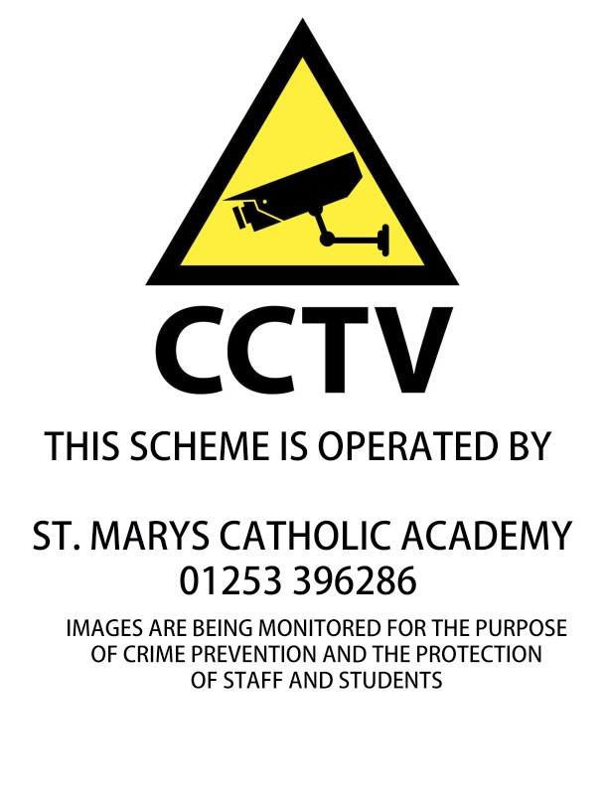

Appendix 2 – CCTV Log Sheet Example

All CCTV access must be logged in accordance with this policy; an example of such a log can be found below.

Date & time | Name of the person viewing/duplicating image(s)  Please print name AND sign | Name of any other authorized person(s) viewing image(s)  Please print name | Reason for viewing/duplication of image(s) | Further comment/action taken

Appendix 3 – CCTV Camera Location Log

A camera log for each site must be completed and kept up to date at all times. Please ensure all details are completed.
Camera  Name/Number | Type  Static/Dome | Location | Coverage

