Pupil premium strategy statement – Holy Family Catholic Primary School

School overview
Detail | Data
Number of pupils in school | 228
Proportion (%) of pupil premium eligible pupils | 35 (15%)
Academic year/years that our current pupil premium strategy plan covers (3-year plans are recommended – you must still publish an updated statement each academic year) | September 2024-2027
Date this statement was published | September 2025
Date on which it will be reviewed | September 2026
Statement authorised by | Mrs J Weatherall
Pupil premium lead | Mr M Shield
Governor / Trustee lead | Mrs C Irons

Funding overview
Detail | Amount
Pupil premium funding allocation this academic year | £45,450
Pupil premium funding carried forward from previous years (enter £0 if not applicable) | £0
Total budget for this academic year  If your school is an academy in a trust that pools this funding, state the amount available to your school this academic year | £45,450

Part A: Pupil premium strategy plan

Statement of intent


‘Seeing Christ In Ourselves and Others’
Holy Family School aims to encourage all children to see Christ in themselves and others in a caring environment, which allows them the opportunities to develop to their full potential.

‘Our Vision is a school where children are nurtured, inspired, excel and are proud of their achievements.’
In Holy Family School, we nurture the development of every child in a happy, caring and stimulating environment. We believe every child should have the best start in life and acquire these core abilities to read, to write, to be competent mathematicians and to be effective communicators.
Through excellence in teaching, we provide an enriching curriculum that engages our pupils, provides a diverse range of invaluable learning experiences and harnesses the use of technology to enhance their development.
Our pupils are inspired to learn, to reach their potential and to be proud of their achievements. We encourage each and every one of them to become independent, resilient and collaborative learners. As our pupils move through the school they grow spiritually, emotionally and academically to become confident young people, who use their knowledge, skills and talents for the good of both themselves and others. We value our partnerships with parents and carers, parish, other schools, the wider community and we welcome their contribution to realising our vision.
Children at Holy Family RC Primary School (disadvantaged and not) will be in receipt of high-quality learning which is carefully planned and sequenced and delivered with thoughtful pedagogy based upon strong educational research and knowledge of how children learn.
Through quality first teaching and increased opportunities for reinforcement of learning both within school and in partnership with home, children will make strong progress in reading, writing and maths as well as the wider curriculum.
We acknowledge the direct link between our Pupil Premium children and those children with SEND needs. Teachers work very closely with SEND support and ensure a holistic approach to meeting their needs. We want to enhance oral language skills, address SEMH concerns, increase basic literacy and numeracy skills, offer increased reading opportunities via reading books matched to phonics and reading for pleasure, and ensure children have access to targeted high-quality adult support through targeted intervention programmes.
We expect all pupils (disadvantaged or not) to engage in all aspects of school life equally. We will provide pastoral support for both pupils, parents, and will work with families to support school attendance so that all children are able to engage with the full learning experience at Holy Family.
We will also facilitate a wide range of enrichment experiences both in and out of school, which will positively impact on their academic achievement and well-being.

Challenges
This details the key challenges to achievement that we have identified among our disadvantaged pupils.
Challenge number | Detail of challenge
1 | The school must maintain a flexible and creative approach to the effective deployment of a small number of support staff to meet specific needs of children and whole school
2 | Provide enrichment experiences for learning they would not usually experience including local trips, visit to the theatre, residential trips and partner working with parents.
3 | Struggle for some disadvantaged pupils to focus on learning and progress because of social and emotional needs
4 | 27% of the children with PP status in school also have SEN status.
5 | Attendance for PP children is 93.3% which is below the school target of 96% for all pupils.

Intended outcomes
This explains the outcomes we are aiming for by the end of our current strategy plan, and how we will measure whether they have been achieved.
Intended outcome | Success criteria
The school has to maintain a flexible and creative approach to the effective deployment of a small number of support staff to meet specific needs of children and whole school | School to adopt a flexible approach to the pupils needs. Additional support to target PP pupils in order to ensure they make progress in line with their peers.  Termly reviews of the PP progress held and further support deployed as required.
Ensure enrichment experiences for learning are facilitated including local trips, visit to the theatre, residential trips and workshops with parents. | Use PP funding to ensure that the children are able to access and partake in enrichment experiences that would otherwise be inaccessible.
Struggle for some disadvantaged pupils to focus on learning and progress because of social and emotional needs | Support for families put in place to ensure the children’s social and emotional needs are facilitated. Support will be a priority this year as the school community recovers post-pandemic.
All PP children are supported to maximise their academic potential. | PP children SEN status has specific support for their needs.  High quality teaching and support ensure the PP children make academic progress.
Increased attendance rates for pupils eligible for PP | Overall PP attendance improves from 93.1% to 96% in line with ‘other’ pupils.

Activity in this academic year
This details how we intend to spend our pupil premium funding this academic year to address the challenges listed above.

Teaching (for example, CPD, recruitment and retention)
Budgeted cost: £ 20000
Activity | Evidence that supports this approach | Challenge number(s) addressed
No staff permanently ‘assigned’ to a class, although most assigned to supporting a specific child/ child in their EHCP needs.  All TA’s have a timetable of specific interventions/ therapies.  Further teaching staff to do First Aid training to ensure TA support isn’t used for trips because of the knock-on effect to school systems | Sutton Trust / EEF research on effective deployment of teaching assistants  ‘pre/post’ learning EEF research guidance  EEF SEND guidance document | 1

Targeted academic support (for example, tutoring, one-to-one support, structured interventions)
Budgeted cost: £ 12,950
Activity | Evidence that supports this approach | Challenge number(s) addressed
Baseline assessments done on children’s language skills and academic understanding on entry.  Assessments will inform teaching and any required intervention.  Interventions planned for pupils across EYFS, KS1 and KS2 to support PP children working in line with peers.  Progress meetings with teachers regarding the PP children to ensure their provision is appropriate to their needs and they are making progress.  Interventions planned across KS1 to support any language barriers. | Research from EEF and other sources that the more words children have at 5 the better they do academically in SAT’s and ultimately at GCSE.  Work done on Tier 2 vocab correlation with academic success  EEF Literacy in KS1 revision  Continuous improvement agenda EEF Nuffield Early Language intervention project  Equity and Quality in Education - SUPPORTING DISADVANTAGED STUDENTS AND SCHOOLS | 1 and 4

Wider strategies (for example, related to attendance, behaviour, wellbeing)
Budgeted cost: £ 12,500
Activity | Evidence that supports this approach | Challenge number(s) addressed
Embed whole Trust wide absence policy which fines for unauthorised absence. Made this explicit to parents. Reiterate at parents’ evenings and meet and greet sessions etc. the importance of continuous attendance. Praise parents/class on newsletter and Class Dojo for being highest attendance in school | Attendance was also a key focus for the schools White Paper, Opportunity for all, published in March (DfE, 2022b) and which included a pledge for a national data system “to drive up attendance and make it easier for agencies to protect vulnerable children”. | 5
Staff to work for positive mental health through PSHCE, staff CPD and in specific emotional well-being individual sessions when required.  TA who is Mental Health First Aider to provide support for vulnerable pupils especially those struggling with mental health, social well-being, child protection, family difficulties and low self-esteem. | Mental Health and Wellbeing Provision in schools (research report)  Rebecca Brown October 2022  Extensive research showing that Children’s mental health has to be in a positive place before effective learning can take place. | 3
Educational visits planned in advance.  Termly monitoring of wider curriculum provision across year groups.  Lesson observations and learning environment reviews show learning is linked back to the classroom e.g. vocabulary.  Evidence in book scrutiny of children drawing on broader experiences and related language. | Learning is contextualised in concrete experiences and language rich environments.  Ofsted research (2019) places emphasis on improving cultural capital, particularly for disadvantaged pupils. | 2

Total budgeted cost: £ 45,450

Part B: Review of the previous academic year (2024-2025)

Outcomes for disadvantaged pupils
Academic Impact - 23/24
EYFS: There were no disadvantaged pupils in 2025 compared to 6 in 2024. We recognise that for this cohort some children may meet the criteria for pupil premium support during their journey through primary education at Holy Family. We will continue to monitor this cohort to see if the pupil premium provision requires any changes as this group of children progress through school.
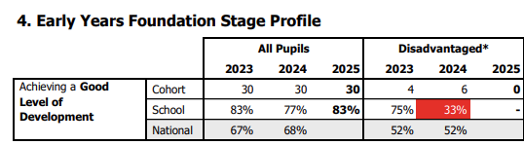
Phonics:
End of Year 1: Five of the six disadvantaged pupils in Year 1 passed the phonics screening. The pupil who did not pass also has received support for speech and language and has EAL. This does present a gap between all pupils (93% pass) and the disadvantaged pupils (83% pass). Additional phonics provision is in place for this pupil in Year 2.
End of Year 2: All disadvantaged pupils passed the phonics screening by the end of Year 2, which has closed the gap to other pupils, both nationally and at Holy Family.
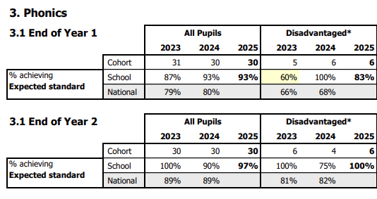

KS2 – Multiplication Table Check (Year 4):
The average score of disadvantaged pupils on the MTC is up 2.3 points in comparison to 2024. The average score of the disadvantaged pupils was higher than the average score of all pupils.
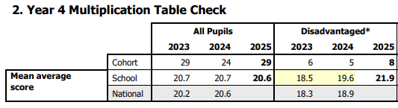
KS2 – (Year 6):
Attainment of the disadvantaged pupils at the expected standard for RWM was 100%.
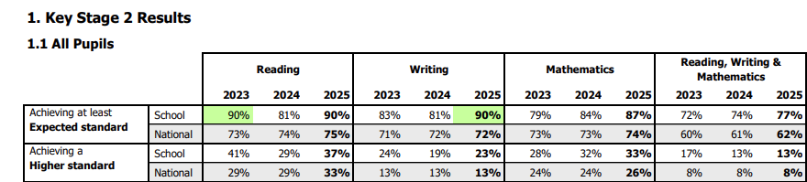
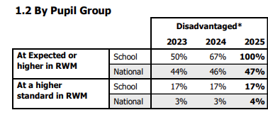
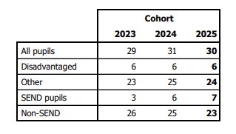

Higher Standard (Year 6)
Attainment of the disadvantaged pupils at the higher standard was 17% in comparison to all pupils (school) 13% and all pupils (national) 8%.

Monitoring and Provision
There is a range of extra-curricular clubs at lunchtime as well as after school. These places are fully funded for pupil premium students. The school provides many enrichment opportunities free of charge for pupil premium children or heavily subsidised opportunities. No child misses out! Music tuition has also been provided free of charge to those who want it.
A strong professional dialogue will be kept open between class teachers and SLT.
Regular termly and half termly pupil progress meetings which discuss the progress and next steps of individual children are held with Senior leaders and class teachers. This also forms part of individual performance management. Data shows that with targeted intention or quality first teaching, PP children have made strong progress and attained broadly in line. Children with SEND and PP have been slightly less successful but have still made progress.
Pupils access a wide range of interventions to meet their SEND needs
SEND interventions and SEND practices are continually monitored, evaluated and improved. Interventions and EHCPs are regularly scrutinised, and strategies adapted to meet the needs of the children on a regular basis. this has supported outcomes for children who have SEND and are PP.
Attendance of PP children improved to 93.1% is still below the target of 96%. School/Trust systems will be continued to be utilised to maximise attendance and support pupils and families that are struggling with this.

