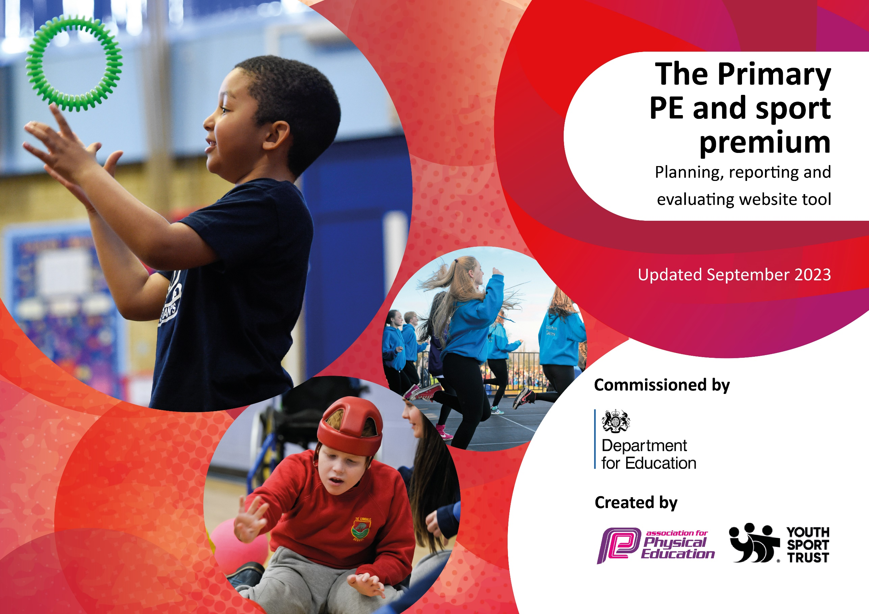

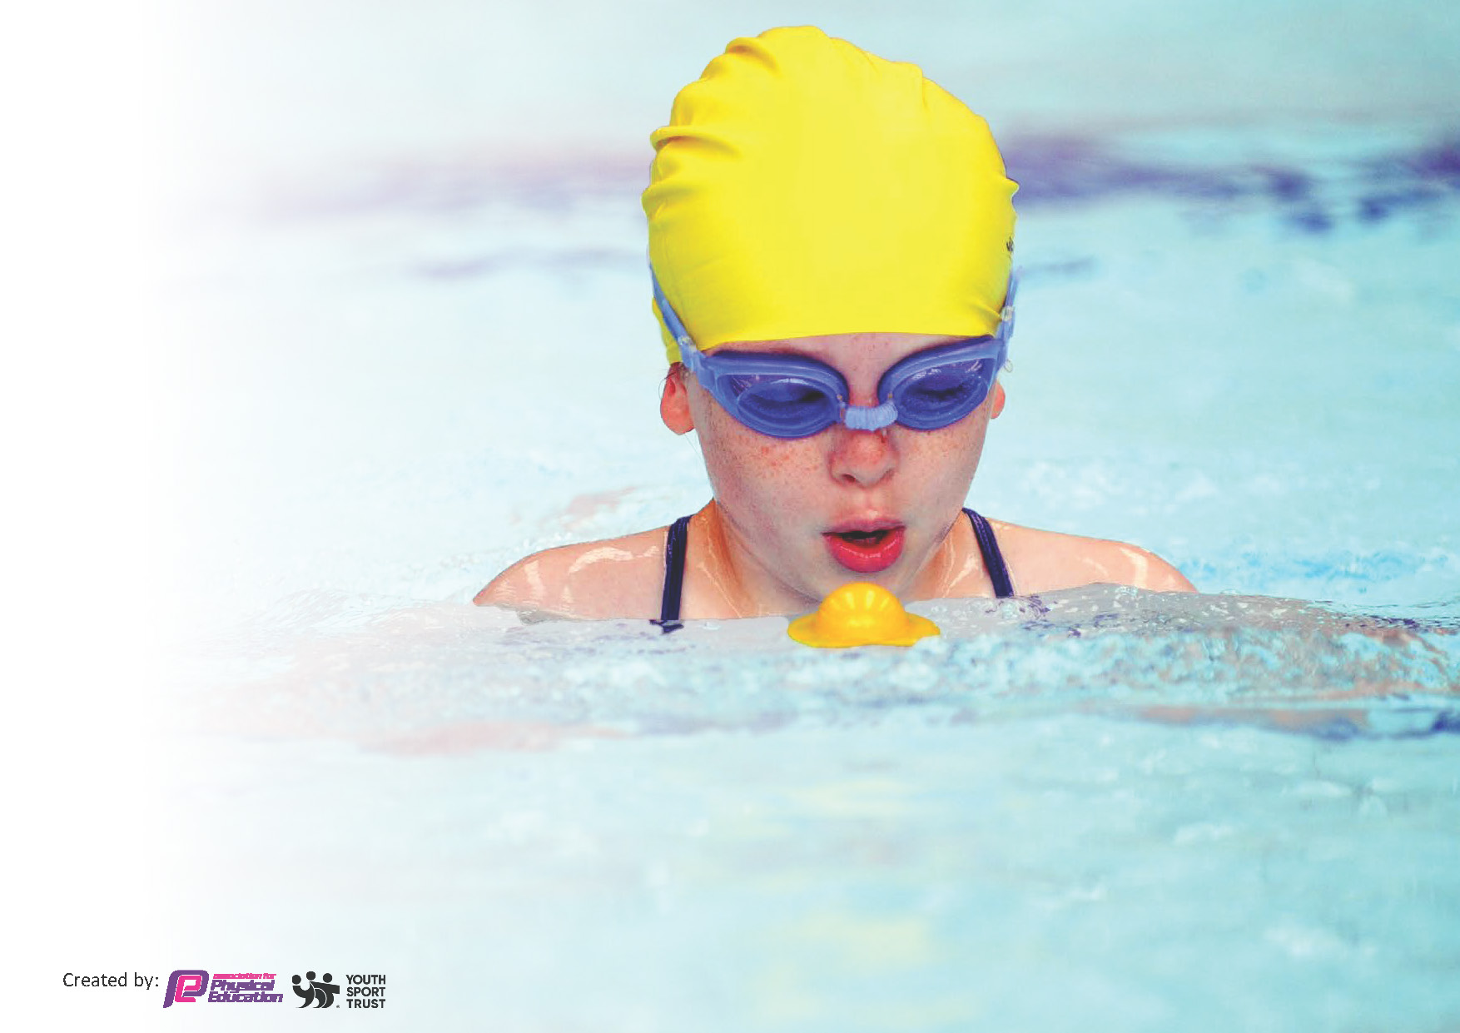
This template can be used for multiple purposes:
by:
- It enables schools to effectively plan their use of the Primary PE and sport premium
- It helps schools to meet the requirements (as set out in guidance) to publish information on their Primary PE and sport premium
- It will be an effective document to support Ofsted inspections enabling schools to evidence progress in Physical Education (PE) and evidence swimming attainment, which forms part of the PE National Curriculum. We would recommend schools consider
the Intent, Implementation and Impact of any spend, as examined within the Education Inspection Framework.

It is important that your grant is used effectively and based on school need.

Schools must use the funding to make additional and sustainable
improvements to the quality of the PE, School Sport and Physical Activity (PESSPA)
they offer. This means that you should use the Primary PE and sport premium to:

- Build capacity and capability within the school to ensure that improvements made now will benefit pupils joining the school in future years
- Develop or add to the PESSPA activities that your school already offers.

The Primary PE and sport premium should not be used to fund capital spend projects; the school’s core budget should fund these. Further detail on capital expenditure can be found in the updated Primary PE and sport premium guidance.

The Primary PE and sport premium guidance, outlines 5 key priorities that funding should be used towards. It is not

necessary that spending has to meet all the key priorities, you should select the priorities that you aim to use any funding towards.

Although completing this template is not a requirement for schools, schools are required to publish details of how they spend this funding. Schools must also outline what the impact this funding has had on pupils’ PE and sport participation and attainment and how any spending will be sustainable in the future. All funding must be spent by 31st July 2024.

The Department for Education has worked closely with the Association for Physical Education (afPE) and the Youth Sport Trust (YST) to develop this template and encourages schools to use it. This template is an effective way of meeting the reporting requirements of the Primary PE and sport premium.

Key priorities and Planning
This planning template will allow schools to accurately plan their spending.

Action – what are you planning to do | Who does this action impact? | Key indicator to meet | Impacts and how sustainability will be achieved? | Cost linked to the action
All children are encouraged to be actively engaged with physical activity. As a school, weather permitting, all children complete their weekly mile, and through break times and lunch times, children are given the opportunity to take part in planned activities organised by our school sports leaders. Pupil Voice Surveys designed and completed by PE Lead and Sports Leaders regarding playtimes and sport to grasp a bigger picture of engagement. | Training provided to Sports Leaders by PE lead to ensure understanding of purposeful activities is in place. Training refreshed monthly, with fortnightly reviews with Sports Leader team and PE lead to check in on activities. Additional equipment purchased for these activities as well as additional equipment for children whilst on the playground. | Key indicator 1: The engagement of all pupils in regular physical activity – Chief Medical Officers guidelines recommend that primary school pupils undertake at least 30 minutes of physical activity a day in school | More pupils are actively engaged in physical activity when outside of the classroom. Children are beginning to take own initiatives and responsibility when organising games and for actively encouraging others to join in. Activities are designed following Pupil Voice surveys to attract a broader spectrum of participants. Clubs have also been carefully selected to meet the needs and engagement of participants.  This is something we will be continuing with going forward, ensure all children are able to access and take part in their 30 minutes physical activity per day. Children’s voice is extremely important to the engagement in activity, so regular feedback from classes will continue to support our development in this area. | £665.60

We aim for all children across the school to have access to a range of activities on a range of different levels, allowing them to broaden their depth of knowledge within not only their skill set, but in their ability to transfer these skills into competitive sport. We are also actively encouraging girls to take part in sport, particularly football, and have offered sports events for SEN children to take part in within a safe and calm environment. | Through agreeing to the local SLA offer, children have access to a range of activities from EYFS through to Y6. Children are given the chance to participate in festivals of sport, apply their knowledge learnt within PE lessons into real life situations, and if they wish take part in competitive sport. We have had volunteers into school offering taster sessions, demonstrating pathways into different sports outside of school and making links within the wider community. We have encouraged girls to put themselves forwards as leaders within Sport, and had success in developing a girls only football team, leading to girls joining clubs and finding a love for the sport. | Key indicator 2: The profile of PESSPA being raised across the school as a tool for whole school improvement | Children are experiencing a broader offer within the PE curriculum which stretches further than the classroom in school. They are able to mix with other children from different schools, and experience sport at a variety of levels, whilst not only developing their physical skills, but developing their personal attributes such as their mental toughness, resilience and determination. Children are finding a passion for different sports following their learning in school, and have been sign posted to a number of different pathways within the local community, including Headlanders Netball, Judo Dan, and Darlington Harriers Athletics club.  We aim in the next academic year to achieve Platinum School Games Mark. In order to do this, we will be completing a case study around one of the following areas:  • Demonstrate how you are engaging those young people that need it the most in the School Games and evidence how you know they are benefiting  • Demonstrate how you are a physically literate school and how this positively impacts on your young people  • Demonstrate how you are developing and co-creating your offer with your young people  • Demonstrate your understanding of young people’s motivations and how you build this into your offer  • Demonstrate how you have embedded positive experiences of competition into your offer and how this has made a difference to your uptake  • Demonstrate how have you ensured that you have developed and maintained 60 active minutes across your school. | £1,500
All staff are provided with training and support in order to be fully confident and competent in the teaching of PE. Sporting Futures provide additional support and training for Staff members during PE lessons in order for staff to receive additional CPD. Staff to also pull on the expertise of each other to support own development eg – PE lead registered youth S&C development, Teachers who are a netball coaches/dance teachers. | Staff become more confident in their own ability for the teaching of PE, as well as develop their own love for the subject by working alongside others. Staff work alongside PE lead in planning their PE sessions. PE lead has created an overview assessment for what PE is to be taught across the school throughout the year, and provide resources to support teaching of the subject. | Key indicator 3: Increased confidence, knowledge and skills of all staff in teaching PE and sport | Staff engagement with the subject increased, and capability levels increase. Staff taking ownership of own CPD and feel comfortable approaching PE lead/other members of staff to continue own development within the subject.  Staff to continue with own CPD within subject, maintaining positive relationship with PE leader to assist with development. PE to continue making links with sports coaches outside of school to assist in own CPD which can then be shared with staff. | £7565
Additional achievements:  Outdoor activities (y6 residential)  In school visitors for taster sessions of non-school sports (eg judo)  Careers week included visit from Sports Coach to inspire children to work within sports industry.  Reception Multi Skills sports day with St Mary’s Cockerton (in planning)  Activities taken part organised by the Darlington SSP including both competitive and non competitive events with links to the wider region (Tees Valley) and inclusivity for all. | By the end of Year 6 all children will have been given the opportunity to attend a residential trip. The school has signed up to the Darlignton SSP SLA to have access to a range of opportunities for each child to participate in. PE lead in contact with Darlington SGOs to support development of broader experience within school. | Key indicator 4: Broader experience of a range of sports and activities offered to all pupils | Children will have been given experiences to broaden their understanding of sport from taking part and having a go, to competition, and even through the organisation of sporting activities themselves. Children have a greater understanding that sport is not just a competition and it is for fun. Children also aware that all sports are accessible to anyone no matter their ability/gender/beliefs – it is an opportunity to come together as one.  This is something which is ongoing for the school as part of our SGM, and will continue as we develop through to Platinum Standard. SD to continue making links with SGO and Sports Coaches/Persons who can continue to support us in inspiring children within sport. | £1985
Through the Darlington SSP SLA, children are given the opportunity from an early age to participate in competitive sport. Children are able to participate in multiple sports as both individuals and as a team. Children are to be given positive experiences around competition, developing their confidence and reaching a level of self actualisation. | Through the school games values Children learn self discipline and sportsmanship whilst being gracious in both winning and defeat. Children are able to take part in a wide range of activities against school across the town, giving them the opportunity to develop friendships through sport. Children to develop a sense of competitiveness and fulfilment from taking part. Children have access and are directed to a variety of different club pathways which they can then develop themselves further. | Key indicator 5: Increased participation in competitive sport | A higher percentage of children are actively engaged in sport outside of school. Through pupil voice surveys, children have shown they are engaging in a wide range of clubs with the opportunity to become competitive, for example, swimming, football, snooker, badminton and gymnastics. They are sharing their love for sport with others, and seeking involvement in activities by all.  This is something we look to continue into the next academic year. Children will continue to develop as both individuals and as members of a team. Children to continue developing own sense of ownership within sport by designing and running house competitions with support from PE lead. | £1500

Swimming Data
Meeting National Curriculum requirements for swimming and water safety.
Priority should always be given to ensuring that pupils can perform safe self-rescue even if they do not fully meet the first two requirements of the National Curriculum programme of study

Question | Stats: | Further context  Relative to local challenges
What percentage of your current Year 6 cohort can swim competently, confidently and proficiently over a distance of at least 25 metres? | 79% | Local pool closure and local authority transport costs and failure to pick children up at the agreed time to take the cohort to swimming.
What percentage of your current Year 6 cohort can use a range of strokes effectively [for example, front crawl, backstroke, and breaststroke]? | 67% | Local pool closure reduced the amount of practice the children could have of the variety of strokes.

What percentage of your current Year 6 cohort are able to perform safe self-rescue in different water-based situations? | 83%
If your schools swimming data is below national expectation, you can choose to use the Primary PE and sport premium to provide additional top-up sessions for those pupils that did not meet National Curriculum  requirements after the completion of core lessons. Have you done this? | Yes/No | Local pool closure provided a barrier to this.
Have you provided CPD to improve the knowledge and confidence of staff to be able to teach swimming and water safety? | Yes/No | Water safety was delivered online via zoom to the children by the swimming teachers from the local authority.

Signed off by:

Head Teacher: | Jane Weatherall
Subject Leader or the individual responsible for the Primary PE and sport premium: | Charlotte Wildsmith
Governor:
Date: | Autumn 2024

