SEND Information Report
Approved on:
July 2023
Next review:
June-July 2024
Holy Family RC Primary School

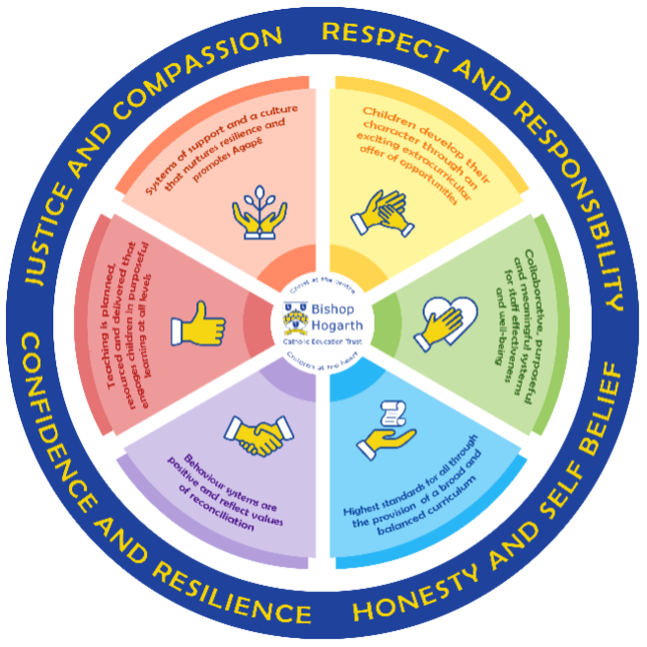
As part of the family of Bishop Hogarth Catholic Education Trust, our school has at its core, the virtues, and values of:
Respect for others and themselves, recognising that we are all created in the image of God and therefore must be compassionate towards others, especially the vulnerable. ​
Confidence in their own abilities, knowing that their talents are gifts from God and resilience to persevere when things become difficult. ​
Honesty in regard to the world around them and themselves and the ability to take responsibility for the times we may fall short of the mark. ​
Gratitude for all the amazing gifts from God and willingness to share their gifts both personal and material. ​

As an inclusive school, all teachers are teachers of pupils with Special Educational Needs & Disabilities. We deliver a curriculum and create an environment that meets the needs of every pupil within our school. We ensure that every pupil with Special Educational Needs and / or disabilities makes the best progress possible. We foster and promote effective working partnerships with parents / carers, pupils, and outside agencies. We consider the ‘whole’ child and strive to ensure that all our SEND pupils are prepared for adulthood.​

Our school’s approach to supporting pupils with SEND
Our school aims to encourage all children to see Christ in themselves and others.
“You are a child of God. You are dearly loved, wonderfully made and precious in his sight. Before God made you, He knew you. There is no one else like you.”
(Psalm 139)

- At Holy Family R.C. Primary School we aim to secure the highest achievement attainable for each child.
- Teachers are responsible for the progress of ALL pupils in their class. High quality teaching is personalised to need, making appropriate use of ICT. This is the first step in supporting pupils who may have SEND. All are challenged to do their very best.
- All children are known well by the all the teaching and support staff within school. They develop strong, nurturing relationships with the children they work with every day. Good behaviour and organisation is rewarded. Sanctions exist to support consistently high standards of behaviour and our Behaviour Policy can be accessed from the school website http://www.holyfamilyprimary.org.uk/policies/.

- Your child can express their views in several ways, including via the School Council or directly to school staff. The role of the School Council Representatives is to ensure that all pupils have a voice in school.
- We manage medical needs by working closely with parents and healthcare professionals. We listen to and act on their advice, providing staff training when needed. Our Supporting Children with Medical Needs Policy can be accessed from the school website http://www.holyfamilyprimary.org.uk/policies/.
All teachers have Qualified Teacher Status (QTS) and teaching assistants have a minimum of a Level 2 qualification. They also have a wealth of experience which is over and above the qualifications needed for their jobs and specialist services outside of school are accessed when the need arises.
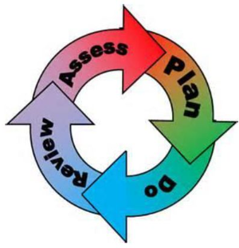
How will the school staff support my child?
The graduated response-Identifying, planning for and supporting pupils with SEND
Where a pupil is identified as having a special educational need, School will follow a graduated approach which takes the form of cycles of ‘Assess, Plan, Do, Review’. ​
• Assess a child’s special educational need. ​
• Plan the provision to meet your child’s aspirations and agreed outcomes. ​
• Do put the provision in place to meet those outcomes. ​
• Review the support and progress.

How does the school know if children need extra help and what do I do if I think my child has special educational needs?
- Assess
- Pupils with additional needs are identified in a number of ways including communication with parents/carers and close analysis of current and prior attainment data.
- Children who are in the care of the Local Authority have a Personal Education Plan (PEP) with clear targets and actions which reflect the child’s needs and provide a continuous record of their achievements.
- The steps taken for all children requiring additional support are reflected in the graduated approach as set out in the SEND Code of Practice: 0-25 years (2014) www.gov.uk/government/publications/send-code-of-practice-0-to-25
- If a pupil has received support in a previous setting, discussion with parents/carers, pupil, staff from the prior setting and the class teacher/school SEN Co-ordinator can help to inform provision.
- If you are concerned that your child might have SEND, please contact the Head Teacher or School SENDCO via the office.
- As you know your child best, we would appreciate sharing relevant information at the earliest opportunity. We would include your child in this process so they are fully involved as appropriate from the outset.
- Some children might need special arrangements to enable them to access statutory assessments at the end of each Key Stage. The Head Teacher and SENDCO manage this work in line with the annual arrangements published by recommendations from:
- www.gov.uk/teacher-assessment-key-stage-1-tasks-and-tests
- www.gov.uk/government/collections/key-stage-2-tests-administer-the-tests
- We follow the Department for Education model, “Assess, Plan, Do, Review” and your input will be invited at each stage.
- For further support, you can contact the Local Authority Parent Partnership Officer on 01325 388618 or www.darlington.gov.uk/Children/SEN/Parent+Partnership/Parent+Partnership.htm
- or email parent.partnership@darlington.gov.uk
- For additional information, please see details of Darlington’s full Local Offer of SEND support at: http://darlington.fsd.org.uk/kb5/darlington/fsd/disabilities.page?disabilitieschannel=0

- Plan
- All teachers are teachers of pupils with SEND. We work closely with outside agencies to ensure our staff are trained appropriately in order to equip them with suitable strategies and approaches to help them to meet a wide range of learning needs. Teaching Assistants are deployed throughout school where they can best serve pupils’ needs in close collaboration with class teachers and the school SENDCO.
- We start from the position that each child in our school family is unique, valued and special and we promote the self worth of each by giving love, recognition, praise, understanding and the opportunities to succeed. Each child will be encouraged to grow, in the fullest sense, and develop his or her human potential by participating fully, as far as he or she is able, in the life of the school.
- Where a child fails to make adequate progress, despite additional help, we seek advice from relevant outside professionals. These include:
- Educational Psychologist
- Child and Adolescent Mental health Service (CAMHS)
- Occupational Health (Sensory Support Services)
- Physiotherapy
- Child and Adolescent Mental Health Service
- Darlington SEND Outreach Team (Social communication outreach service, cognition and learning out reach service)
- Low Incidence needs service (LINS)
- Hearing Impaired Service
- Speech and Language Service
- Early Years Inclusion Service
- School Nursing and the growing healthy team
- St Teresa’s Hospice Bereavement Service (????)
- Daisy chain offer advice and support to parents of children in Darlington. More advice is available here FINAL-Family-Support-brochure.pdf (daisychainproject.co.uk).

- Information about a pupil’s SEND is shared with members of staff supporting and working with the individual pupils, as we believe a collaborative approach helps all staff have a better picture of the pupils they are supporting.
- We discuss specific concerns with parents/carers and pupils in order to more fully understand pupils’ needs and to aid in the provision of personalised support.
- Teaching and learning approaches are modified in order to support the needs of all learners and we comply with expectations set within equality and disability law. For more information please refer to the Equality Act 2010 (updated in 2018) at: www.legislation.gov.uk/equality-act-2010-guidance

- Do
Our teachers are skilled at adapting teaching and learning to meet the diverse needs in each class. ​
Daily planning considers individual children’s needs and requirements and is annotated and adapted according to need. Explicit reference is made in the teacher’s planning to the needs of those children identified with SEND. ​
Adaptive teaching is approached in a range of ways to support access to the curriculum and ensure that all children can experience success and challenge in their learning. ​
Grouping arrangements consider the different skills and abilities of each child. This ensures that learning is maximised. ​

Additional adults support groups and individual children with the long-term goal of developing independent learning skills. The class teacher monitors this support to avoid students becoming over reliant on this. ​
We fully encourage parental support and offer opportunities for individual meetings with parents/carers to provide clarity and recommendations on how they can support their child at home.

- Review
- ‘Additional’ or ‘different’ provision is delivered in a range of ways, including through provision of additional specialist resources, the support of an additional member of staff within the whole class setting or timetabled 1:1 or small group support to deliver specified support or interventions.
- Your child’s teacher will manage / guide any relevant interventions, which will be reflected in lesson planning.
- Where necessary, and with your full consent, we will approach outside services for advice to strengthen the provision offered to your child. We encourage you to get involved in your child’s additional provision and are currently working to develop clearer forms of practical advice for parents/carers. We believe that best outcomes are achieved when there is a consistent home-school approach being taken, wherever possible.
- If good progress is still not being made, despite all steps taken, we move to the next step of the graduated approach put forward within the 0-25 Special Educational Needs and Disability Code of Practice
(www.gov.uk/government/publications/send-code-of-practice-0-to-25)
- Data is closely monitored and reviewed by the class teacher, SENDCO and school leadership team to ensure that your child’s provision is having a positive impact on outcomes.
- We fully encourage parental support and invite parents to regular planned meetings which take place termly in order to discuss progress and recommendations on how children’s learning can be supported at home.
- Parents of a child with an Education Health Care (EHC) plans are invited to attend the annual review of this plan. Education, Health and Care Plans – Darlington
- We have a member of the school Local Governing Body who has specific responsibility for SEND.
- We have a growing parent group who we aim to help steer our vision and provision.

How will the curriculum at our school be matched to my child’s needs?
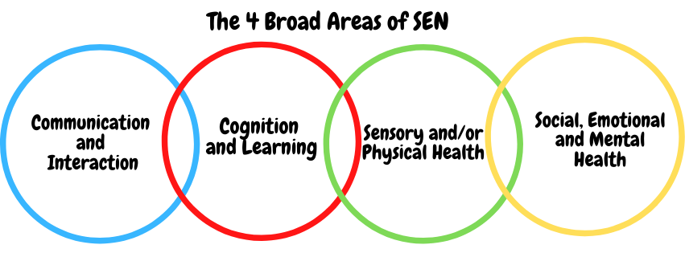SEN needs are classified under four broad areas of need. Below are the strategies, in class support and interventions that school may put in place to support your child. At present we have the highest level of need within the communication and interaction are of need however this is an ever changing picture.
Communication and Interaction
Strategies to support children with these needs include:
-Use of visual timetables in all classes.
-Use of visual prompts as needed.
-Clarifying need on entry/ Identifying need.
-Social skills development through small group work and specific interventions as appropriate (Lego therapy, turn taking skills, games)
-Support in the classroom and at break times as needed, some adaptations will be made to support individual pupils, sports leaders help model playground games and provide some structure to play times.
-Speech and language support from outside agency and delivery of suggested programmes by staff in school.
-Referral to Speech and Language Therapy Services for additional targeted support.
- Where necessary and in consultation with parents support from the Social Communication outreach service is sought and advice given.

Cognition and Learning
Strategies to support children with these needs include:
- Quality first teaching, differentiated for individuals as required.
- Careful deployment of support staff within lessons linked to specific pupils.
- Training for staff.
- Needs of pupils known by all staff.
- Differentiated materials including coloured background and overlays, use of picture and word banks, visual clues to learning etc.
- Support staff deployed to encourage engagement.
- Range of teaching and learning strategies.
- Flexible groupings
- Frequent repetition and reinforcement
- Practical aids for learning, e.g. table squares, time/number lines, pictures, photos, accessible reading material suited to age, individualised success criteria
- Access to advice and support from specialist staff.
- Access arrangements to assessments including scribe, readers and adapted texts.
- Support from outside agencies e.g. Educational Psychologist which form part of Individual Support Plan

Sensory/Physical
Strategies to support children with these needs include:
- Access to Sensory Support services for advice on planning for students with a visual or hearing impairment. (LINS)
- Teachers will be made aware of the implications of physical and sensory impairments and adapt lessons accordingly.
- Use of alternative coloured paper/ background on white boards, coloured overlays etc. if appropriate.
- Liaison with outside agencies for specific equipment to aid access to the curriculum.
- Provision of specialist ICT equipment as advised and prescribed by therapists.
- Occupational Therapist/ Physiotherapist targeted programmes.
- Concrete apparatus available to support learning, e.g. Numicon materials (numeracy)
- Adapted curriculum to enable access e.g. alternative recording devices, modified PE curriculum
- Sensory resources available e.g. wobble board, headphones/ear guards
- Access to support for personal care.

Social, Emotional and Mental Health
Strategies to support children with these needs include:
- Deployment of teaching assistants and lunchtime staff to support needs of the individual.
- Whole school reward system to promote behaviour for learning.
- Use of individual reward system tailored to interests and needs of specific children.
- Working with outside agencies to promote safe behaviours.
- Links to parents/ carers via staff with family liaison and attendance support.
- Social skills support including group work with support staff to support development of friendships.
- Educational Psychologist/ CAMHS as appropriate.
- Individual support within lessons through differentiation of tasks or deployment of support staff.
- Whole school themed activities during Anti-Bullying week to promote inclusion of all pupils.
- Referral to the Mental Health Support Team and Key stage 2 workshops as offered by the service.
- Our Early years teacher has had training in emotional literacy for the Early Years (ELSEY)
- We are continuously developing our practice and are embedding our emotional regulation support strategies and use metacognitive approaches to help pupils with self and co regulation strategies.

What training is provided for staff supporting children with SEND?
Some of the additional training and qualifications our staff have includes:
- Qualified First Aid Staff
- Training in the administration of medication
- Epi-pen trained
- Diabetes awareness
- Speech and Language
- Attachment
- Moving and Handling
- Dyslexia Training
- Trauma informed approaches
- Sunflower programme sensory training.
- We also develop our approach and have regular whole school professional development with an SEND focus.

How do we support transition in our school?

Transition within classes/key stages: ​
- We recognise that some students need more support at transition points, such as when moving between Key Stages or when moving to a new school setting. At such times we offer personalised transition programmes to support individual SEND children.
- We have a transition programme and have pupils who are starting school and moving to new classes visit their new class and meet the class teacher. We use Class Dojo to share information about their new classroom and photos of staff so that pupils can look at these whilst preparing for transition.

Transition to Secondary settings: ​
- Our year 6 pupils all access mental health transition workshops led by the mental health practitioners in school.
- We strive to provide continuity of support and reduce your child’s potential anxiety by working closely with staff in the next Key Stage/school.
- We work closely with schools in order to support transition to Key Stage 3. This includes individual transition plans which provide opportunities for additional visits to a new setting, the use of photo diaries and opportunities for children and parents to meet key staff prior to moving in consultation with professionals, pupils and parents.

Where can I get further information about services for my child?

The Local Offer
https://livingwell.darlington.gov.uk/Categories/528

For further advice about SEND in Darlington please contact
SEND Information, Advice and Support Service (SEND IASS) – Darlington

What key school documents refer to support and provision for pupils with SEND?

- SEND Policy​
- Admissions Policy​
- Supporting Pupils with Medical Needs Policy​
- Accessibility Plan​

Accessibility​
- Our facilities offer support for those with reduced mobility / wheelchair users and include ramps to enable access to the building and adapted toilet facilities.
- We have window blinds and carpets in all teaching areas to improve the auditory and visual environment for our learners with sensory needs.
- We are committed to children with SEND being included in activities both inside and outside the classroom. We expect all students to be able to participate and achieve in every aspect of school life. Our Equality and Inclusion Policy can be accessed from the school website: http://www.holyfamilyprimary.org.uk/policies/.

Activities Outside of School​
- We are committed to children with SEND being included in activities both inside and outside the classroom. We expect all students to be able to participate and achieve in every aspect of school life. Our Equality and Inclusion Policy can be accessed from the school website: http://www.holyfamilyprimary.org.uk/policies/.

What to do if you have a complaint, a compliment, or a query.

The school details and relevant contacts
- Should you wish to discuss something about your child or have any concerns regarding the provision made, please contact the Head Teacher or School SENDCO via the school office on 01325 380821 or email admin@holyfamilyprimary.org.uk. Alternatively, you may contact Carmel Education Trust on 01325 254525 or via their website www.carmeleducationtrust.org.uk.
- Mrs J Weatherall – Head Teacher (Holy Family R.C. Primary)
- Mrs R Smith –SENDCO (Holy Family R.C. Primary)
​
Name of school SEND governor.
Mr Tony Graham

