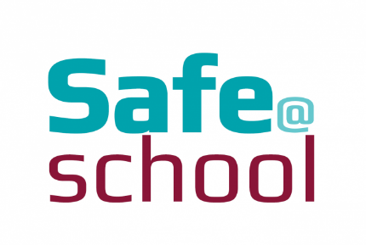
20^{th -} 22rd May 2019

Dear Parent/Carer,

From Monday 20th- Wednesday 22nd of May schools around the country are celebrating ‘National Nurturing Week’. This is a chance for all students at Hope High to join in with some social activities and ‘Life Skills’ focussed lessons.

Lessons will focus on key life skills such as, opening a bank account, handling money, sewing and repairing, staple food cooking and planting vegetables.

On Wednesday 22nd of May, Hope High school will be hosting a ‘Bring and Buy’ sale for Parents and Carers, Staff and Students. Parents/Carers are invited into school from 1pm, where refreshments will be served and raffle tickets will be sold. Funds raised during this event will go to ‘Nurture UK’ and will also help to buy new resources for our nurture intervention Sessions.

Students will be asked what makes them feel safe at school. Over the past 2 years staff at Hope High school have been working together towards gaining the ‘National Nurture Award’. Staff at Hope work in line with the nurture principles on a daily basis.

The Six Principles of Nurture
1. Children's learning is understood developmentally
2. The classroom offers a safe base
3. The importance of nurture for the development of wellbeing
4. Language is a vital means of communication
5. All behaviour is communication
6. The importance of transition in children's lives

Nurture Week is an opportunity to find out exactly what makes all of us feel safe in school, championing the successes and identifying areas to work on and improve. It’s a time to bring the wider community in and celebrate what brings us together and go the extra mile for the children and young people who need additional support.

Any donations to the ‘Bring and Buy’ sale would be greatly appreciated and can be sent in with students up to Tuesday 21st May.

We at Hope are looking forward to seeing you at this event.

Many Thanks

Mrs C Baguley
Nurture Keyworker

