Task 6: Staying safe and respecting others when using the internet
Criteria 8.3 understand the need to stay safe and to respect others when using ICT-based communication

You have been asked by student services to create a simple guide entitled ‘Staying Safe Online’ using Microsoft Word. Your guide must include the following information and be illustrated using suitable images.
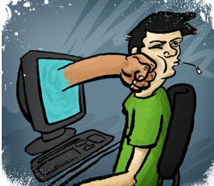

Identify 3 threats to user safety when using the internet and describe the possible consequences.

Identify 3 ways to minimise security risks when using the internet.

Identify 3 safety precautions that show that you can work responsibly online.

Identify 3 ways to keep personal information secure and describe of what could happen if someone found out your password and username.

Football has been marred by allegations of racism in the last few weeks. What could you do to show others respect when using social messaging sites like face book.

