Hope High School

Child-on-Child Abuse Policy

Keeping Hope High School Safe and Happy
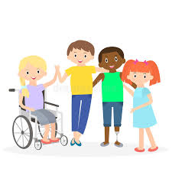
Last updated: June 2023

Contents:

Feeling safe and happy at school
- What is child-on-child abuse?
- Bullying
- Your Body
- Friends
- How do I know if I am being abused?
- What do I do if someone else is being abused?
- What do I do if I am being abused?
- Who can I talk to?
- How can I help stop abuse from happening?

Feeling safe and happy at school
At Hope High School, we want to make sure that you feel looked after, safe and happy when you are in and out of school.
Sometimes we don’t know if something bad is happening, so you need to tell us.

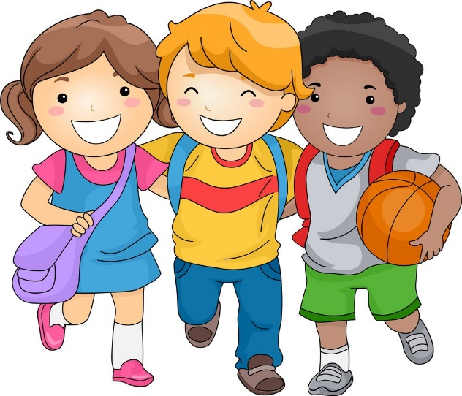

What is child-on-child abuse?
A child is someone who might be your friend, a child at school or another child you know.
Abuse is when someone hurts you or makes you feel sad.
Child-on-child abuse can happen inside and outside of school and it can also happen online. It is important to tell a grown up if you see child on child abuse.
Remember to ask a teacher if you are unsure about what child-on-child abuse looks like.

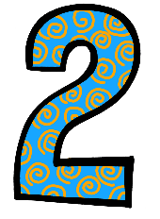
Bullying
Bullying happens when someone tries to hurt another person, to make them feel sad. People can be bullied in many different ways which may include the following:
- Saying horrible things about someone or bossing them about.
- Hitting, kicking, shaking, biting, hair pulling or purposely hurting someone. Remember sometimes our friends may not mean to hurt us but we should still tell a grown –up.
- Saying horrible things about somebody because of the way they look, the colour of their skin, their religion, whether they are a girl or a boy or are unsure, or because of who they choose to love.
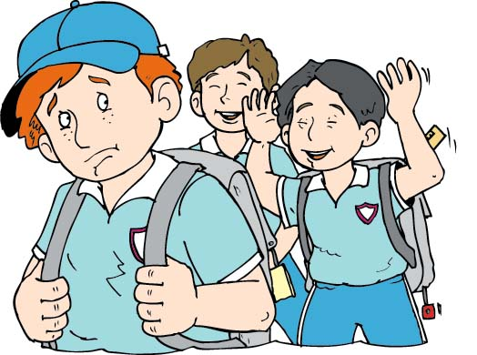
- Cyberbullying includes any kind of bullying which takes place online; cyberbullies send unkind messages over the internet and sometimes share secret information online to make someone sad.
Bullying is not always done by one person and can often involve a group of people ‘ganging up’ on someone – if you ever see someone being bullied, never join in and always tell a teacher.
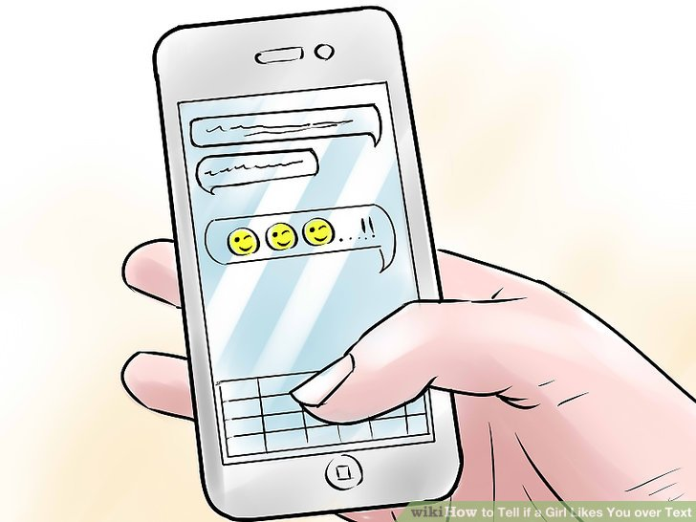
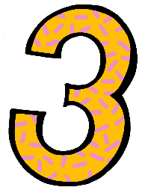

Your Body
Your body is your body and no-one has the right to hurt you or touch your private parts. Your private parts are the parts of your body that your underwear covers.
If someone tries to touch your private parts, say ‘No’ and go and tell a grown-up you trust.
If someone asks you to touch their private parts, say ‘No’ and go and tell a grown up you trust.
If someone tries to take a picture of your private parts or shows you pictures of someone else’s private parts, say ‘No’ and tell a grown up you trust.
If someone asks you to do something that makes you feel uncomfortable, say ‘No’ and go and tell a grown up you trust.

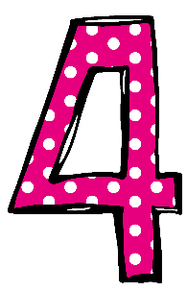
Friends
A child who is a good friend to you will make you feel happy and safe.
A child who is not a good friend to you will make you feel scared, worried or unsafe.

A Good Friend:
- Makes you smile.
- Makes you happy
- Is kind to you
- Says sorry if they do something to upset you
- Makes you feel safe

Someone is not a good friend if they:
- Hurt you on purpose.
- Make you do things you don’t want to do
- Scare you on purpose
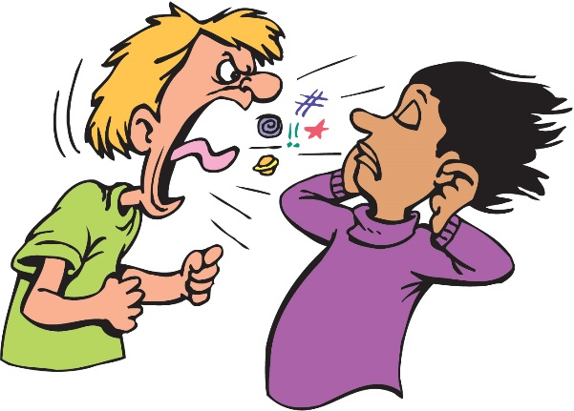
- Shout at you and tell you what to do
- Make fun of you
- Make you feel sad.

How do I know if I am being abused?
It might be hard for you to know if you are being abused and you might not really understand it is happening but you will feel lots of different things that don’t feel nice.
You might:
- Not want to come to school
- Have bruises and scratches where someone has hurt you
- Feel sad
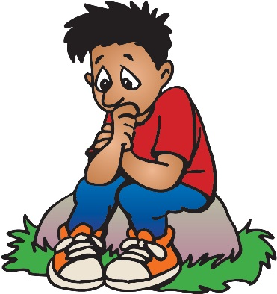
- Feel worried
- Get headaches or tummy aches.
- Feel nervous.
- Not be able to sleep or have bad dreams.

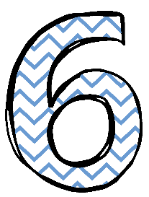

What do I do if someone else is being abused?
If you think that someone is being abused, it is important that you help that person.
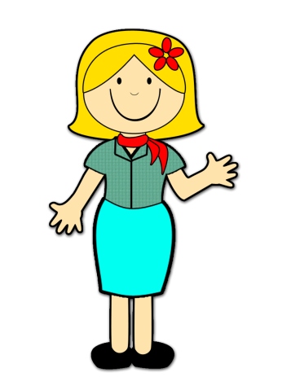
.
Tell a teacher or a grown up you trust as soon as you can.
You should never feel scared to tell someone
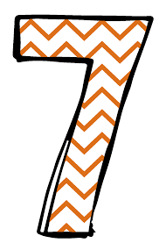

What do I do if I am being abused?
The first thing you should do is tell someone you trust. This could be a family member, a friend or a teacher.
You can also tell the person abusing you to leave you alone.
You should try not to:
- Do what the person says.
- Let what the person says or does make you sad.
- Get angry or hit them.
Always remember that if you are being abused, it is not your fault and you are never alone.

Who can I talk to?
It is important you tell someone as soon as you think that you are being abused, or you think that someone else is being abused.
Speaking to someone like your Mum, Dad, key worker or teacher will mean that we can make sure the abuse stops and doesn’t happen again.
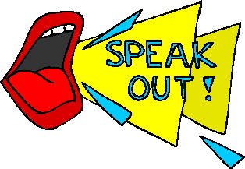
The list below shows the people at our school that you can speak to:
- Mrs Dunbavin, Mrs Fletcher, Mrs Baguley, Mr Harrison and Mrs Granite ( DSL’s)
- Your teacher
- Your key worker
- Intervention Staff

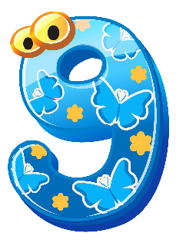

How can I help stop abuse from happening?
We can all help stop abuse at our school by:
- Helping each other
- Being kind, friendly and respectful to others.
- Thinking about people’s feelings before we say or do something.
- Being careful who we talk to online
- Looking back at this booklet
- Talking to someone when we are worried.
You should know that abuse is never OK and if you abuse someone, you will get into trouble.

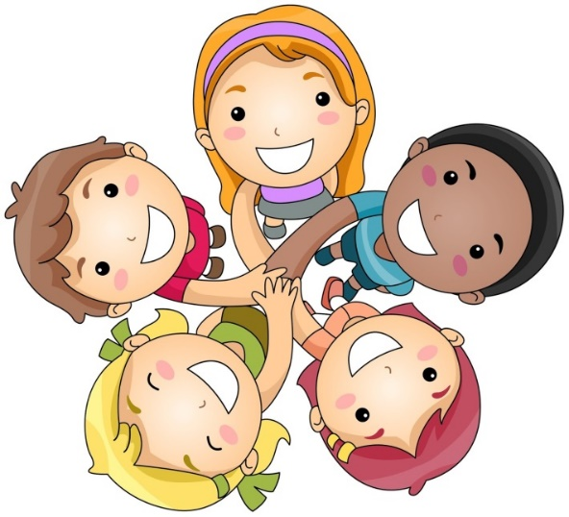
Let’s make Hope High School a safe and happy place!

