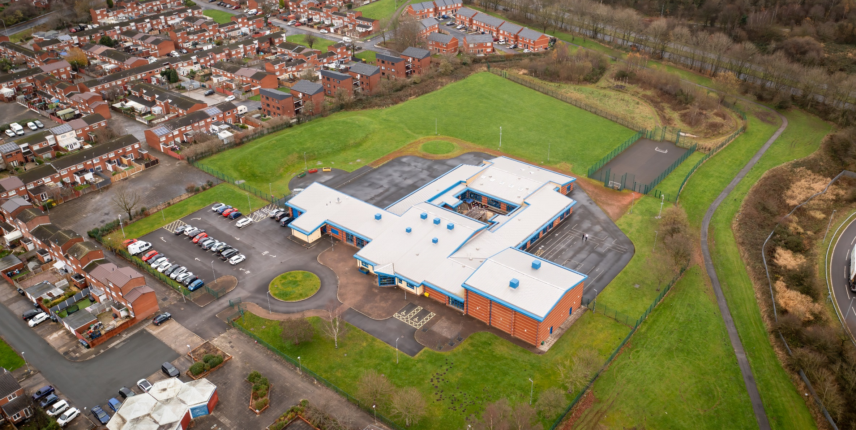

01 April 2023

Hope High School ART CURRICULUM POLICY

Art Curriculum Policy
Hope High School
Carfield
Skelmersdale
Lancashire
WN8 9DP
Tel: 01695 721066

Curriculum Purpose. “Learning for Life”
Our curriculum should allow all learners to have parity of opportunity, be life ready, harness their potential, promote creativity, have rich experiences, and broaden their life choices. ​
At Hope High School the Curriculum is ambitious and tailored to meet the needs of ALL pupils. Pupils study a broad and balanced range of subjects up to Functional Skills Level 1 & 2, BTEC Level 1 & 2, and GCSE. At Key Stage 3 pupils have the opportunity to follow a knowledge rich curriculum in a wide range of subjects. At Key Stage 4 pupils will follow a Core Curriculum and follow 2 pathways in an area of interest to them. This will allow them to flourish and develop their knowledge and skills in subjects that will provide opportunities for college courses and apprenticeships in the future.

Purpose
Our policy is intended to:
- Introduce the aims and objectives of the Art Subject.
- Outline the fundamental skill set in Art.
- Outline the knowledge, skills and understanding for all Key stages.
- Explain the effective Teaching and Learning strategies utilised in Art.
- Provide the formative and summative assessment strategies used Art.

Aims:
Through Art we want the pupils at Hope High School to be:
- Stimulated within a creative environment, and encouraged to develop imagination.
- Able to develop a broad range of Artist knowledge and develop media skills in response to focus Artists.
- Able to refine fine motor skills through use of varied media and equipment.
- Able to understand the impact that Artistic skills can carry into further life.
- Able to expand on subject specific vocabulary.
- Ready to access a career/college course in an Art related area when they leave school.

Objectives:
To help meet the Aims of the Art Curriculum the department will:
- Provide opportunities for pupils to work with a range of materials, tools, equipment when creating portfolios and final pieces.
- Help pupils understand that making a mistake is a positive learning experience. It is these experiences that will develop independence, and inspire/refine ideas.
- Ensure through quality teaching that pupils receive a knowledge rich curriculum where they acquire the Artistic knowledge and vocabulary to support future applications to colleges and apprenticeships.
- Expose pupils to museums and Art galleries, to aid in producing first hand research, and also widen knowledge on career avenues within the Art world.
- Ensure learners have access to a wide range of resources which are freely available and regularly maintained.
- Will work alongside other Targeted areas of the curriculum to reinforce cross curricular knowledge and skills.
- Develop Schemes of Work that are tailored to the individual needs of the learners.
- Support pupils in achieving a GCSE qualification that contributes to them progressing onto a college course of their choice.

Subject Content

Key Stage 3
Accessing the KS3 Art curriculum will ensure that the learners are involved in a variety of practical lessons ranging from drawing, mark making, painting, printing, photography. All media exploration will be informed by the focus Artist at the beginning of each new project, which will enable the students to respond using Art vocabulary and provide self feedback. All students will have access to Career information, which will be based around each new theme.
When creating work, pupils should be taught to:

Investigate
- Use research to study the work of other Artists, to discover what makes an informed piece of art.
- Discuss their own Artistic opinions in group settings, to discover new vocabulary.
- Assess and investigate the formal elements of Art.
- Investigate a range of media and techniques that are relevant to the Scheme of work.
- To convey how images relate to the time and or Culture and to understand their importance.
- Investigate a range of vocabulary to prepare students with subject specific language skills for GCSE.

Development
- Refine and increase understanding of media and techniques to record observations.
- Develop creative capabilities while exploring Artist images.
- To expand knowledge and demonstration of safe working practises in Art and Design.
- Develop knowledge of the different career paths available within Art and Design.

Evaluate
- Analyse the work of past and present Artists and Designers to develop and broaden their understanding of key messages.
- Evaluate and refine their ideas through self feedback and class presentations.
- Understand developments in Art and Design techniques and assess new media appropriately.
- Demonstrate good knowledge of subject specific vocabulary.

Key Stage 4 – AQA GCSE Art and Design Qualification Overview
The AQA GCSE in Art and Design is split into two parts, consisting of 60% Coursework, and 40% includes an externally set Assignment (Exam). This qualification is linear which means that students will submit all their non-exam assessment at the end of the course. The course awards points to the Students via four Assessment Objectives (AO’s). These AO’s can be worth up to 24 Marks each.
AO1 – Develop ideas through investigations, demonstrating critical understanding of Sources.
AO2 – Refine work by exploring ideas, selecting and experimenting with appropriate media, materials, techniques and processes.
AO3 – Record ideas, observations and insights relevant to intentions as work progresses.
AO4 – Present a personal and meaningful response that realises intentions and demonstrates understanding of visual language.
“Students must learn through practical experience and demonstrate knowledge and understanding of sources that inform their creative intentions. Intentions should be realised through purposeful engagement with visual language, visual concepts, media, materials and the application of appropriate techniques and working methods. Students must develop and apply relevant subject-specific skills in order to use visual language to communicate personal ideas, meanings and responses. Students must, over time, reflect critically upon their creative journey and its effectiveness in relation to the realisation of personal intentions.”

Component One : Portfolio
There is no restriction on the scale of work, media or materials used. Each student must select and present a portfolio which includes:
- A sustained project developed in response to the theme Closeups. This brief will evidence the journey from initial research through to the realisation of intentions. This will give students the opportunity to demonstrate, through an extended creative response, their ability to link different areas of knowledge, skills and/or understanding from across their course of study.
- A self directed project resulting from activities such as trials and experiments; skills-based workshops; responses to gallery, museum or site visits; independent study and evidence of the student’s specific role in any group work undertaken.

Students portfolios will show evidence of all Assessment Objective criteria, identifying all sources used, whilst showing drawing developments and written annotation. Work selected for the portfolio should be presented in an appropriate format and could include: mounted studies, sketchbooks, visual diaries, journals, design sheets, design proposals, models, maquettes, prototypes, storyboards, video, photographic or digital presentations.

Component Two : Externally set Assignment (Exam)

AQA provide an externally set assignment with seven different starting points. Students must select and respond to one starting point and create a sketchbook or folder of work based around this.
The externally set assignment provides students with the opportunity to demonstrate, through an extended creative response, their ability to draw together different areas of knowledge, skills and/or understanding in response to their selected starting point. The extended creative response must explicitly evidence students’ ability to draw together different areas of knowledge, skill and/or understanding from initial research with their selected starting point through to their realisation of intentions in the 10 hours of supervised Examination time.
Students must ensure that the total submission for Component 2 evidences coverage of all four assessment objectives and evidence of drawing activity and written annotation. Students must identify and acknowledge sources which are not their own.
A preparation period which can begin on or after 2 January is followed by 10 hours of supervised unaided work in which students are required to realise their intentions.

Component Two Preparatory period
- Students and teachers can access the exam starting points on 2 January (or as soon as possible afterwards) but not before. It is at the discretion of the teacher, when to give out exam papers.
- Students should select one starting point and discuss initial ideas with the teacher.
- Preparatory work may be presented in any suitable format, of which there is no restriction of scale.

Component Two Examination period
- Following the preparatory period, students must undertake 10 hours of unaided examination time which is split over three consecutive days.
- Students may refer to their preparatory work during this time.
- Only the preparatory work and the work produced within the 10 hours of supervised time can be submitted as assessment evidence for this component.
- The Externally set assignment will be graded by the Subject lead, which will then be reviewed by an AQA moderator.

Teaching and Learning
Good quality teaching and learning is at the heart of improved life chances for the pupils at Hope High School. Our pupils benefit from consistency in their lives. Hope High has adopted the teaching and learning model of Rosenshine’s 10 principles of Instruction. These principles will be evident in classrooms daily.
In Art and Design the principles are:
- Daily review. Lessons will begin with a review of learning from previous lessons. This is to support our pupils cognitive load. This could be a review of artist facts, media techniques or student recapping step by step instructions.
- Present new material using small steps. All skills will be demonstrated by the Art lead, and students will be asked to follow along where appropriate.
- Ask questions. A range of interactive questioning techniques will be used to check pupil understanding. Direct questioning, use Kahoot, Blooket and NearPod are just a few of the techniques used to check pupil understanding.
- Provide models. Example projects/visual aids will be provided to support pupil understanding.
- Guide Student practice. Teacher and TA’s will be used to help and support pupils in lessons with an emphasis on encouraging pupil independence.
- Check for student understanding. Formative assessment techniques such as direct questioning of individual pupils and observation of skills and techniques will be used to check knowledge and understanding.
- Obtain a high success rate. Pupils will be encouraged to practise techniques and skills until mastery is achieved in that area.
- Provide scaffolds for difficult tasks. In Art and Design, there are many ways to assist with scaffolding, such as exchanging media, for example using Polystyrene prints rather than Linoleum cutting. We also encourage pupils to share their practises with students who may find a task more difficult.
- Independent practice. Opportunities will be provided to pupils for them to apply their knowledge, skills and understanding to different Artistic scenarios. Independence will be supported and encouraged in all our pupils in a safe and calm environment.
- Weekly and monthly review. Photographic evidence will be kept of pupils work and techniques to demonstrate progress in Art and Design, this will also assist in gaining marks in Assessment Objectives.

Assessment
At Hope High we firmly believe that assessment should be used as a tool to help move pupil learning forward. The day to day, lesson by lesson, formative assessment that takes place with pupils will help them make progress. This will inform teachers of areas of mastery and support them in the development of scaffolding materials to help pupils who need that extra support to achieve mastery.
This formative assessment coupled with end of topic summative assessments will provide the teacher with a holistic overview of a pupil progress and inform the grade for termly reports that are sent to parents/carers.
In Art and Design pupils are assessed on the knowledge and understanding they have on the materials, equipment and techniques that they develop in lessons. This is ongoing and continuous during each lesson through informal feedback. This allows the Subject lead to give quality and constructive feedback regarding what has worked well, and what needs refining. They are assessed on their ability to use this knowledge and practical ability to create work of a high quality. They are also assessed on their ability to use a range of techniques, including sketching, painting, printing and 3D mediums that work to a specific theme. Peer and self-assessment are encouraged when completing work enabling pupils to be involved in their own assessment.
Assessments are made clear to learners to develop their independence and evaluation of their work. This will inform future target setting. Self-evaluation is key in getting learners to understand what they can do well and what they need to improve on further.

Monitoring

The Head of School and leadership team will:
Monitor the subject through the Hope High self-evaluation schedule and monitoring schedule which are reviewed annually

Departmental leader will:
- Monitor learners work and quality of teaching and learning
- Review Curriculum Maps and Schemes of Work based on suitability of use
- Review and monitor risk assessments for practical lessons
- Analyse pupil performance data
- Attend link meetings

Links to other policies:
• Teaching and Learning
• Behaviour for Learning
• Monitoring
• Assessment for Learning
• Health and Safety
• Marking and Feedback
Date Approved:
Review date:
Signed subject Lead:
Signed Headteacher:

