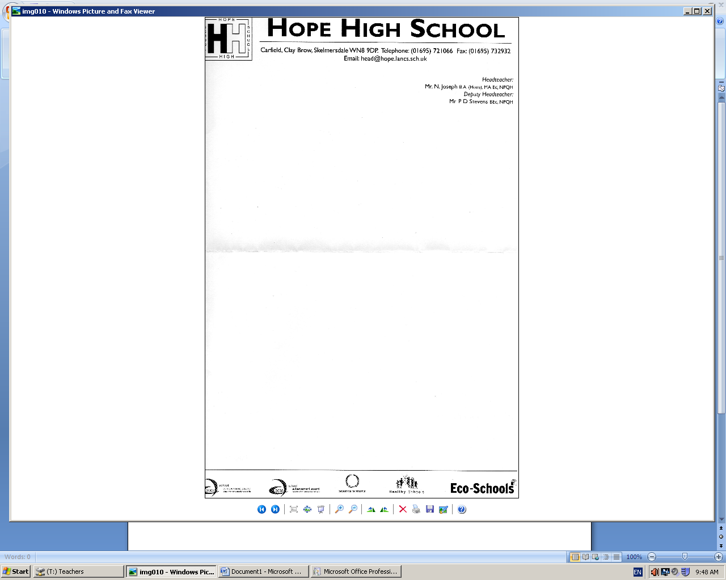


Ref: Summer BBQ and Progress Afternoon Wednesday 10th July 2019
Dear Parent/ Guardian,
I am writing to inform you that Hope High school will be celebrating the end of term and the fantastic achievements of our students in the past academic year with a summer BBQ and Progress Afternoon on Wednesday 10th July, from 12.30pm – 16.15pm
It has been a very successful academic year for the staff and pupils of Hope High School; the majority of our pupils have made rapid and sustained progress across the core curriculum; also the Key Stage 4 pupils have successfully completed examinations, coursework and work placements earning vocational qualifications.
School will be open for all parents and carers to attend from 12:30pm where we will be hosting various activities including inflatable assault course, games and competitions. We will be making and selling cakes and the pupils will be invited to join in water games battle. We will also be providing BBQ food prepared by members of SLT. From 2.15pm to 4.15pm you will be invited into the hall where you will be able to discuss your child’s progress with tutors, teachers and key workers.
Please ensure you child brings spare clothes or a PE kit to wear during the water games battle and heat/sun protection.
If you would like to attend but have no form of transport we can arrange this for you. If you do require transport please let us know as soon as possible.

We look forward to seeing you and helping us celebrate all our achievements this year. Please complete and return the slip below no later than Friday 29th June 2019.

Yours faithfully

Mr. M Tracey
Assistant Headteacher
--------------------------------------------------------------------------------------------------------------------------------------------

I will be attending the BBQ and do not require transport

I will be attending the BBQ and do require transport

I cannot attend the BBQ

Signed _________________________________
Pupil __________________________________

