**Easy Banana Cake**

|  |  |  |  |  |  |  |
| --- | --- | --- | --- | --- | --- | --- |
| **http://www.healingdaily.com/detoxification-diet/essential-fatty-acids-not-margarine.jpg** | http://kellys-expat-shopping.nl/files/2013/06/tate-lyle-caster.jpg | http://cdn.expatsgrocery.com/media/catalog/product/cache/1/image/953x/9df78eab33525d08d6e5fb8d27136e95/1/1/112276_3.1405740485.jpg | http://images.wisegeek.com/cracked-brown-egg.jpg | http://4.bp.blogspot.com/_D9-UNHOvATc/TJk7fZrfkMI/AAAAAAAABD8/-H22H_38N1g/s1600/bananas.jpg | **http://www.english-shop.de/images/McDSelfraisingFlour.jpg** | http://cache1.asset-cache.net/xt/56399750.jpg?v=1&g=fs1%7C0%7CPDI%7C99%7C750&s=1 |
| **125g butter** | **150g caster sugar** | **1tsp vanilla extract** | **1**  **Egg**  (beaten) | **2**  **Bananas**  (mashed) | **190g self raising flour** | **60ml**  **milk** |

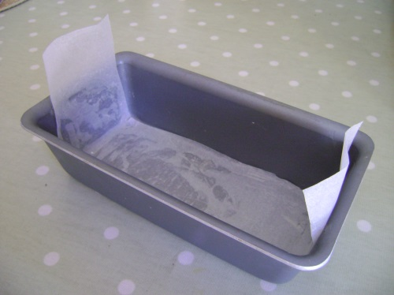

1. Grease and line a tin with paper.

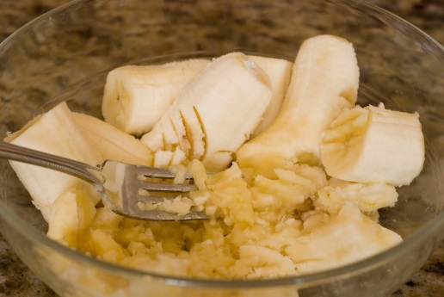

2. Mash the bananas

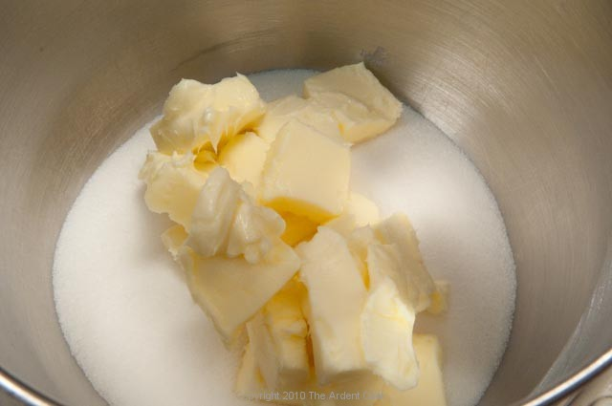

3. Melt butter, sugar and vanilla in a saucepan over a medium heat.

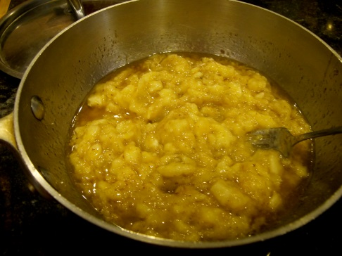

4. Remove from heat and mix in the mashed bananas.

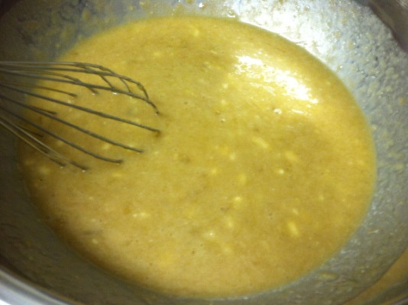

5. Add a beaten egg and mix well.

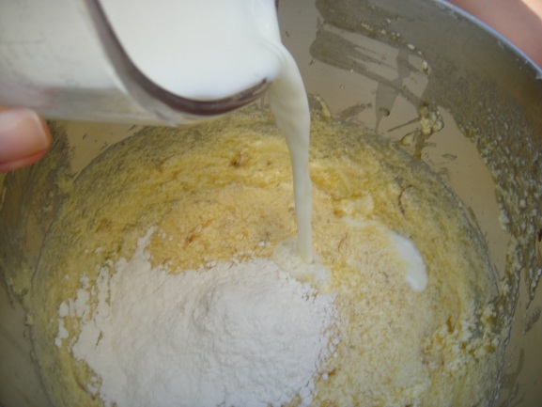

6. Stir in the flour and the milk.

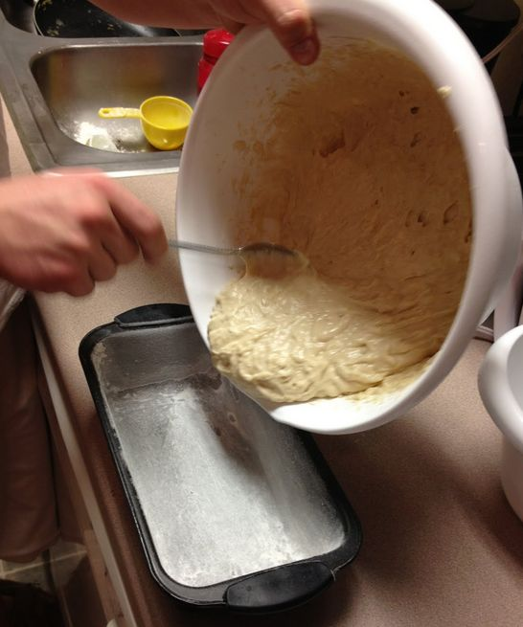

7. Pour the mixture into the tin.

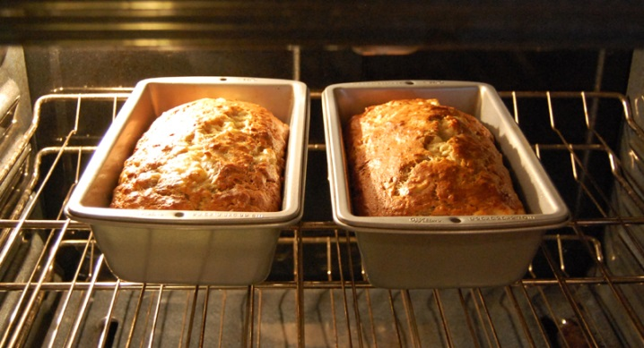

8. Bake at 170 C for 35 minutes.

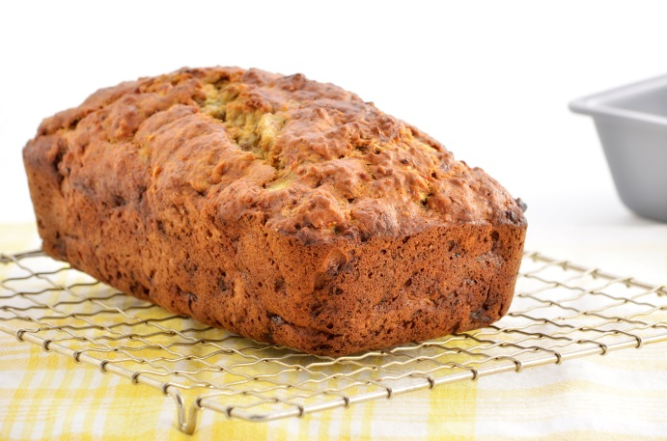

9. Leave to cool on a wire rack.