**Beef Burritos:** Prepare and cook the ingredients

|  |  |  |  |  |  |
| --- | --- | --- | --- | --- | --- |
| http://www.picpedia.co.uk/images/r/red-pepper.jpg | [Image result for passata](https://www.bing.com/images/search?q=passata&id=A5D418DC4AD7C346F5F20A4AD961D31EB46D4BB5&FORM=IQFRBA) | [Image result for mince and pepper in pan](https://www.bing.com/images/search?view=detailV2&ccid=Gt9/5bw0&id=9BB3E567ECB02831F139380DDF84781AE490F468&thid=OIP.Gt9_5bw0k8ABU2rFtP2tPgHaFj&mediaurl=https://hungrybutbusy.files.wordpress.com/2010/07/mince-and-onions.jpg&exph=375&expw=500&q=mince+and+pepper+in+pan&simid=608051785372469937&selectedIndex=3) | [Image result for onuion](https://www.bing.com/images/search?q=onuion&id=FCF4421AF1D912AD1FBA1EFE18F219B99D2ACF71&FORM=IQFRBA) | http://www.premierexports.co.uk/1745-1451-large/schwartz-paprika-jar-34g.jpg | http://cdn.micksnutsonline.com.au/wp-content/uploads/2014/08/Grinder-Organic-Whole-Black-100.jpg |
| **1**  Red Pepper | **3 tbsp**  Passata | **200g**  Beef | **1**  Onion | **1** tsp  Paprika | Black Pepper |

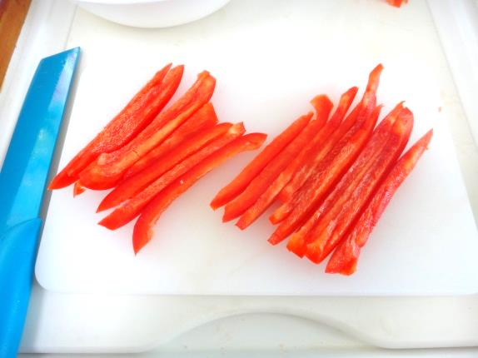

1. Cut the pepper into strips

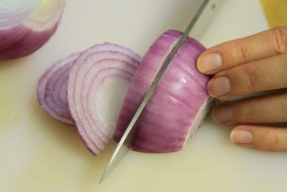

2. Peel and slice the onion

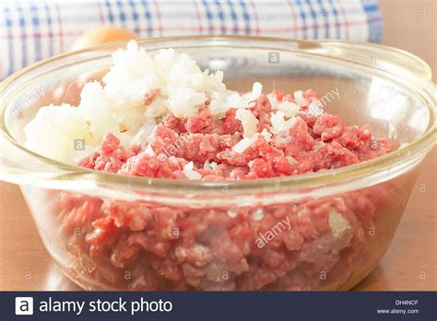

3. Put the pepper, onion, and beef into a bowl with the paprika.

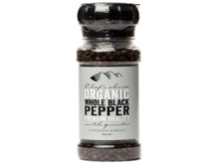

4. Add some black pepper and mix well.

[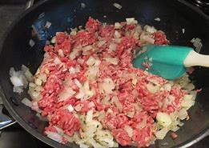](https://www.bing.com/images/search?view=detailV2&ccid=Gt9/5bw0&id=9BB3E567ECB02831F139380DDF84781AE490F468&thid=OIP.Gt9_5bw0k8ABU2rFtP2tPgHaFj&mediaurl=https://hungrybutbusy.files.wordpress.com/2010/07/mince-and-onions.jpg&exph=375&expw=500&q=mince+and+pepper+in+pan&simid=608051785372469937&selectedIndex=3)

5. Put the red pepper, onion and Beef into a pan to cook until brown.

[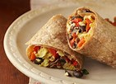](https://www.bing.com/images/search?q=burritos&id=F8B4DD0479555BC11DF83403A948A6CD0B23BC6C&FORM=IARRTH)

6. Add the passata to the mix. Warm through and then spoon the mixture on your wraps before rolling

**Chicken Fajitas**: Prepare the guacamole and make the fajitas

|  |  |  |  |  |  |  |
| --- | --- | --- | --- | --- | --- | --- |
| http://img2.timeinc.net/health/images/slides/avocado-heart-400x400.jpg | http://upload.wikimedia.org/wikipedia/commons/5/56/NCI_flour_tortillas.jpg | http://www.britishcornershop.co.uk/images/large/SGN2847.jpg | http://groceries.morrisons.com/productImages/215/215810011_0_640x640.jpg?identifier=fd029dc4f11d5b9f3612272554606bdd | http://4.bp.blogspot.com/-Rc3PicIucu4/UA2JvjfeUCI/AAAAAAAAETI/UNAG50296vc/s1600/Tesco+everyday+value+natural+low+fat+yogurt.jpg | http://lds.net/wp-content/uploads/2014/05/Cherry-tomatoes-700x468.jpg | http://www.freedigitalphotos.net/image/s_grated-cheese1.jpg |
| **1**  Avocado | **2**  Flour tortillas | **½** tsp  Chilli Powder | **½** tsp Ground Coriander | **150ml**  Natural Yogurt | **5**  cherry tomatoes | **50g**  GratedCheese |

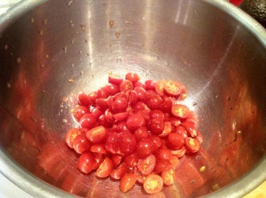

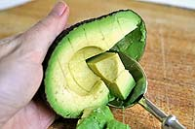1. Chop the tomatoes and put into a bowl. Add the Chilli powder and Ground Coriander.   
  
2. Cut the avocado in half. Scoop out the flesh and put into the bowl.

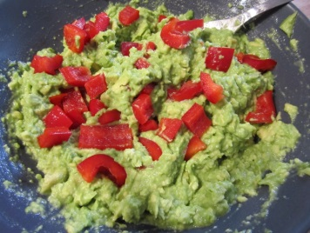

3. Squeeze the lime juice over the avocado and tomatoes. Then chop finely.

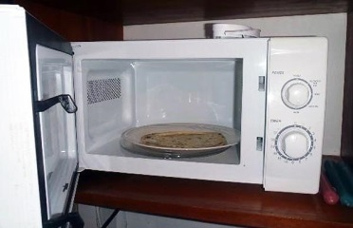

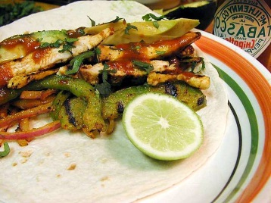4. Warm the tortillas up in a microwave and put on to plates.

5. Put the cooked chicken and vegetables in the middle of the tortilla.

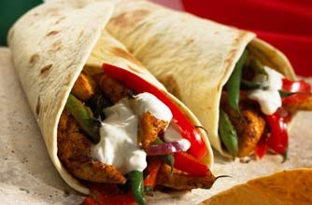

6. Add yogurt, guacamole and cheese before folding your fajita and eating.