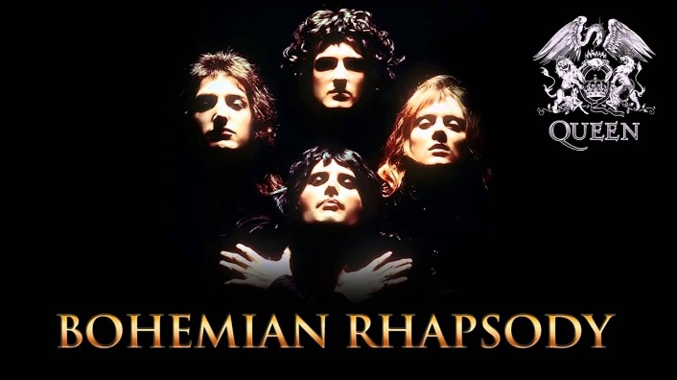
“Bohemian Rhapsody”…but not as we know it!
Name Form

“Bohemian Rhapsody” by Queen is a very well-known popular song. Your task is to REWRITE THE LYRICS on one of the following topics: (circle which topic you’ve selected).

TAKE-AWAY FOOD LIFE AT YOUR SCHOOL FORTNITE TV PROGRAMMES
You can use some of Queen’s existing lyrics (but not too many!) or substitute all of them with your own brand-new lyrics on your chosen topic. Use the table below to help you plan your “new” song. Try to match the RHYTHM AND METRE of the original song with your new lyrics (use an online music site to listen to the original if you have access).
ORIGINAL QUEEN LYRICS | YOUR NEW LYRICS
Is this the real life?
Is this just fantasy?
Caught in a landslide
No escape from reality
Open your eyes
Look up to the skies and see
I'm just a poor boy, I need no sympathy
Because I'm easy come, easy go
A little high, little low
Anyway the wind blows,
doesn't really matter to me, to me.
Mama, just killed a man
Put a gun against his head
Pulled my trigger, now he's dead
Mama, life had just begun
But now I've gone and thrown it all away
Mama, ooo
Didn't mean to make you cry
If I'm not back again this time tomorrow
Carry on, carry on, as if nothing really matters
Too late, my time has come
Sends shivers down my spine
Body's aching all the time
Goodbye everybody I've got to go
Gotta leave you all behind and face the truth
Mama, ooo (anyway the wind blows)
I don't want to die
I sometimes wish I'd never been born at all
ORIGINAL QUEEN LYRICS | YOUR NEW LYRICS
I see a little silhouetto of a man
Scaramouch, scaramouch will you do the fandango
Thunderbolt and lightning very very frightening me
Gallileo, Gallileo,
Gallileo, Gallileo,
Gallileo Figaro – magnifico
But I'm just a poor boy and nobody loves me
He's just a poor boy from a poor family
Spare him his life from this monstrosity
Easy come easy go will you let me go
Bismillah! No we will not let you go - let him go
Bismillah! We will not let you go - let him go
Bismillah! We will not let you go let me go
Will not let you go let me go (never)
Never let you go let me go
Never let me go ooo
No, no, no, no, no, no, no
Oh mama mia, mama mia, mama mia let me go
Beelzebub has a devil put aside for me
For me
For me
So you think you can stone me and spit in my eye
So you think you can love me and leave me to die
Oh baby can't do this to me baby
Just gotta get out just gotta get right outta here
Ooh yeah, ooh yeah
Nothing really matters
Anyone can see
Nothing really matters nothing really matters to me
Anyway the wind blows

Finally, give your “new” song a name

Stretch & Challenge: Rehearse and perform your “new” song. You may be able to find a suitable ‘backing track’ or ‘karaoke singalong’ track online to help you with this.

