CAPABILITY POLICY & PROCEDURE – SUPPORT STAFF

Contents
1 Policy Overview 2
1.1 Policy Details 2
1.2 Record of Policy Amendments 2
1.3 Monitoring and Evaluation of the Policy 2
1.4 Related School Policies and Documents 3
1.5 Equality And Diversity Statement 3
1.6 Policy References 3
1.7 Policy Aims 4
1.8 Policy Link to School Vision, Mission and Aims 4
1.9 Abbreviations Used in Policy 4
2 Policy and Procedure Introduction 5
3 Introduction & Purpose 5
4 Confidentiality 5
5 Procedure 6
5.1 Stage 1 – Formal Performance Interview 6
5.2 Stage 2 - Second Performance Interview 7
5.3 Stage 3 - Capability Hearing 8
5.4 Right of Appeal 8
Appendix A – Recording Capability Concerns 10
Annex1 - Capability Hearing/Appeals Procedure 11
Annex2 - Addendum to Capability Procedure 12

Policy Overview

Policy Details
Policy Title: | CAPABILITY POLICY & PROCEDURE – SUPPORT STAFF
Target Audience: | Support Staff
Policy Review Date: | On or before 30 July 2024
Policy Review Lead: | Helen Dunbavin
Personnel Involved in the  Review of this Policy: | Headteacher, Deputy Headteacher, Senior Leadership Team
This policy was developed  through consultation with: | Senior Leadership Team
This policy was presented to  the Board of Governors on: | Autumn Term 2023
This policy was ratified by the Board of Governors on: | 18th October 2023
This policy is effective from: | 1st of September 2023
Frequency of Policy Review: | This policy should be reviewed annually
Headteacher | Helen Dunbavin
Chair of Board of Governors | Matthew Walker

Record of Policy Amendments
The following table outlines any significant changes/amendments made to this policy since it was last ratified by the Board of Governors.
DATE OF REVIEW OR  AMENDMENT | SUMMARY OF CHANGES / AMENDMENTS TO POLICY | AMENDED BY

Monitoring and Evaluation of the Policy
It is the responsibility of the Board of Governors, in liaison with the Headteacher, to monitor the effectiveness of this policy. This policy will be reviewed annually but may be updated sooner in response to:
- relevant circulars and publications provided by the Department of Education (DFE) / Education Authority (LEA);
- a recommendation by Ofsted
- learning which emerges from issues/situations which arise; or
- a review of other related school policies that impact this policy.
To ensure that this policy is relevant and up to date, comments and suggestions for additions or amendments are sought from users of this document. To contribute towards the process of review, please contact the Policy Review Lead listed with this document or an SLT member.

Related School Policies and Documents
This policy is related to the following school policies and documents:
Document/Policy name
Pay Policy – Support Staff
Appraisal Policy – Support Staff

Equality And Diversity Statement
Hope High School is committed to the fair treatment of all in line with the Equality Act 2010. An equality impact assessment has been completed on this policy to ensure that it can be implemented consistently regardless of any protected characteristics, and all will be treated with dignity and respect.

Policy References
This policy has been developed with reference to the following relevant sources and publications:
Document/Policy name
Lancashire County Council | School Support Staff | Model Capability Procedure (Revised May 2023)

Policy Aims
This policy and its associated procedures aim to:
This policy sets out the arrangements that will apply when support staff, fall below the level of performance that is expected of them.

Policy Link to School Vision, Mission and Aims
This policy reflects the Hope High Schools vision for Inspiring Excellence, Fulfilling Potential, and the school’s mission to provide a stimulating, challenging and caring environment that allows each individual to develop to his/her full potential.
The policy relates directly to the following school aims whereby we:
- challenge and stimulate the minds of pupils through excellent teaching, diverse learning opportunities, and a rich, balanced curriculum;
- provide pupils with every opportunity to flourish academically and to develop their skills, gifts and talents as individuals;
- tailor personalised learning and specialist support to meet the needs of pupils so that they reach their full potential;
- offer an extensive extra-curricular programme that enriches and extends the curriculum, encouraging pupils to explore and develop their personal interests;
- develop wide ranging opportunities for pupil leadership to enable pupils to develop the skills, knowledge and qualities they will need to be leaders in the future;
- support and encourage pupils to play an active and responsible role in society, to develop as global citizens and to use their talents for the service of others; and
- work in close partnership with parents/guardians and members of the wider community to provide the best possible education for all pupils.

Abbreviations Used in Policy
The following abbreviations are used throughout this policy:
DFE | Department for Education
LEA | Lancashire Education Authority
HT | Headteacher
DHT | Deputy Headteacher
AHT | Assistant Headteacher
SENCO | Special Education Needs Coordinator
DSL | Designated Safeguarding Lead

Policy and Procedure Introduction
Adopted Lancashire County Council Model Capability Procedure (May 2023).

Introduction & Purpose
- The Capability Policy and Procedure document is intended to encourage employees to achieve and maintain a satisfactory standard of performance.
- The Capability Procedure provides a process for dealing with ongoing unacceptable performance standards where informal forms of management support and intervention have not produced the desired results.
- This procedure is not intended to be used where an employee’s poor performance at work is the result of wilful neglect of duty, failure to carry out reasonable instructions or any other act(s) of misconduct which will be considered under the School’s Disciplinary Procedure.
- No formal action under this procedure will be taken against any Trade Union representative/shop steward until the circumstances of the case have been discussed with a full time official of the Union concerned (unless the individual concerned does not agree with this course of action).
- A sudden deterioration in the standard of work may be due to a number of factors some of which may be temporary in nature. Efforts should be made to resolve such problems through discussion and support. Such discussions may lead to a decision to refer the employee to the Occupational Health Unit.
- This procedure has been written on the understanding that capability concerns are managed by the Headteacher, and dismissal decisions are taken by the Disciplinary and Dismissal Committee of the Governing Board. In accordance with the provisions of the Education Act 2002 and the School Staffing (England) Regulations 2003, the Governing Board may elect to delegate the power to make initial dismissal decisions to the Headteacher. If this is the case, the initial dismissal decision will be taken by the Headteacher, and the appeal referred to the Appeals Committee of the Governing Board. For further details, see Annex 2.
- In these circumstances, to preserve the integrity of the process, the Headteacher should delegate the responsibility for the management of the capability concern to another member of the School Management Team, thereby leaving the Headteacher available to consider what action should be taken at the end of the formal procedure, including dismissal.
- In such cases, any reference to the role of the Headteacher within this procedure should be taken to mean the person responsible for managing the capability process, and any reference to the Disciplinary and Dismissal Committee should be taken to mean Headteacher.
- The Executive Director Education & Children's Services or their nominee will be entitled to attend any Meeting/Hearing/Appeal for the purpose of giving advice.

Confidentiality
All documentation and discussions at meetings within this procedure are confidential. The School processes personal data collected during the informal and formal stages of this procedure in accordance with its data protection policy. In particular, personal data collected under this procedure is held securely and accessed by, and disclosed to, individuals only for the purposes of conducting the procedure or seeking professional advice. Inappropriate access or disclosure of employee data constitutes a data breach and should be reported in accordance with the school's data protection policy. It may also constitute a disciplinary offence, which will be dealt with under the disciplinary procedure.

Procedure

Stage 1 – Formal Performance Interview
- Where normal management, supervision and appraisal processes, including the provision of necessary support mechanisms have failed to produce necessary improvements within an agreed timescale, the manager will convene a Formal Performance Interview.

- The manager will give the employee at least 5 days' notice of the interview. The invite letter will outline how the employee's performance falls short of expected standards, including the areas of concern and the consequences of the employee’s performance. The invite will also describe actions already taken and support given to help achieve an improvement in performance.

- The employee has the right to be accompanied by a Trade Union representative or work colleague during the Interview. Where the employee’s Trade Union representative is not available on the specified date, the interview must be postponed for up to five working days if the employee can provide a reasonable alternative time within this five day period.

- The purpose of the interview is for the manager to explain to the employee:
- the standards of performance required;
- how the employee falls short of achieving these standards of performance;
- the consequences of their poor standard of performance;
- the improvement necessary and how the employee can be helped to achieve it;
- how improvements will be monitored or assessed and over what period;
- that if their performance does not improve to the required standard and is not maintained, this could lead to dismissal under this Procedure
For the employee to:
- achieve a clear understanding of expectations;
- give any explanation or comment in relation to their standard of performance;
- comment on how they can be further supported to improve.
The outcome of the Formal Performance Interview will be recorded in writing and a copy provided to the employee. This letter will provide details of the targets to be achieved, details of any agreed support/training, how performance will be monitored, the timescales of the review period including the date of the review meeting and cautionary advice that failure to improve to the standard of performance required could lead to dismissal. Appendix A contains a suggested template for outlining the concerns and how they will be addressed.
If, at the end of the monitoring period, it is determined that the required improvement has been achieved, this will be confirmed and followed up in writing. The employee will be informed that if at any time within a 12 month period of this confirmation, performance again falls below an acceptable standard, the formal procedure will recommence at Stage 2.
If, at the end of the monitoring period, it is determined that the employee’s performance has not improved to the required standard, the manager will convene a Stage 2 Second Performance Interview.

Stage 2 - Second Performance Interview

- The employee will be advised of this meeting in writing and given at least 5 working days' notice of the meeting. The employee has the right to be accompanied by their trade union representative or work colleague.

- At this interview, the manager will:
- Review overall performance over the monitoring period;
- Identify continued areas of underperformance or any further issues which will be considered;
- Review support mechanisms previously identified
The employee will be given the opportunity to respond to any points raised in the meeting and comment on any issues affecting performance.
- If the manager considers that the employee has failed to, or has not continued to, meet the standards and objectives as set out in the written outcome of the interview and no adequate mitigating circumstances have been identified, the manager may determine that a further formal review period is necessary. If the required improvement is achieved, this will be confirmed in writing. The employee will be informed that if, at any time within a 12 month period of this confirmation, performance falls below an acceptable standard, the formal procedure will recommence at Stage 3. If the required improvement is not achieved, the manager will refer the matter to Stage 3. The employee will be informed in writing of this decision.

- The Headteacher or other appropriate person, may determine that the matter should be referred to the Disciplinary and Dismissal Committee for a capability hearing, which will give consideration to the employee’s suitability for future employment. The Disciplinary and Dismissal Committee will normally comprise no fewer than three governors.

- Prior to referral to the Disciplinary and Dismissal Committee, the Headteacher should consider the possibility of a mutually agreed reassignment to an alternative vacant post within the School or a mutually agreed variation to the employee’s existing contract of employment, for a trial period of three months. If the trial is successful, the arrangements will be confirmed as permanent. Alternatively the manager may determine with the agreement of the employee that the trial period be extended by a maximum of three further months. Any search for a different post to which to reassign the employee should be completed within one month. If no acceptable post is available or the trial period fails, the matter will be referred to the Disciplinary & Dismissal Committee.

Where a reassignment or variation to contract involves a reduction in pay, the rate of pay for the assigned post/duties will be effected three months from the date the employee’s reassignment/contractual variation is agreed. The three month period referred to in this paragraph includes the period of any trial.

Stage 3 - Capability Hearing
- The Clerk to the Governors, the Headteacher or other appropriate person will notify the employee in writing of the date, time and place of the Capability Hearing. The employee will be given at least 10 working days' notice of the hearing. The notification letter will contain details of the capability concerns which are to be considered and will inform the employee of their right to be accompanied by a trade union representative or work colleague. The letter will advise the employee that they may be dismissed at the end of the Hearing and will include copies of any relevant documentation to be considered at the hearing.

- If the employee wishes to present documentary evidence to the hearing or to call witnesses, details of these should be provided to the Clerk to the Governors, Headteacher or other appropriate person at least two working days in advance of the hearing.

- The Disciplinary and Dismissal Committee will be advised by a member of the Schools HR Team. The Clerk to the Governors or other appropriate person will produce a summary note of the Hearing.

- The procedure to be followed at the Capability Hearing (or Appeals Committee) is set out in Annex 1.

- The options available to the Disciplinary and Dismissal Committee are as follows:-

  - to take no further action
  - to direct that a further period of appropriate training, formal monitoring and review should be undertaken.
  - where it is concluded that the employee is not capable of undertaking the duties of their post, the Committee may dismiss the employee from the service of the School.

- The decision of the Disciplinary and Dismissal Committee will be confirmed in writing within five working days of the Hearing, including any right of appeal against the decision.

- Where a decision is taken to dismiss the employee, the full contractual period of notice will be given. In the event of an appeal being submitted, the period of notice will continue to run. If the appeal hearing is after the date of dismissal and the appeal is successful, the employee will be reinstated retrospectively to the date of dismissal.

Right of Appeal
- An appeal must be submitted in writing to the Clerk to Governors within five working days of receipt of the official notification of the Disciplinary and Dismissal Committee/Headteacher’s decision.

- An appeal will be considered by an Appeals Committee of the Governing Board comprising no fewer than three Governors. The appeal will be heard as quickly as possible and wherever practicable no later than 20 working days from of the date of the receipt of notification of appeal.

- The appeal date will provide a minimum of five working days notice of the date, time and place of the hearing. The documentation considered by the Disciplinary and Dismissal Committee/Headteacher together with the written decision will be placed before the Appeals Committee, advised by a member of the Schools HR Team.

- The appeal hearing will follow the same format as that used in the Disciplinary and Dismissal Committee or the Headteacher Hearing outlined at Annex 1.

- The following decisions are open to the Appeals Committee:

- Disallow the appeal and uphold the original decision of the Disciplinary and Dismissal Committee/Headteacher
- Allow the appeal and reinstate the employee to their former position
- Reinstate the employee to their former position with a recommendation for a further period of target setting, monitoring and review

Appendix A – Recording Capability Concerns
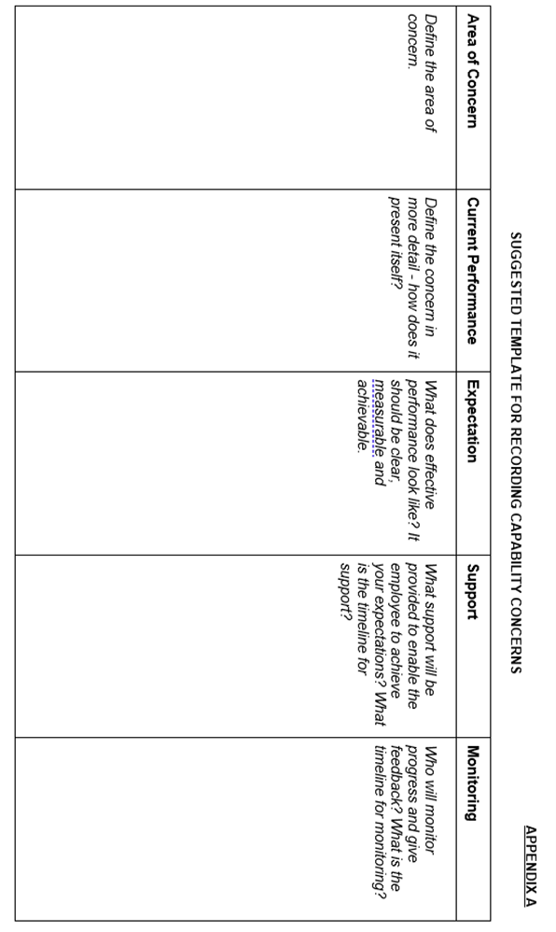

Annex1 - Capability Hearing/Appeals Procedure

The following procedure is appropriate for any level of hearing including appeal.
PROCEDURE AT THE HEARING
- The case against the employee will be presented by the Headteacher or other appropriate person (the presenter of the report) who will be entitled to call witnesses and present documentation to support the case.
Witnesses will only be present for the period during which they are required to give evidence directly to the Hearing.
- The employee and/or their representative and the person/Committee hearing the case will question the presenter of the report and any witnesses called.
- The employee and/or their representative will present a statement of case and will be entitled to call witnesses to support the case.
- The presenter of the report and the person/Committee hearing the case will question the employee and any witnesses called.
- The presenter of the report and the employee and/or their representative (in that order) will have the opportunity to make a closing statement (No new evidence may be introduced at this stage)
- All parties will withdraw except the person/Committee conducting the hearing who will deliberate in private, and if present, the Executive Director Education & Children's Services representative and Clerk to the meeting. Should either party need to be recalled to clarify any points of uncertainty, both sides should return notwithstanding that the point giving cause for concern relates to one party.
- The parties will be informed of the decision and the employee will be given written confirmation of the decision, within 5 working days, which will also indicate any right of appeal.

Annex2 - Addendum to Capability Procedure
School Staffing (England) Regulations 2003 – Delegation to Headteacher of authority to make initial dismissal decisions.
These Regulations allow for the Governing Board to delegate authority to make initial dismissal decisions to Headteachers. Therefore, the Headteacher becomes responsible for all initial disciplinary action up to and including dismissal.
The Governing Board will need to take a decision as to whether they wish to delegate this responsibility. They need to bear in mind that the statutory guidance accompanying the Regulations specifies a series of circumstances where such an arrangement may not be appropriate. These are as follows:
- A Headteacher who is unwilling to accept this function and who has hitherto not been required to do so. The position could be reviewed on the appointment of a successor Head.

- Where the Headteacher has been directly involved in the process leading up to the consideration of dismissal – for example, through managing the capability case. Experience shows that this is invariably the case and therefore, referral for consideration by the Dismissals Committee preserves the integrity of the disciplinary process. However, in large Schools, it may be possible to delegate the responsibility for investigation to another member of the management team, thereby leaving the Headteacher available to consider, what disciplinary action, up and including dismissal, should be taken. Appeals against disciplinary action should still be considered by the Appeals Committee.

- Where the Governing Board of a school with a religious character (i.e. Voluntary Aided, Foundation and Voluntary Controlled Schools) has agreed that governor involvement will serve to preserve this character. Therefore, advice should be sought from the relevant Diocesan Authority.

- Where the local authority may have made representations to the Chair of Governors on the grounds of serious concerns about the performance of the Headteacher.
Where a Governing Board does decide to delegate the authority to make initial dismissal decisions, they are strongly advised to consult with staff and their professional associations before finally confirming their decision.

