**Cheesy Vegetable bake**

|  |  |  |  |  |
| --- | --- | --- | --- | --- |
|  | http://media.tumblr.com/tumblr_m72j8dV8Ii1qkzq2g.jpg | **http://www.healingdaily.com/detoxification-diet/essential-fatty-acids-not-margarine.jpg** | http://www.foodsubs.com/Photos/egg.jpg | **http://www.async.caltech.edu/~mika/potato/POTATO.jpg** |
| **150ml**  Milk | **100g**  Cheese | **25g**  Margarine | **1**  Egg | **1**  Potato |
|  | http://www.longleyfarm.com/sites/default/files/styles/product_image/public/JERSEY-SP-CREAM-150G.png?itok=Gd-ma5Os | http://www.greensteve.com/wp-content/uploads/2013/01/two-loose-carrots.jpg | http://www.needlesandknowhow.com/wp-content/uploads/2013/02/breadcrumbs.jpg | http://truecouponing.com/wp-content/uploads/2014/07/vidalia-onion.jpg |
| **1**  Parsnip | **125ml**  Cream | **2**  Carrots | **3** tbls Breadcrumbs | **1**  Onion |

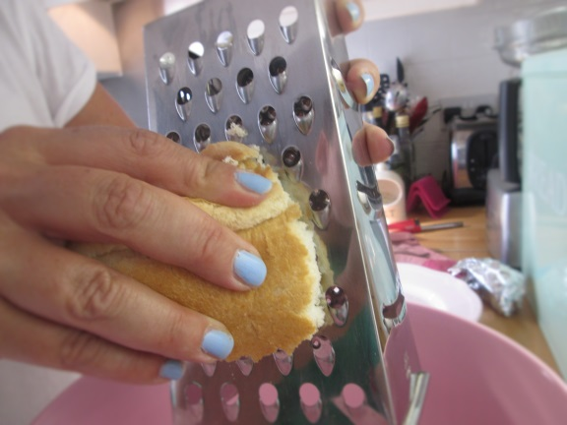

1. Carefully grate some crusts of bread to make the breadcrumbs

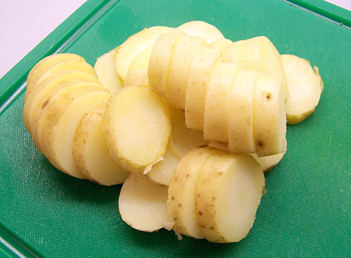

2. Peel and chop the vegetables into slices.



3. Put the carrots in the bottom of a baking dish. Add the margarine.

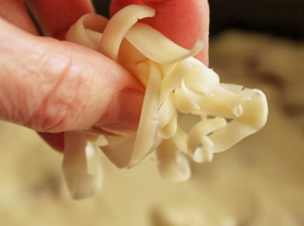

4. Sprinkle over some of the grated cheese.

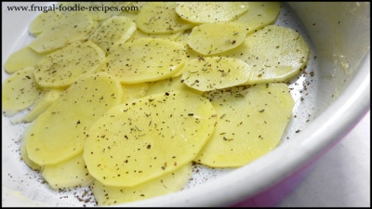

5. Layer the parsnip and add a knob of margarine. Repeat with the potato and the onion.



6. Sprinkle over the remaining cheese.

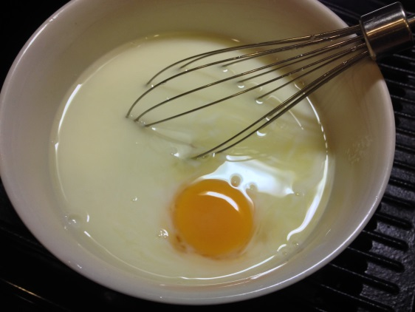

7. Mix the milk, cream and egg together.

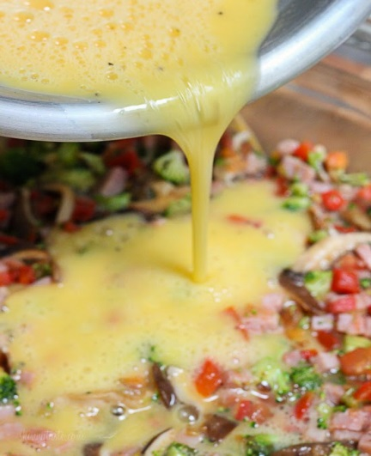

8. Pour mixture over the vegetables.

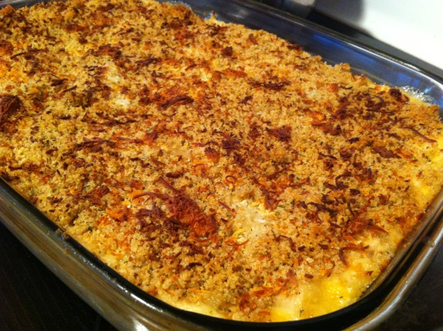

9. Top with the breadcrumbs and bake in a preheated oven 190C for 45 minutes.