**Chicken fajitas:** Prepare and cook the ingredients

|  |  |  |  |  |  |
| --- | --- | --- | --- | --- | --- |
| http://www.picpedia.co.uk/images/r/red-pepper.jpg | http://cdn3.volusion.com/gyauc.spxen/v/vspfiles/photos/REDONION200-2.jpg?1342260329 | https://www.cookingplanit.com/public/uploads/inventory/chicken_breast__1332428869.jpg | http://lenaskitchen.files.wordpress.com/2008/05/lime3.jpg | http://www.premierexports.co.uk/1745-1451-large/schwartz-paprika-jar-34g.jpg | http://cdn.micksnutsonline.com.au/wp-content/uploads/2014/08/Grinder-Organic-Whole-Black-100.jpg |
| **1**  Red Pepper | **1**  Red onion | **1**  Chicken breast | **1**  lime | **1** tsp  Paprika | Black Pepper |

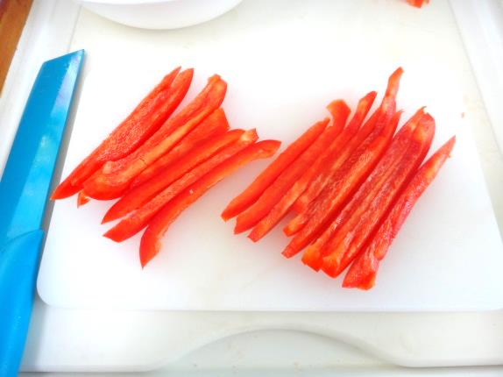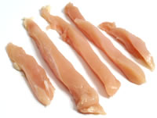

1. Cut the pepper and the chicken into strips

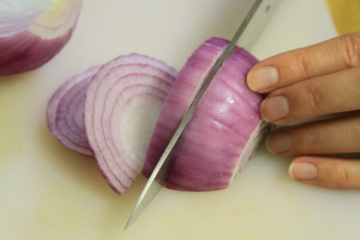

2. Peel and slice the onion

Chicken Chorizo Wrap
2 Chicken Breasts / Chorizo / Red Pepper / Red Onion / Tortilla Wraps / Sour Cream / Cumin Powder / Smoked Paprika / Oil (not pictured) (1)
[[MORE]]
CHOP pepper and onion bits
SLICE chicken breast into thin strips
THROW into a bowl
ADD one teaspoon of cumin, smoked paprika and a drop of oil (2)
MIX together
CUT chorizo into strips
HEAT a frying pan and another pan
SIZZLE chicken in frying pan
POUR drop of oil into other pan
SOFTEN peppers and onion in other pan (3)
TOSS chorizo into chicken pan (3)
SPRINKLE paprika into sour cream and stir
STIR softened veg with chicken and chorizo
SPOON sour cream onto tortilla wrap (4)
PILE on chicken chorizo mix (4)
WRAP it tight. Tight. (5)
GET the book on iTunes
GO COOK YOURSELF

3. Put the pepper, onion, and chicken into a bowl with the paprika.

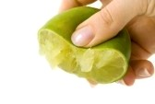

4. Squeeze the juice of half a lime, add some olive oil, black pepper and mix well.

[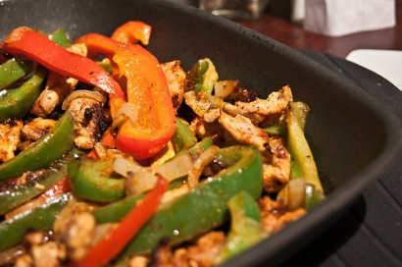](http://www.flickr.com/photos/littleladylove/5606788527/)

5. Put the red pepper, onion and chicken into a pan to cook for 6 to 8 minutes.

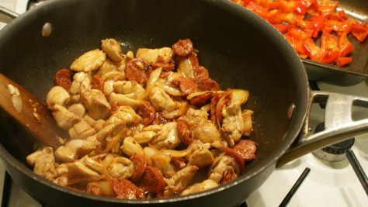

6. Turn the pieces of chicken and vegetables over so they don't burn.

**Chicken Fajitas**: Prepare the guacamole and make the fajitas

|  |  |  |  |  |  |  |
| --- | --- | --- | --- | --- | --- | --- |
| http://img2.timeinc.net/health/images/slides/avocado-heart-400x400.jpg | http://upload.wikimedia.org/wikipedia/commons/5/56/NCI_flour_tortillas.jpg | http://www.britishcornershop.co.uk/images/large/SGN2847.jpg | http://groceries.morrisons.com/productImages/215/215810011_0_640x640.jpg?identifier=fd029dc4f11d5b9f3612272554606bdd | http://4.bp.blogspot.com/-Rc3PicIucu4/UA2JvjfeUCI/AAAAAAAAETI/UNAG50296vc/s1600/Tesco+everyday+value+natural+low+fat+yogurt.jpg | http://lds.net/wp-content/uploads/2014/05/Cherry-tomatoes-700x468.jpg | http://www.freedigitalphotos.net/image/s_grated-cheese1.jpg |
| **1**  Avocado | **2**  Flour tortillas | **½** tsp  Chilli Powder | **½** tsp Ground Coriander | **150ml**  Natural Yogurt | **5**  cherry tomatoes | **50g**  GratedCheese |

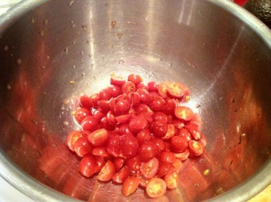

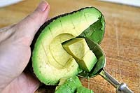1. Chop the tomatoes and put into a bowl. Add the Chilli powder and Ground Coriander.   
  
2. Cut the avocado in half. Scoop out the flesh and put into the bowl.

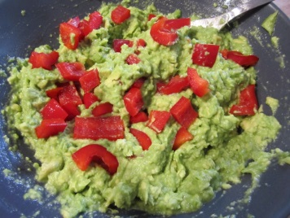

3. Squeeze the lime juice over the avocado and tomatoes. Then chop finely.

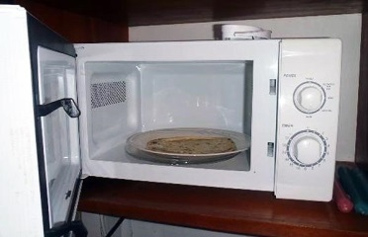

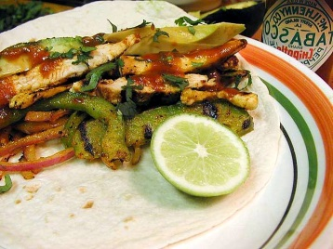4. Warm the tortillas up in a microwave and put on to plates.

5. Put the cooked chicken and vegetables in the middle of the tortilla.

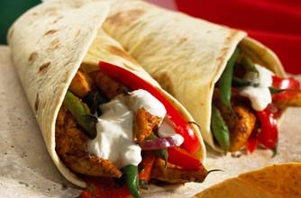

6. Add yogurt, guacamole and cheese before folding your fajita and eating.