Chicken fajitas: Prepare and cook the ingredients
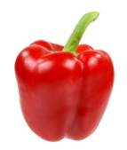 | 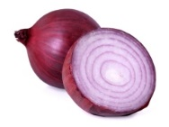 |  | 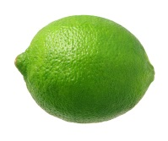 |  |  | 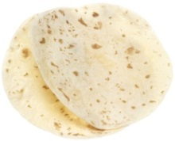
1  Red Pepper | 1  Red onion | 1  Chicken breast | 1  lime | 1 tsp  Paprika | Black Pepper | 2  Flour tortillas
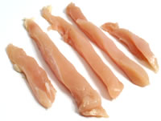
1. Cut the pepper and the chicken into strips
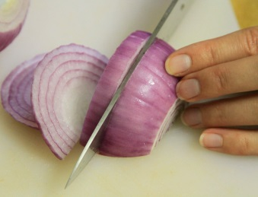

2. Peel and slice the onion
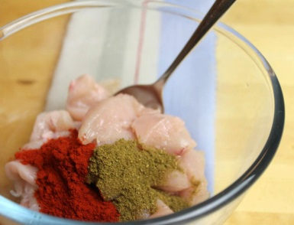

3. Put the pepper, onion, and chicken into a bowl with the paprika.
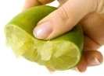

4. Squeeze the juice of half a lime, add some olive oil, black pepper and mix well.
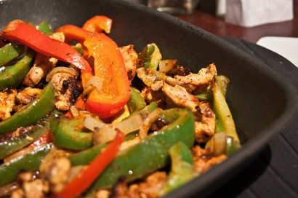
5. Put the red pepper, onion and chicken into a pan to cook for 6 to 8 minutes.
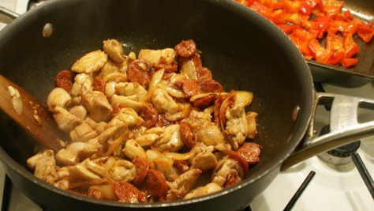

6. Turn the pieces of chicken and vegetables over so they don't burn.

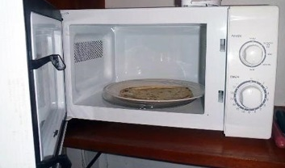

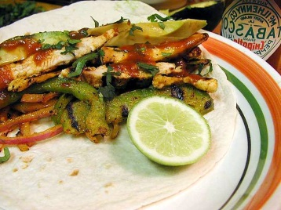
7. Warm the tortillas up in a microwave and put on to plates.

8. Put the cooked chicken and vegetables in the middle of the tortilla.
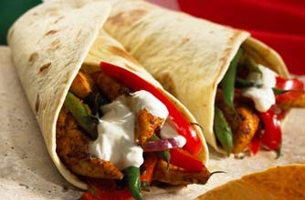
9. Add yogurt, guacamole and cheese before folding your fajita and eating.

