Chocolate Brownies

2  eggs | 100g  Cocoa | 100g margarine | 200g  Brown sugar | 150g  plain flour

1. Pre-heat the oven to 180°C and grease the tin.

2. Cream the margarine and sugar together in a mixing bowl. Then stir in the cocoa

3. Break the eggs into a jug and beat with a fork.

4. Pour the eggs into the mixing bowl and stir in with a whisk.

5. Add the flour and stir in with a spatula.

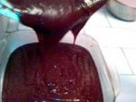
6. Pour the mixture into a baking tin and bake in the oven for 20 - 25 minutes.

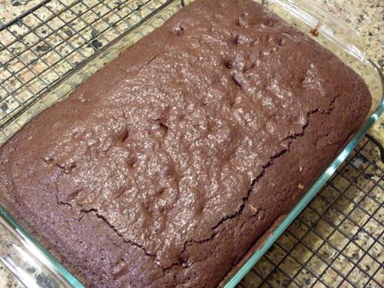
7. Remove from the oven, place on a cooling rack and leave to cool.
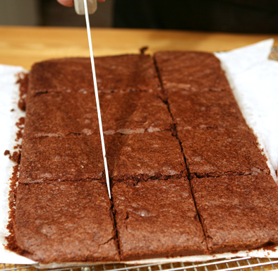

8. Cut into pieces and enjoy!

