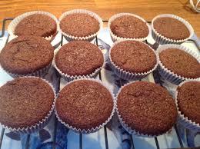
Chocolate Fairy Cakes

 |  |  |  | 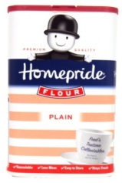
2  eggs | 15g  Cocoa | 100g Margarine | 100g  Caster Sugar | 85g  plain flour

1. Pre-heat the oven to 180°C and grease the tin.

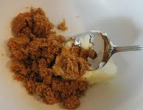
2. Cream the margarine and sugar together in a mixing bowl. Then stir in the cocoa

3. Break the eggs into a jug and beat with a fork.

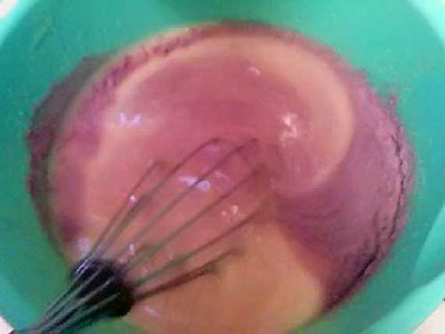
4. Pour the eggs into the mixing bowl and stir in.

5. Add the flour and stir in with a spatula or spoon.

6. Pour the mixture into cake cases and bake in the oven for 15-20 minutes.

7. Remove from the oven, place on a cooling rack and leave to cool.

