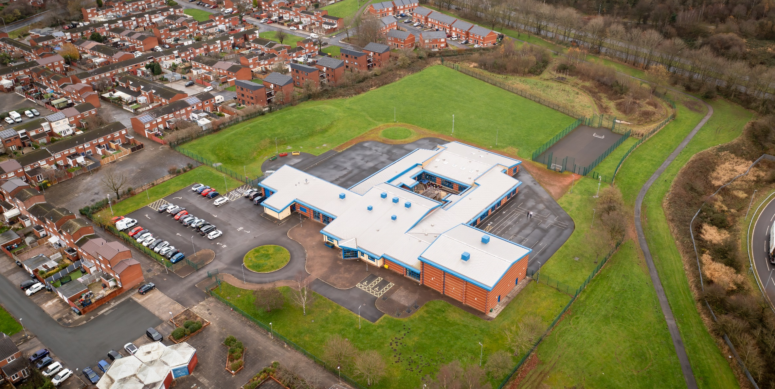

01 April 2023

Hope High School DESIGN TECHNOLOGY CURRICULUM POLICY

Design Technology Curriculum Policy
Hope High School
Carfield
Skelmersdale
Lancashire
WN8 9DP
Tel: 01695 721066

Curriculum Purpose. “Learning for Life”
Our curriculum should allow all learners to have parity of opportunity, be life ready, harness their potential, promote creativity, have rich experiences, and broaden their life choices. ​
At Hope High School the Curriculum is ambitious and tailored to meet the needs of ALL pupils. Pupils study a broad and balanced range of subjects up to Functional Skills Level 1 & 2, BTEC Level 1 & 2, and GCSE. At Key Stage 3 pupils have the opportunity to follow a knowledge rich curriculum in a wide range of subjects. At Key Stage 4 pupils will follow a Core Curriculum and follow 2 pathways in an area of interest to them. This will allow them to flourish and develop their knowledge and skills in subjects that will provide opportunities for college courses and apprenticeships in the future.

Purpose
Our policy is intended to:
- Introduce the aims and objectives of the Design Technology Department.
- Outline the key components within Design Technology
- Outline the knowledge skills and understanding for all Key stages
- Explain the effective Teaching and Learning strategies utilised in Design Technology
- Provide the formative and summative assessment strategies used within Design Technology

Aims:
Through Design Technology we want the pupils at Hope High School to be:
- Creative and imaginative when designing and making products that solve real life problems that are relevant to them.
- Able to acquire a broad range of subject knowledge and draw on disciplines such as mathematics, science, engineering, computing and art when designing and making.
- Resourceful, innovative, enterprising, and capable citizens, who utilise the skills they have learnt in school to life beyond school.
- Able to understand the impact of a technological society on daily life and that of the wider world.
- Ready to access a career/college course in a Design Technology related area when they leave school.

Objectives:
To help meet the Aims of the Design Technology Curriculum the department will:
- Provide opportunities for pupils to work with a range of materials, tools, equipment and machinery when designing and making products.
- Help pupils understand that making a mistake is a positive learning experience. It is these experiences that will develop independence.
- Ensure through quality teaching that pupils receive a knowledge rich curriculum where they acquire the technical knowledge to support future applications to colleges and apprenticeships.
- Expose pupils to the latest developments in technology that are used in industry. Examples of this will be pupils using 2D and 3D Computer Aided Design software and 2D and 3D Computer Aided Manufacturing equipment such as the laser cutter and 3D printer.
- Ensure learners have access to a wide range of resources which are freely available and regularly maintained.
- Will work alongside other Targeted areas of the curriculum.
- Develop Schemes of Work that are tailored to the individual needs of the learners.
- Support pupils in achieving a BTEC qualification that contributes to them progressing onto a college course of their choice.

Subject Content

Key Stage 3
Through a variety of creative and practical activities, pupils should be taught the knowledge, understanding and skills needed to engage in an iterative process of designing and making. They should work in a range of domestic and local contexts [for example, the home, health, leisure and culture], and industrial contexts [for example, engineering, manufacturing, construction, food, energy, agriculture (including horticulture) and fashion].
When designing and making, pupils should be taught to:

Design.
- use research and exploration, such as the study of different cultures, to identify and understand user needs.
- identify and solve their own design problems and understand how to reformulate problems given to them
- develop specifications to inform the design of innovative, functional, appealing products that respond to needs in a variety of situations
- use a variety of approaches [for example, biomimicry and user-centred design], to generate creative ideas and avoid stereotypical responses
- develop and communicate design ideas using annotated sketches, detailed plans, 3-D and mathematical modelling, oral and digital presentations and computer-based tools

Make
- select from and use specialist tools, techniques, processes, equipment and machinery precisely, including computer-aided manufacture
- select from and use a wider, more complex range of materials, components and ingredients, taking into account their properties

Evaluate
- analyse the work of past and present professionals and others to develop and broaden their understanding
- investigate new and emerging technologies
- test, evaluate and refine their ideas and products against a specification, taking into account the views of intended users and other interested groups
- understand developments in design and technology, its impact on individuals, society and the environment, and the responsibilities of designers, engineers and technologists

Key Stage 4 - BTEC Level 1 Construction Award

Qualification Overview
The Pearson BTEC Level 1 Introductory Award is designed around practical skills and tasks that place an emphasis on learners demonstrating what they can do rather than what they know in theory. The qualifications give learners the opportunity to acquire and develop generic, transferable and sector-specific skills in order to complete tasks and demonstrate a level of achievement that enables them to progress to further learning. The Award offers a basic introduction to the construction sector and could be studied alongside other subjects. The qualification prepares learners for further learning at a higher level in construction.
For the Construction Award pupils will complete 2 Units.

Unit A2 - Developing a Personal Progression Plan. (Mandatory Unit)

Purpose
The unit will help pupils find out what opportunities are available to them in the future and how to get to the next stage. They will carry out a self-audit, identifying strengths and what they need to develop to be able to meet their progression goals. They will learn how to set goals and plan ways to achieve them. They will then produce a personal progression plan to help them reach the next step in their life. The skills they develop in this unit will be good preparation when applying for another course or training programme.

Learning aims:
In this unit pupils will:
- Explore the skills and behaviours needed to meet a personal progression goal.
- Produce a progression plan to meet intended progression goal.

Unit 7 – Making Carpentry Joints

Purpose
This unit will help pupils develop the skills needed to make carpentry joints. They will find out how to read from a drawing, measure out timber and mark cuts. They will learn how to use the correct tools and equipment to make a wooden frame. They will develop the skills needed to join the pieces of timber together by making joints. They will learn about hazards when using woodworking tools and how to work safely.
This unit will help pupils develop skills to progress to qualifications in different sectors, as well as to progress to other qualifications in construction. The transferable and sector skills they develop in this unit can enable them to progress to further learning.

Learning Aims
In this unit pupils will:
- Plan tasks and manage own responsibilities when making carpentry joints.
- Use selected tools and materials to make a wooden frame.

Teaching and Learning
Good quality teaching and learning is at the heart of improved life chances for the pupils at Hope High School. Our pupils benefit from consistency in their lives. Hope High has adopted the teaching and learning model of Rosenshine’s 10 principles of Instruction. These principles will be evident in classrooms daily.
In Design Technology the principles are:
- Daily review. Lessons will begin with a review of learning from previous lessons. This is to support our pupils cognitive load. This could be a review of new tools used or a re-cap on a new process.
- Present new material using small steps. Teacher demonstration is an integral part of the delivery of the subject. New concepts and skills will be introduced in small steps using live or video demonstration.
- Ask questions. A range of interactive questioning techniques will be used to check pupil understanding. Direct questioning, use of interactive whiteboards and NearPod are just a few of the techniques used to check pupil understanding.
- Provide models. Example projects/visual aids will be provided to support pupil understanding.
- Guide Student practice. Teachers, TA’s and the school technician will be used to help and support pupils in lessons with an emphasis on encouraging pupil independence.
- Check for student understanding. Formative assessment techniques such as direct questioning of individual pupils and observation of skills and techniques will be used to check knowledge and understanding.
- Obtain a high success rate. Pupils will be encouraged to practise techniques and skills until mastery is achieved in that area.
- Provide scaffolds for difficult tasks. In Design Technology the support of the teacher, TA or Technician is one of the main scaffolds that can support our students in difficult tasks. An individual demonstration, support with a practical process or a verbal instruction can help pupils move forward with their learning in DT.
- Independent practice. Opportunities will be provided to pupils for them to apply their knowledge, skills and understanding to different design scenarios. Independence will be supported and encouraged in all our pupils in a safe and calm environment.
- Weekly and monthly review. Photographic evidence will be kept of pupil work to demonstrate progress in DT. Pupils will revisit skills they used previously to help consolidate and support learning.

Assessment
At Hope High we firmly believe that assessment should be used as a tool to help move pupil learning forward. The day to day, lesson by lesson, formative assessment that takes place with pupils will help them make progress. This will inform teachers of areas of mastery and support them in the development of scaffolding materials to help pupils who need that extra support to achieve mastery.
This formative assessment coupled with end of topic summative assessments will provide the teacher with a holistic overview of a pupil progress and inform the grade for termly reports that are sent to parents/carers.
In Design Technology pupils are assessed on the knowledge and understanding they have on the materials, tools, equipment and processes that they use in lessons. They are assessed on their ability to use this knowledge and practical ability to make products to a high quality. They are also assessed on their ability to use a range of techniques, including sketching and CAD to design products that meet a specific brief.
Assessments are made clear to learners to develop their independence and evaluation of their work. This will inform future target setting. Self-evaluation is key in getting learners to understand what they can do well and what they need to improve on further.

Monitoring

The Head of School and leadership team will:
Monitor the subject through the Hope High self-evaluation schedule and monitoring schedule which are reviewed annually

Departmental leader will:
- Monitor learners work and quality of teaching and learning
- Review Curriculum Maps and Schemes of Work based on suitability of use
- Review and monitor risk assessments for practical lessons
- Analyse pupil performance data
- Attend link meetings

Links to other policies:
• Teaching and Learning
• Behaviour for Learning
• Monitoring
• Assessment for Learning
• Health and Safety
• Marking and Feedback
Date Approved:
Review date:
Signed subject Lead:
Signed Headteacher:

