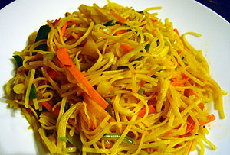
B Egg Noodles Sri Lankan Style
 |  | 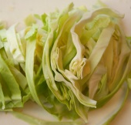 |  |  | 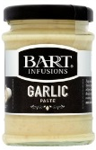
12oz egg noodles | 1 carrot (sliced) | ¼ cabbage (sliced) | 1  Leek  (sliced) | 1tsp ginger paste | 1tsp garlic paste | 2tbsp tomato ketchup | 1tbsp  soy sauce
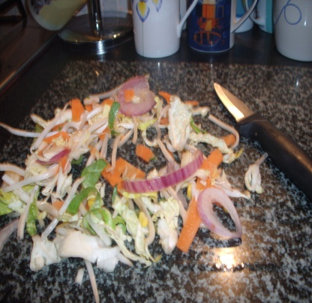
1. Cut the cabbage, leeks and carrots into thin slices.
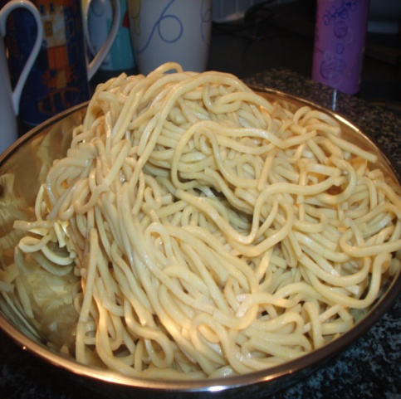

2. Cook the noodles.

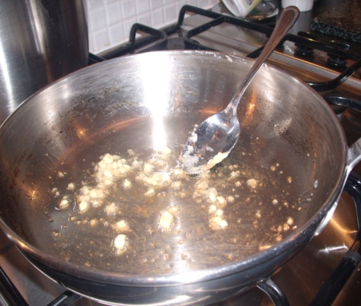
3. Heat some oil in a large pan. Fry the ginger and garlic until soft.
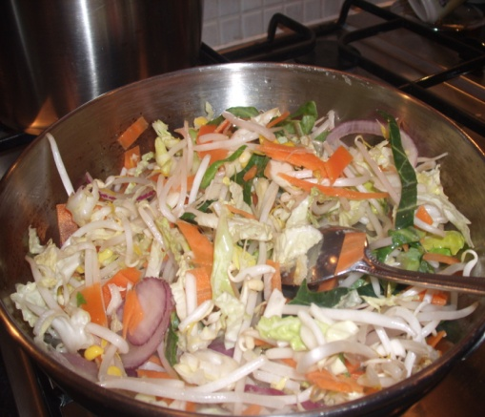

4. Add the carrots, cabbage and leeks.
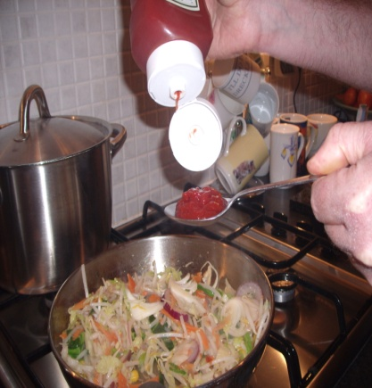
5. Add the tomato sauce and Soy Sauce. Add salt and pepper.
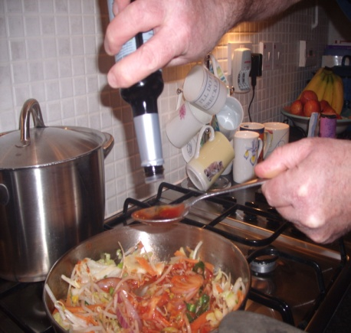

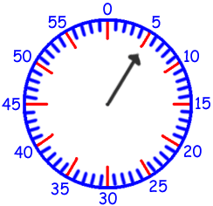

6. Cook for about 5 minutes.
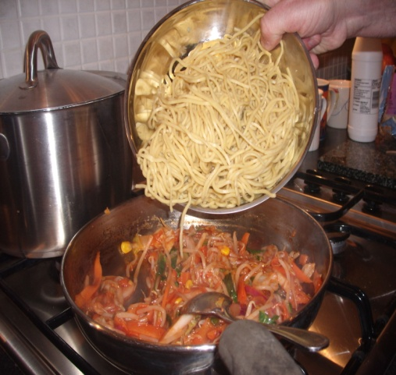

7. Add the cooked noodles. Stir and cook for two minutes.

8. Put into a foil tray and put on the side to cool.

