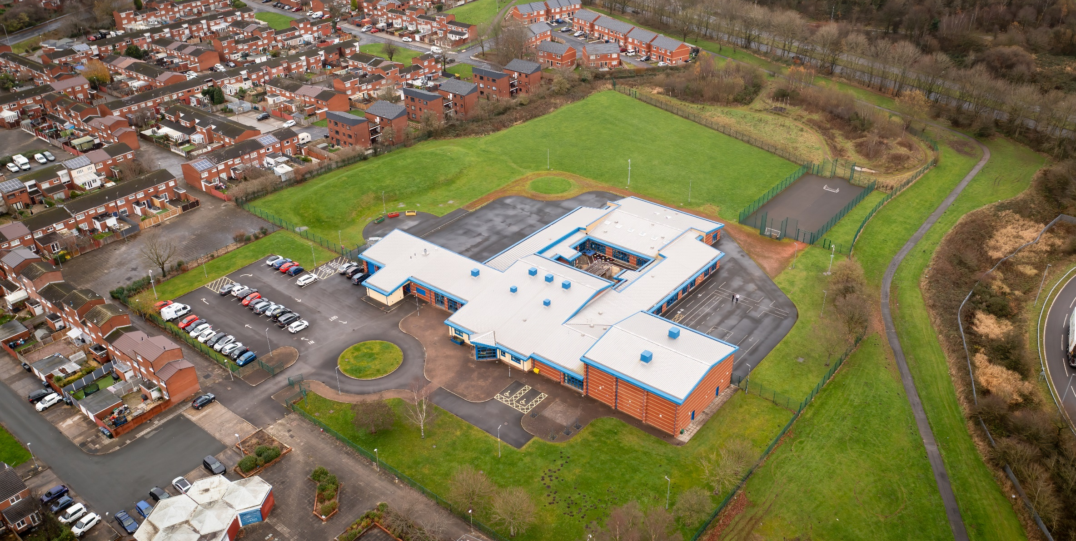

01 April 2023

Hope High School ENGLISH CURRICULUM POLICY

English Curriculum Policy
Hope High School
Carfield
Skelmersdale
Lancashire
WN8 9DP
Tel: 01695 721066

Curriculum Purpose. “Learning for Life”
Our curriculum should allow all learners to have parity of opportunity, be life ready, harness their potential, promote creativity, have rich experiences, and broaden their life choices. ​
At Hope High School the Curriculum is ambitious and tailored to meet the needs of ALL pupils. Pupils study a broad and balanced range of subjects up to Functional Skills Level 1 & 2, BTEC Level 1 & 2, and GCSE. At Key Stage 3 pupils have the opportunity to follow a knowledge rich curriculum in a wide range of subjects. At Key Stage 4 pupils will follow a Core Curriculum and follow 2 pathways in an area of interest to them. This will allow them to flourish and develop their knowledge and skills in subjects that will provide opportunities for college courses and apprenticeships in the future.

Purpose
Our policy is intended to:
- Introduce the aims and objectives of the English Department.
- Outline the key components within English
- Outline the knowledge skills and understanding for all Key stages
- Explain the effective Teaching and Learning strategies utilised in English
- Provide the formative and summative assessment strategies used within English

Aims:
Through English we want the pupils at Hope High School to:
- read easily, fluently and with good understanding
- develop the habit of reading widely and often, for both pleasure and information
- acquire a wide vocabulary, an understanding of grammar and knowledge of linguistic conventions for reading, writing and spoken language
- appreciate our rich and varied literary heritage
- write clearly, accurately and coherently, adapting their language and style in and for a range of contexts, purposes and audiences
- use discussion in order to learn; they should be able to elaborate and explain clearly their understanding and ideas
- are competent in the arts of speaking and listening, making formal presentations, demonstrating to others and participating in debate.

Objectives:
To help meet the Aims of the English Curriculum the department will:
- Provide opportunities for pupils to work with a range of texts: narrative, poetry, plays; media and visual texts; and a full range of non-fiction; texts from other times, cultures and traditions.
- Through reading in particular, have a chance to develop culturally, emotionally, intellectually, socially and spiritually.
- Ensure through quality teaching that pupils receive a knowledge rich curriculum where they acquire the linguistic knowledge and functional skills to support future applications to colleges and apprenticeships.
- Develop schemes of work that are tailored to the individual needs of the learners; are created with progression and engagement in mind.
- Work alongside other areas of the curriculum: enjoying thematic schemes which link to Humanities or Science, for example.
- Help pupils understand that making a mistake is a positive learning experience. It is these experiences that will develop independence.
- Support pupils in achieving a qualification that contributes to them progressing onto a college course of their choice.

Overall, as a department, we are committed to helping our pupils become inquisitive readers, creative writers and confident speakers, who enjoy their English lessons.

Subject Content

Key Stage 3
English has a pre-eminent place in education and in society. A high-quality education in English will teach pupils to speak and write fluently so that they can communicate their ideas and emotions to others and through their reading and listening, others can communicate with them. All the skills of language are essential to participating fully as a member of society; pupils, therefore, who do not learn to speak, read and write fluently and confidently are effectively disenfranchised.
In English, pupils should be taught to:

Reading:
- Read a wide variety of challenging texts from different genres, times and cultures.
- Read whole books, to read in depth and to read for pleasure and information.
- Read texts critically and analytically: considering how language, sentence structure and form are developed for particular audiences and purposes.
- Make critical comparisons and evaluations of a range of texts.
- Apply wider knowledge of the context of a text to develop understanding.
- Be able to give considered personal responses to a text, using evidence and explanation coherently when expressing their viewpoint.
- Use reading as a tool to develop writing skills and speaking and listening skills.

Writing:
- develop their knowledge of and skills in writing, refining their drafting skills and developing resilience to write at length
- write formal and academic essays as well as writing imaginatively and creatively
- summarise and organise material, and support ideas and arguments with any necessary factual detail
- draw on knowledge of literary and rhetorical devices from their reading and listening to enhance the impact of their writing
- write for a variety of purposes and audiences across a range of contexts
- acquire an increasingly wide knowledge of vocabulary and grammar

Grammar:
- understand the relationships between words, how to understand nuances in meaning, and how to develop their understanding of, and ability to use, figurative language
- control their speaking and writing consciously, understand why sentences are constructed as they are and to use Standard English
- understand and use age-appropriate vocabulary, including linguistic and literary terminology, for discussing their reading, writing and spoken language
- pupils learn the correct grammatical terms in English

Spoken Language
- using Standard English confidently in a range of formal and informal contexts, including classroom discussion
- give short speeches and presentations, expressing their own ideas and keeping to the point
- participate in formal debates and structured discussions, summarising and/or building on what has been said
- improvising, rehearsing and performing play scripts and poetry in order to generate language
- discuss language use and meaning, using role, intonation, tone, volume, mood, silence, stillness and action to add impact

Key Stage 4 – Functional Skills English (Level 1 and Level 2)

Qualification Overview
All pupils will be entered for Functional Skills English.
The specification content covers the scope of study for each of the three separate components. For ease of comparison Level 1 and Level 2 content is presented together:

3.1 - Reading

Purpose
Learners will be required to engage with a range of straightforward texts on a range of topics. These will be of varying lengths that instruct, describe, explain or persuade. At Level 2 learners will also need to engage with some complex texts.

3.2 Writing

Purpose
At Level 1 learners will be required to produce straightforward texts such as narratives, instructions, explanations and reports of varying lengths. At Level 2 learners will be required to produce straightforward and complex texts such as articles, narratives, explanations and reports of varying lengths.

3.3 Speaking, Listening and Communicating

Purpose
At Level 1 learners will need to complete tasks that require them to either respond to or produce narratives, explanations, discussions, instructions, information, descriptions and presentations all of varying lengths. At Level 2 learners will need to complete tasks that require them to either respond to or produce extended narratives and information (information may be on technical, concrete or abstract topics), discussions, detailed explanations and presentations, all of varying lengths.

Key Stage 4 – GCSE English
GCSE English Language is designed on the basis that students should read and be assessed on high-quality, challenging texts from the 19th, 20th and 21st centuries. The specification offers the attraction of two equally-balanced papers, relating reading sources to the topic and theme of writing tasks. The reading sources act as stimulus for writing tasks, providing students with a clear route through each paper.

Qualification Overview

Explorations in creative reading and writing
The aim of this paper is to engage students in a creative text and inspire them to write creatively themselves by:
- in section A, reading a literature fiction text in order to consider how established writers use narrative and descriptive techniques to capture the interest of readers
- in section B, writing their own creative text, inspired by the topic that they have responded to in section A to demonstrate their narrative and descriptive skills in response to a written prompt, scenario or visual image.

Writers’ viewpoints and perspectives
The aim of this paper is to develop students’ insights into how writers have particular viewpoints and perspectives on issues or themes that are important to the way we think and live our lives. It will encourage students to demonstrate their skills by:
- in section A, reading two linked sources from different time periods and genres in order to consider how each presents a perspective or viewpoint to influence the reader
- in section B, producing a written text to a specified audience, purpose and form in which they give their own perspective on the theme that has been introduced to them in section A.

3.1 - Reading

Purpose
Learners will be required to engage with a range of straightforward texts on a range of topics. These will be of varying lengths that instruct, describe, explain or persuade. At Level 2 learners will also need to engage with some complex texts.

3.2 Writing

Purpose
At Level 1 learners will be required to produce straightforward texts such as narratives, instructions, explanations and reports of varying lengths. At Level 2 learners will be required to produce straightforward and complex texts such as articles, narratives, explanations and reports of varying lengths.

3.3 Speaking, Listening and Communicating

Purpose
At Level 1 learners will need to complete tasks that require them to either respond to or produce narratives, explanations, discussions, instructions, information, descriptions and presentations all of varying lengths. At Level 2 learners will need to complete tasks that require them to either respond to or produce extended narratives and information (information may be on technical, concrete or abstract topics), discussions, detailed explanations and presentations, all of varying lengths.

Teaching and Learning
Good quality teaching and learning is at the heart of improved life chances for the pupils at Hope High School. Our pupils benefit from consistency in their lives. Hope High has adopted the teaching and learning model of Rosenshine’s 10 principles of Instruction. These principles will be evident in classrooms daily.
In English the principles are:
- Lessons begin with a short task which may: practise a key spelling or grammar skill; independent reading; recall of information, ideas or knowledge; develop vocabulary knowledge.
- Daily review: lessons will then begin with a review of learning from previous lessons. This is to support our pupils’ cognitive load and ensure they aware of how this learning or skill fits the ‘bigger picture’.
- Present new material using small steps. Teacher demonstration is an integral part of the delivery of the subject. New concepts and skills will be introduced in small steps using teacher modelling: I do, we do, you do.
- Provide model answers: Exemplar answers written by the teacher, other students or examination board will be provided to support pupil understanding.
- Ask questions to check student understanding and recall: A range of interactive questioning techniques will be used to check pupil understanding. Direct questioning, use of interactive whiteboards and low stake quizzes are just a few of the techniques used to check pupil understanding.
- Guide Student practice: Teachers and TA’s will be used to help and support pupils in lessons with an emphasis on encouraging pupil independence.
- Provide scaffolds for difficult tasks: In English the support of the teacher or TA is one of the main scaffolds that can support our students in difficult tasks. Pupils may also be provided with model answers, writing frames or sentence starters, word banks or visual stimuli.
- Independent practice: Opportunities will be provided to pupils for them to apply their knowledge, skills and understanding to different texts, question types and writing stimuli with increasing difficulty over time. Independence will be supported and encouraged in all our pupils in a safe and calm environment.
- Obtain a high success rate. Pupils will be encouraged to practise techniques and skills until mastery is achieved in that area.

Assessment
At Hope High we firmly believe that assessment should be used as a tool to help move pupil learning forward. The day to day, lesson by lesson, formative assessment that takes place with pupils will help them make progress. This will inform teachers of areas of mastery and support them in the development of scaffolding materials to help pupils who need that extra support to achieve mastery. Formative assessment will occur through speaking and listening and participation in class discussions; low stakes quizzes and recall tasks; reading and writing activities and progress checks.
This formative assessment coupled with end of topic summative assessments will provide the teacher with a holistic overview of a pupil progress and inform the grade for termly reports that are sent to parents/carers.
In English pupils are assessed on the knowledge and understanding they have in reading, writing and spoken language alongside grammatical skills, spelling and vocabulary acquisition and understanding.
Self-assessment is key in assisting learners to understand what they can do well and what they need to improve further. Some assessments will be low-key and in informal conditions whilst other assessments will be formal to learners to develop their independence and evaluation of their work. This will inform future target setting and possible intervention.

Monitoring

The Head of School and leadership team will:
Monitor the subject through the Hope High self-evaluation schedule and monitoring schedule which are reviewed annually

Departmental leader will:
- Monitor learners work and quality of teaching and learning
- Review Curriculum Maps and Schemes of Work based on suitability of use
- Review and monitor risk assessments for practical lessons
- Analyse pupil performance data
- Attend link meetings

Links to other policies:
• Teaching and Learning
• Behaviour for Learning
• Monitoring
• Assessment for Learning
• Health and Safety
• Marking and Feedback
Date Approved:
Review date:
Signed subject Lead:
Signed Headteacher:

