Flapjacks
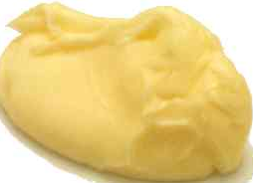 | 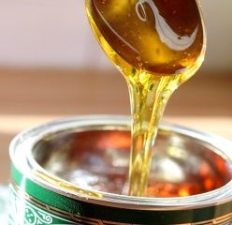 | 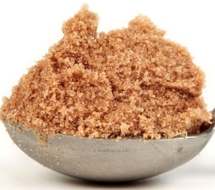 | 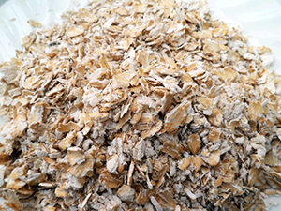
125g  butter | 3 tbsps golden syrup | 125g  brown sugar | 250g porridge oats
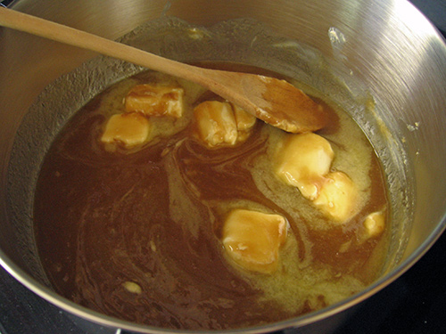
1. Put the butter, sugar and syrup into a pan and melt on a low heat.
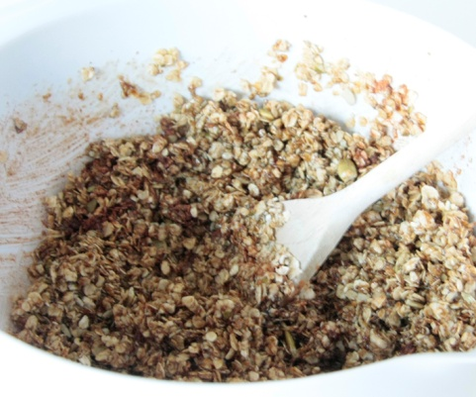

2. Turn off the heat and mix in the oats.

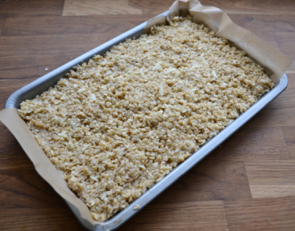
3. Pour into a tray lined with greaseproof paper.
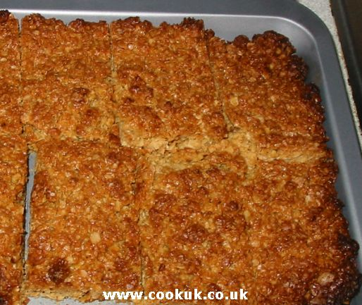

4. Bake in oven at 180C for 20 minutes.
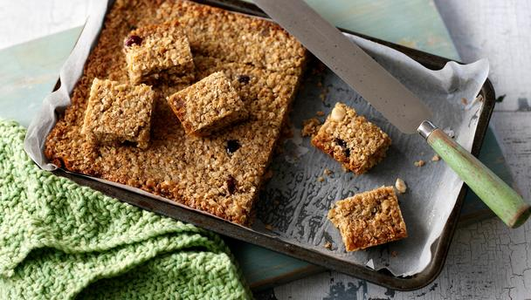
5. When cool, turn out and cut into squares.

