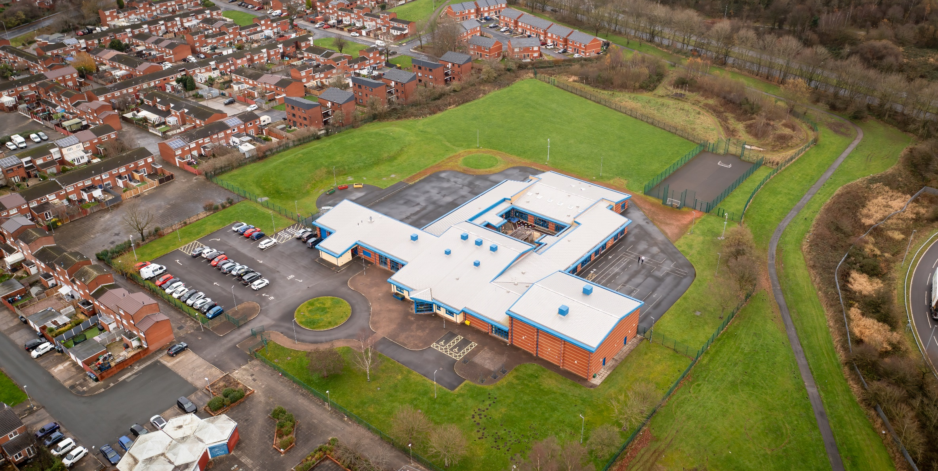

01 April 2023

Hope High School Food Technology CURRICULUM POLICY

Food Technology Curriculum Policy
Hope High School
Carfield
Skelmersdale
Lancashire
WN8 9DP
Tel: 01695 721066

Curriculum Purpose. “Learning for Life”
Our curriculum should allow all learners to have parity of opportunity, be life ready, harness their potential, promote creativity, have rich experiences, and broaden their life choices. ​
At Hope High School the Curriculum is ambitious and tailored to meet the needs of ALL pupils. Pupils study a broad and balanced range of subjects up to Functional Skills Level 1 & 2, BTEC Level 1 & 2, and GCSE. At Key Stage 3 pupils have the opportunity to follow a knowledge rich curriculum in a wide range of subjects. At Key Stage 4 pupils will follow a Core Curriculum and follow 2 pathways in an area of interest to them. This will allow them to flourish and develop their knowledge and skills in subjects that will provide opportunities for college courses and apprenticeships in the future.

Purpose
Our policy is intended to:
- Introduce the aims and objectives of the Food Technology Department.
- Outline the key components within Food Technology.
- Outline the knowledge skills and understanding for all key stages.
- Explain the effective Teaching and Learning strategies utilised in Food Technology.
- Provide the formative and summative assessment strategies used within Food Technology.

Aims:
Through Food Technology we want the pupils at Hope High School to be:
- Creative and imaginative when designing and making foods that are relevant to them.
- Able to acquire a broad range of subject knowledge and draw on disciplines such as mathematics, science, PE and art when designing and making.
- Resourceful, innovative, enterprising, and capable citizens, who utilise the skills they have learnt in school to life beyond school.
- Able to understand the impact of food on daily life and that of the wider world.
- Ready to access a career/college course in a Design Technology related area when they leave school.

Objectives:
To help meet the Aims of the Food Technology Curriculum the department will:
- Provide opportunities for pupils to work with a range of ingredients, appliances and equipment when designing and making products.
- Help pupils understand that making a mistake is a positive learning experience. It is these experiences that will develop independence.
- Ensure through quality teaching that pupils receive a knowledge rich curriculum where they acquire the technical knowledge to support future applications to colleges and apprenticeships.
- Expose pupils to the latest various cultures and their cuisines, helping to broaden their knowledge of the wider world as well as British Values
- Ensure learners have access to a wide range of resources which are freely available and regularly maintained.
- Will work alongside other Targeted areas of the curriculum.
- Develop Schemes of Work that are tailored to the individual needs of the learners.
- Support pupils in achieving a BTEC qualification that contributes to them progressing onto a college course of their choice.

Subject Content

Key Stage 3
A high-quality Food Technology education provides the foundations for independence in life after school. Food is a vital part our lives; all pupils should be taught the essential aspects of the knowledge, methods, and processes of Food Technology. Through building up a body of key foundational knowledge and concepts, pupils should be encouraged to recognise the importance of food in our daily lives. They should be encouraged to understand where different aspects can impact food: it’s flavours, taste, textures, appearance and nutritional values.
- understand and apply the principles of nutrition and health
- cook a repertoire of predominantly savoury dishes so that they are able to feed themselves and others a healthy and varied diet
- become competent in a range of cooking techniques [for example, selecting and preparing ingredients; using utensils and electrical equipment; applying heat in different ways; using awareness of taste, texture and smell to decide how to season dishes and combine ingredients; adapting and using their own recipes]
- understand the source, seasonality and characteristics of a broad range of ingredients

Food Technology knowledge and understanding
The programmes of study describe a sequence of knowledge and concepts. While it is important that pupils make progress, it is also vitally important that they develop secure understanding of each key block of knowledge and concepts in order to progress to the next stage. Insecure, superficial understanding will not allow genuine progression: pupils may struggle at key points of transition (such as between primary and secondary school), build up serious misconceptions, and/or have significant difficulties in understanding more difficult content.
Pupils should be able to describe associated processes and key characteristics in common language, but they should also be familiar with, and use, technical terminology accurately and precisely. They should build up a specialist vocabulary. They should also apply their mathematical knowledge to their understanding of Food Technology, including weighing, measuring and timing.
The social and economic implications of Food Technology are important. Pupils will be taught about economising as well as how cultural and socio-economic factors will play a part in food production and consumption. They will also learn about the social and economic aspects of food within the wider school curriculum: teachers will wish to use different contexts to maximise their pupils’ engagement with and motivation to study Food Technology. The principal focus of Food Technology teaching in key stage 3 is to become competent in a range of cooking techniques as well as developing a deeper understanding of the principles of nutrition and health.

Spoken language.
Spoken language is a vital aspect in pupils’ development across the whole curriculum – cognitively, socially and linguistically. The quality and variety of language that pupils hear and speak are key factors in developing their Food Technology vocabulary and articulating concepts clearly and precisely. They must be assisted in making their thinking clear, both to themselves and others, and teachers should ensure that pupils build secure foundations by using discussion to probe and remedy any misconceptions.

Key Stage 4 – BTEC Home Cooking

Qualification Overview
The Pearson BTEC Level 1/2 Introductory Award is designed around practical skills and tasks that place an emphasis on learners demonstrating what they can do rather than what they know in theory. The qualifications give learners the opportunity to acquire and develop generic, transferable and sector-specific skills in order to complete tasks and demonstrate a level of achievement that enables them to progress to further learning. The Award offers an introduction to the Food/Catering sector and could be studied alongside other subjects. The qualification prepares learners for further learning at a higher level.

Learning aims:
The learning is broken down into four key aspects:
- knowledge, understanding and confidence to cook meals at home
- an understanding of how to economise when planning a meal
- an ability to transfer skills learned to different recipes
- an ability to inspire others by transferring that knowledge.

Teaching and Learning
Good quality teaching and learning is at the heart of improved life chances for the pupils at Hope High School. Our pupils benefit from consistency in their lives. Hope High has adopted the teaching and learning model of Rosenshine’s 10 principles of Instruction. These principles will be evident in classrooms daily.
In Food Technology the principles are:
- Daily review. Lessons will begin with a review of learning from previous lessons. This is to support our pupils cognitive load. This could be a review of new tools used or a re-cap on a new process.
- Present new material using small steps. Teacher demonstration is an integral part of the delivery of the subject. New concepts and skills will be introduced in small steps using live or video demonstration.
- Ask questions. A range of interactive questioning techniques will be used to check pupil understanding. Direct questioning, use of interactive whiteboards and NearPod are just a few of the techniques used to check pupil understanding.
- Provide models. Example projects/visual aids will be provided to support pupil understanding.
- Guide Student practice. Teachers, TA’s and the school technician will be used to help and support pupils in lessons with an emphasis on encouraging pupil independence.
- Check for student understanding. Formative assessment techniques such as direct questioning of individual pupils and observation of skills and techniques will be used to check knowledge and understanding.
- Obtain a high success rate. Pupils will be encouraged to practise techniques and skills until mastery is achieved in that area.
- Provide scaffolds for difficult tasks. In Food Technology the support of the teacher, TA or Technician is one of the main scaffolds that can support our students in difficult tasks. An individual demonstration, support with a practical process or a verbal instruction can help pupils move forward with their learning in Food Technology.
- Independent practice. Opportunities will be provided to pupils for them to apply their knowledge, skills and understanding to different design scenarios. Independence will be supported and encouraged in all our pupils in a safe and calm environment.
- Weekly and termly review. Photographic evidence will be kept of pupil work to demonstrate progress in Food Technology. Pupils will revisit skills they used previously to help consolidate and support learning.

Assessment
At Hope High we firmly believe that assessment should be used as a tool to help move pupil learning forward. The day to day, lesson by lesson, formative assessment that takes place with pupils will help them make progress. This will inform teachers of areas of mastery and support them in the development of scaffolding materials to help pupils who need that extra support to achieve mastery.
This formative assessment coupled with end of topic summative assessments will provide the teacher with a holistic overview of a pupil progress and inform the grade for termly reports that are sent to parents/carers.
In Design Technology pupils are assessed on the knowledge and understanding they have on the materials, tools, equipment and processes that they use in lessons. They are assessed on their ability to use this knowledge and practical ability to make products to a high quality. They are also assessed on their ability to use a range of techniques, including sketching and CAD to design products that meet a specific brief.
Assessments are made clear to learners to develop their independence and evaluation of their work. This will inform future target setting. Self-evaluation is key in getting learners to understand what they can do well and what they need to improve on further.

Monitoring

The Head of School and leadership team will:
Monitor the subject through the Hope High self-evaluation schedule and monitoring schedule which are reviewed annually

Departmental leader will:
- Monitor learners work and quality of teaching and learning
- Review Curriculum Maps and Schemes of Work based on suitability of use
- Review and monitor risk assessments for practical lessons
- Analyse pupil performance data
- Attend link meetings

Links to other policies:
• Teaching and Learning
• Behaviour for Learning
• Monitoring
• Assessment for Learning
• Health and Safety
• Marking and Feedback
Date Approved:
Review date:
Signed subject Lead:
Signed Headteacher:

