Making your Pizza

Emerging: Use equipment and ingredients with some help

Developing: Use different ingredients and equipment make recipes showing a range of skills

Securing: Use correct equipment with some accuracy and in an appropriate way

|  |  |  |  |  |
| --- | --- | --- | --- | --- |
| http://www.limoncello.co.uk/acatalog/giagpureetube.jpg | [Image result for Yellow Pepper](https://www.bing.com/images/search?q=yellow+pepper&id=5E21BC26DB098272D14869A627F86F70501F71D9&FORM=IQFRBA) | http://www.freedigitalphotos.net/image/s_grated-cheese1.jpg | C:\Users\bainesl\AppData\Local\Microsoft\Windows\INetCache\Content.MSO\CAF95564.tmp | [Image result for buttonmushroom](https://www.bing.com/images/search?view=detailV2&ccid=8DA%2fhIa8&id=C76059AC0F78D8B321016AB9C7E334B736ABD2AB&thid=OIP.8DA_hIa8tiIBBgNPs4msjAHaE7&mediaurl=http%3a%2f%2fwww.meatfreemondays.com%2fwp-content%2fuploads%2f2013%2f04%2fwhite-button-mushroom-medium.jpg&exph=333&expw=500&q=buttonmushroom&simid=608010142385768496&selectedIndex=7&adlt=strict) |
| Tomato puree | ½ Yellow Pepper | 50g grated cheese | 1 Spring Onion | 1 mushroom |

# 

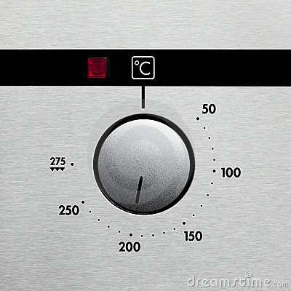1. Pre heat the grill to 200ºC.

1. [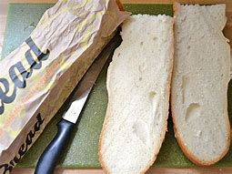](https://www.bing.com/images/search?view=detailV2&ccid=5hs9F5AH&id=CC58CA42054CFCF4CA0FD4DE1434B32AAF502620&thid=OIP.5hs9F5AHHzxYLQogPN5-XgHaFj&mediaurl=https%3a%2f%2flh5.googleusercontent.com%2f-z_-RFcTdZhQ%2fUXwCwTacDeI%2fAAAAAAAAKU8%2ffLzfAyaHlKA%2fw640-h480%2f4%2bfrench%2bbread.jpg&exph=480&expw=640&q=french+bread+cut+along+the+middle&simid=608010009237586854&selectedIndex=43&adlt=strict)
2. 2. Put your (halved) baguette under the grill to toast for 5 mins.
3. [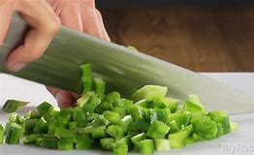](https://www.bing.com/images/search?view=detailV2&ccid=0vLfnsGe&id=9FF45A33352BFB7FBFD66CB3E12EF561E89E366E&thid=OIP.0vLfnsGeuh37vS7QCSE9lAHaEK&mediaurl=https%3a%2f%2ftimeincsecure-a.akamaihd.net%2frtmp_uds%2f429048911%2f201606%2f76%2f429048911_4924525522001_1448201772-vs.jpg%3fpubId%3d429048911%26videoId%3d1448201772&exph=720&expw=1280&q=chopped+pepper+and+mushroom&simid=608051266670889239&selectedIndex=10&adlt=strict)
4. 3. Carefully chop the pepper, onion and mushroom

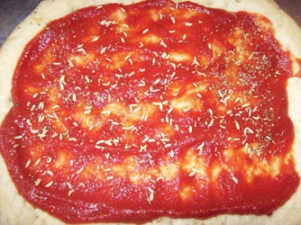

1. 4. Spread tomato puree on top of the baguette slices using a butter knife or a spoon.

[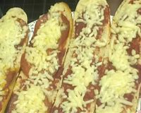](https://www.bing.com/search?q=Pizza+Baguettes&filters=ufn%3a%22Pizza+Baguettes%22+sid%3a%22a1bb6582-36bd-2b75-eb52-fe0ad4668207%22+segment%3a%22generic.carousel%22+secq%3a%22tomato+puree+on+baguette%22+supwlcar%3a%221%22+tsource%3a%22EntitySegments%22+catesegtype%3a%22recipe%22+cack%3a%22ea26984c-4694-451f-9ea1-96a488b46ea1%22+segtype%3a%22UmVjaXBl%22+ctype%3a%220%22+mltype%3a%220%22+eltypedim1%3a%22Recipe%22&FORM=SNAPCR)

1. 5. Sprinkle cheese on top of the tomato puree.
2. [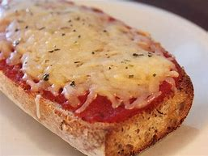](https://www.bing.com/images/search?view=detailV2&ccid=Bo%2fS5Smw&id=9FA04B344D15C001FB73060441FD9F4CE8CF02E6&thid=OIP.Bo_S5SmwY3DNNAGnxy-CwAHaFj&mediaurl=http%3a%2f%2fmedia4.s-nbcnews.com%2fi%2fnewscms%2f2016_10%2f1009131%2fwhole_wheat_french_bread_pizza-shirley_fan_2f90348e6dd7439bb82652cecc6fd63e.jpg&exph=477&expw=636&q=adding+toppings+to+french+bread+pizza&simid=608012281266241693&selectedIndex=60&adlt=strict)6. Add your toppings to the pizza.

1. 7. Place placed under the grill and cook until the cheese is golden brown.