**Friendly Fish Pie**

|  |  |  |  |  |  |
| --- | --- | --- | --- | --- | --- |
| http://thefishman.co.uk/images/food/salfil.jpg | http://www.howbigismypotato.com/potato.jpg | http://media.tumblr.com/tumblr_m72j8dV8Ii1qkzq2g.jpg | http://www.dkimages.com/discover/previews/794/348294.JPG | http://www.aoshen168.com/images/b_pic/6_0.jpg | http://www.allianceonline.co.uk/product_images/LCGT0003.jpg |
| Fish Portion | 1  potato | 30g Cheese | 30g  Sweet corn | Foil tray | Cheese grater |

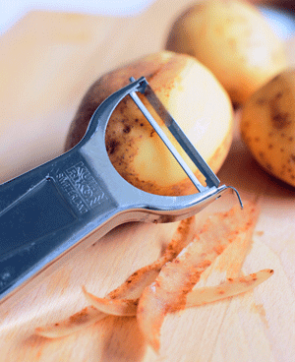

1. 1. Peel and chop the potato

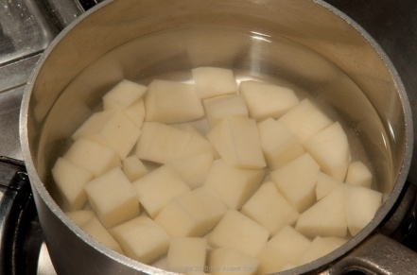

1. 2. Put the potatoes into a saucepan and boil until soft.

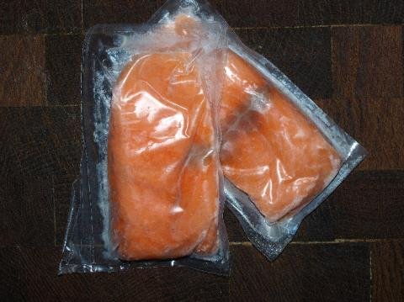

1. 3. Put the fish into a saucepan and boil for 15-20 minutes.

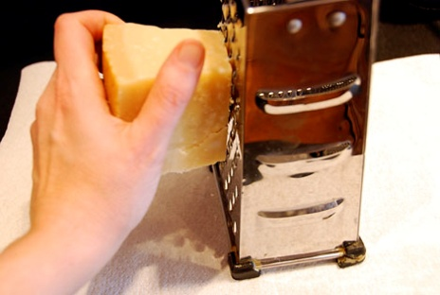

4. Grate the cheese.

1. 5. Put the fish into the bottom of a foil tray.

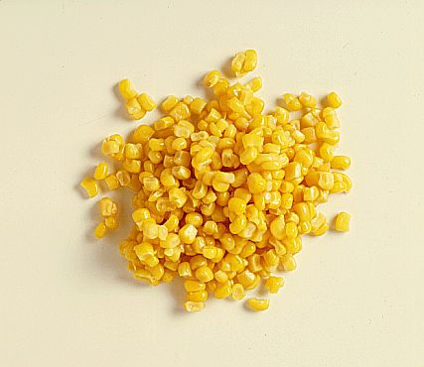

1. 6. Sprinkle the sweet corn over the fish.

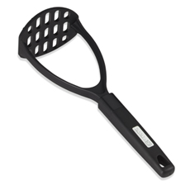

1. 7. Mash the potato and add **half** of the grated cheese. Put the mash on top of the fish
2. 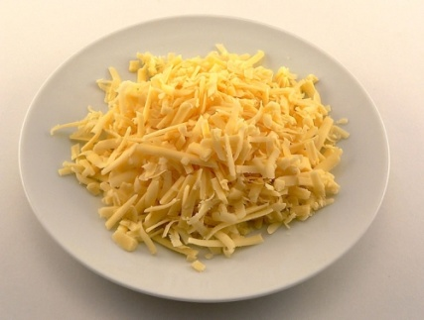8. Sprinkle the rest of the cheese on top of the fish pie.
3. 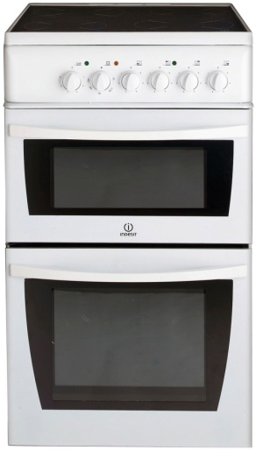
4. 9. Put in the oven for 20mins at 200ºC.