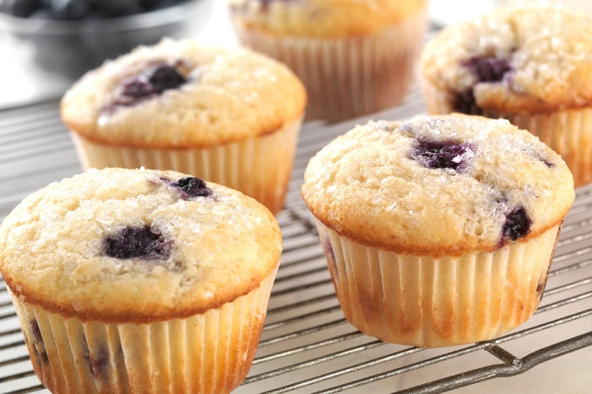
Fruit Muffins
Ingredients
- 250g self raising flour
- 2 x 5ml spoon baking powder
- 1 x 5ml spoon cinnamon powder
- 150g caster sugar
- 250ml milk
- 1 egg
- 90ml oil
- 150g mixed fruit
---------------------------------------------------------------------------------------------------------
Equipment:
Weighing scales, sieve, large bowl, measuring spoons, small bowl, fork, measuring jug, wooden spoon, muffin cases, muffin tin, oven gloves and cooling rack.
---------------------------------------------------------------------------------------------------------
Method:
1. Preheat the oven to 180 ºC or gas mark 4.
2. Sieve the flour and baking powder into a large bowl.
3. Whisk the egg in a small bowl using a fork.
4. Pour the milk, oil and egg into the flour mixture and mix well to form a smooth batter.
5. Stir in the fruit.
6. Spoon the mixture into the muffin cases.
7. Bake for 20 – 25 minutes until the muffins have risen and are golden brown.
8. Carefully take the muffins out of the tin and allow to cool on a cooling rack.

