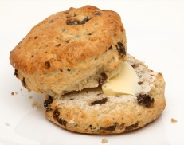**Fruit Scones**

|  |  |  |  |  |
| --- | --- | --- | --- | --- |
| **http://www.english-shop.de/images/McDSelfraisingFlour.jpg** | **http://www.healingdaily.com/detoxification-diet/essential-fatty-acids-not-margarine.jpg** | http://kellys-expat-shopping.nl/files/2013/06/tate-lyle-caster.jpg | http://cache1.asset-cache.net/xt/56399750.jpg?v=1&g=fs1%7C0%7CPDI%7C99%7C750&s=1 | http://thegourmetshop.ie/wp-content/uploads/2013/08/Raisins1.jpg |
| **225g**  self-raising flour | **50g** margarine | **25g**  caster sugar | **125ml**  milk | **50g**  dried fruit |



1. Heat the oven to 200C

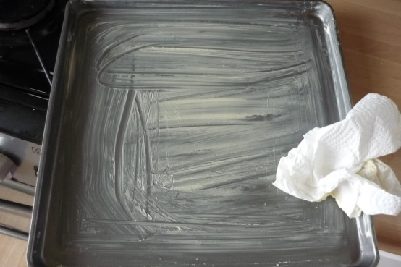

2. Lightly grease a baking tray.

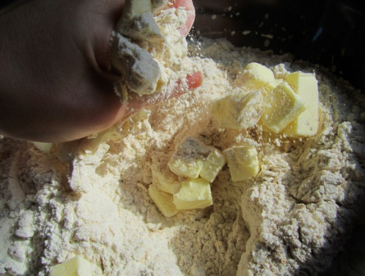

3. Mix the **flour** and **margarine** together. Stir in the **sugar** and the **dried fruit**

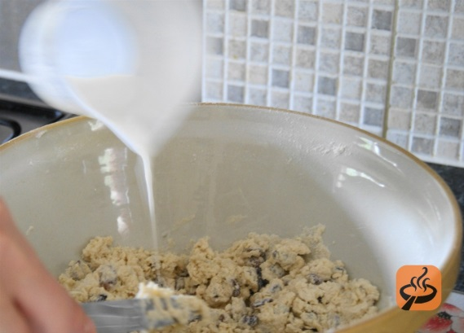

4. Add the **milk** to and mix to get a soft dough.

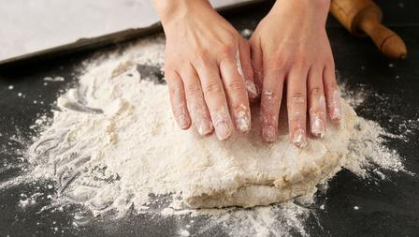

5. Turn on to a floured work surface and knead into a ball.

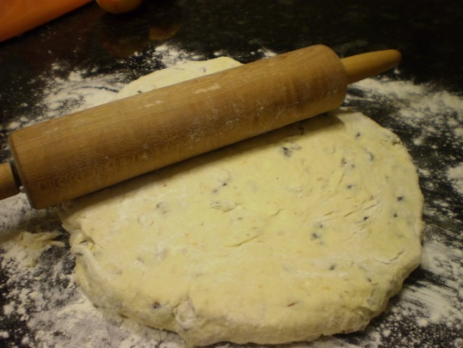

6. Put flour on a rolling pin and roll flat.

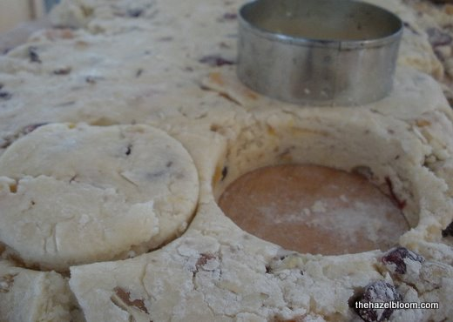

7. Use a cutter to stamp out rounds and place on the baking tray.

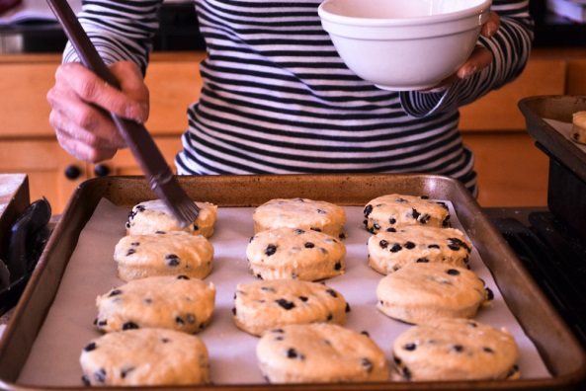

8. Brush tops of scones with **milk** before putting in the oven for 12-15 minutes.

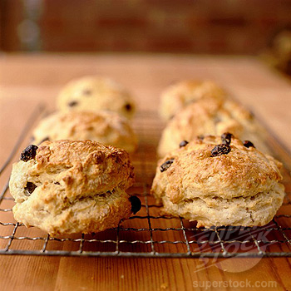

9. Cool on a wire rack and serve with butter and jam.