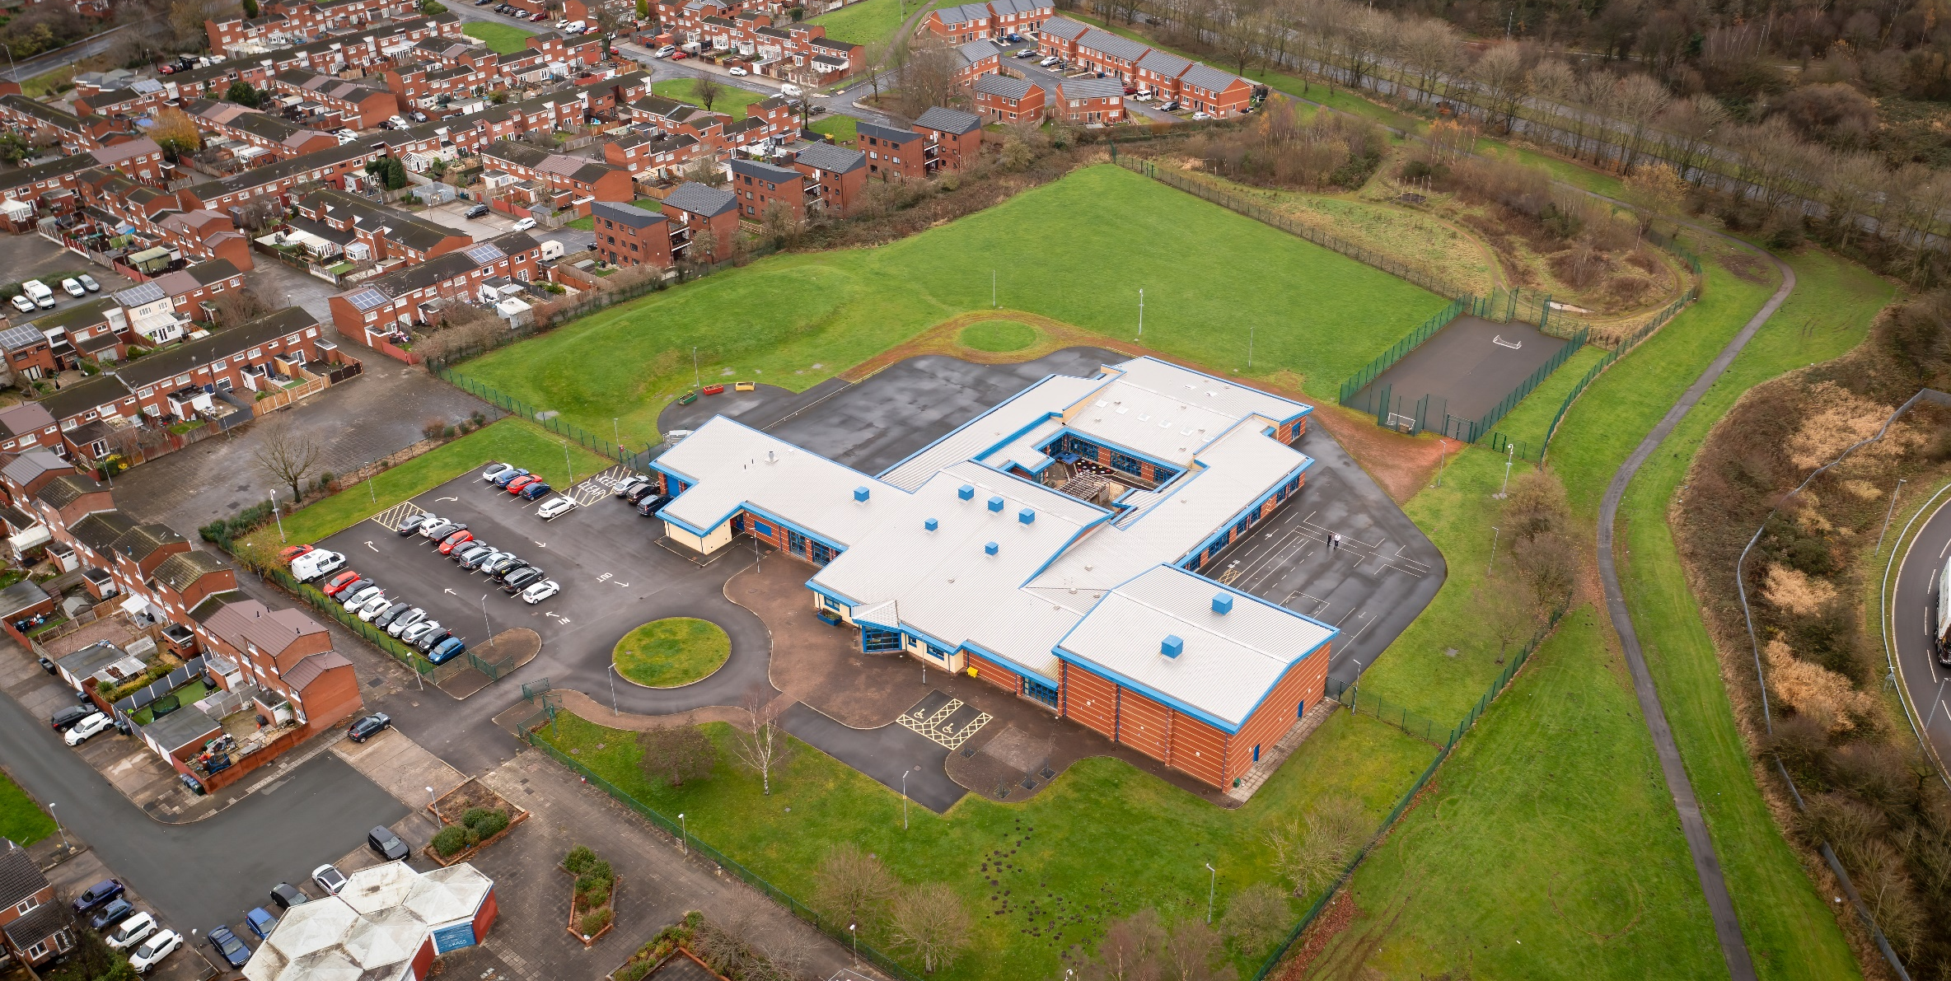

01 April 2023

Hope High School Geography CURRICULUM POLICY

Geography Curriculum Policy
Hope High School
Carfield
Skelmersdale
Lancashire
WN8 9DP
Tel: 01695 721066

Curriculum Purpose. “Learning for Life”
Our curriculum should allow all learners to have parity of opportunity, be life ready, harness their potential, promote creativity, have rich experiences, and broaden their life choices. ​
At Hope High School the Curriculum is ambitious and tailored to meet the needs of ALL pupils. Pupils study a broad and balanced range of subjects up to Functional Skills within Entry Level 1 & 2, BTEC Level 1 & 2, and GCSE. At Key Stage 3 pupils have the opportunity to follow a knowledge rich curriculum in a wide range of subjects. At Key Stage 4 pupils will follow a Core Curriculum and follow 2 pathways in an area of interest to them. This will allow them to flourish and develop their knowledge and skills in subjects that will provide opportunities for college courses and apprenticeships in the future.

Purpose
Our policy is intended to:
- Introduce the aims and objectives of the Geography Department.
- Outline the key components within Geography.
- Outline the knowledge skills and understanding for all Key Stages
- Explain the effective Teaching and Learning strategies utilised in Geography.
- Provide the formative and summative assessment strategies used within Geography.

Aims:
Through Geography we want the pupils at Hope High School to be:
- Develop contextual knowledge of the location of globally significant places – both terrestrial and marine – including their defining physical and human characteristics and how these provide a geographical context for understanding the actions of processes.
- Understand the processes that give rise to key physical and human geographical features of the world, how these are interdependent and how they bring about spatial variation and change over time.
- Are competent in the geographical skills needed to:
- Collect, analyse and communicate with a range of data gathered through experiences of fieldwork that deepen their understanding of geographical processes.
- Interpret a range of sources of geographical information, including maps, diagrams, globes, aerial photographs and Geographical Information Systems (GIS)
- Communicate geographical information in a variety of ways, including through maps, numerical and quantitative skills and writing at length.

Objectives:
To help meet the Aims of the Geography Curriculum the department will:
- To enable children to gain knowledge and understanding of places in the world.
- To increase children’s knowledge of other cultures and, in so doing, teach a respect and understanding of what it means to be a positive citizen in a multi-cultural country.
- To allow children to learn graphic skills, including how to use, draw and interpret maps.
- To enable children to know and understand environmental problems at a local, regional and global level.
- To encourage in children a commitment to sustainable development and an appreciation of what ‘global citizenship’ means.
- Fieldwork is integral to good geography teaching, and we include as many opportunities as we can to involve children in practical geographical research and enquiry.
- Trips to local areas of geographical interest can be arranged to link to our creative curriculum.
- To develop a variety of other skills, including those of enquiry, problem solving, ICT, investigation and how to present their conclusions in the most appropriate way.
- Ensure through quality teaching that pupils receive a knowledge rich curriculum where they acquire the technical knowledge to support future applications to colleges and apprenticeships.
- Will work alongside other Targeted areas of the curriculum. Schemes of Work that are tailored to the individual needs of the learners.
- Support pupils in achieving an Entry Level 1 and GCSE qualifications that contributes to them progressing onto a college course of their choice.

Subject Content

Key Stage 3
Pupils will consolidate and extend their knowledge of the world’s major countries and their physical and human features. They will understand how geographical processes interact to create distinctive human and physical landscapes that change over time. In doing so, they will become aware of increasingly complex geographical systems in the world around them. They will develop greater competence in using geographical knowledge, approaches and concepts [such as models and theories] and geographical skills in analysing and interpreting different data sources. In this way pupils will continue to enrich their locational knowledge and spatial and environmental understanding.
When designing and making, pupils should be taught to:

Locational Knowledge.
- Extend their locational knowledge and deepen their spatial awareness of the world’s countries using maps of the world to focus on Africa, Russia, Asia (including China and India), and the Middle East, focusing on their environmental regions, including polar and hot deserts, key physical and human characteristics, countries and major cities.

Place Knowledge
- Understand geographical similarities, differences and links between places through the study of human and physical geography of a region within Africa, and of a region within Asia.

Human and Physical Geography
- Understand, through the use of detailed place-based exemplars at a variety of scales, the key processes in:
- Physical geography relating to geological timescales and plate tectonics; rocks, weathering and soils; weather and climate, including the change in climate from the Ice Age to the present; and glaciation, hydrology and coasts.
- Human geography relating to population and urbanisation; international development; economic activity in the primary, secondary, tertiary and quaternary sectors; and the use of natural resources.
- Understand how human and physical processes interact to influence, and change landscapes, environments and the climate; and how human activity relies on effective functioning of natural systems Place Knowledge

Geographical skills and fieldwork
- Build on their knowledge of globes, maps and atlases and apply and develop this knowledge routinely in the classroom and in the field.
- Interpret Ordnance Survey maps in the classroom and the field, including using grid references and scale, topographical and other thematic mapping, and aerial and satellite photographs.
- Use Geographical Information Systems (GIS) to view, analyse and interpret places and data.
- Use fieldwork in contrasting locations to collect, analyse and draw conclusions from geographical data, using multiple sources of increasingly complex information.

Key Stage 4 - BTEC Level 1 Construction Award

Qualification Overview
The Pearson BTEC Level 1 Introductory Award is designed around practical skills and tasks that place an emphasis on learners demonstrating what they can do rather than what they know in theory. The qualifications give learners the opportunity to acquire and develop generic, transferable and sector-specific skills in order to complete tasks and demonstrate a level of achievement that enables them to progress to further learning. The Award offers a basic introduction to the construction sector and could be studied alongside other subjects. The qualification prepares learners for further learning at a higher level in construction.
For the Construction Award pupils will complete 2 Units.

Task 1: Dynamic World

Purpose
The unit will help encourage learners to engage with their local place by understanding who lives there and how its changed overtime. Students will engage with the world we live in and how we can be presented with a number of hazards to people and places and explore the tectonic and flood hazards focusing on the cause and the impact. Students will also have the opportunity to investigate why tropical rainforests are so important, how they are being used and think about why we should be looking to interact with them more carefully in the future.

Learning aims:
In this task pupils will:
- Our world: This topic encourages students to engage with their ‘local’ place by understanding who lives there and how it has changed over time. Students also explore how the world is changing with a particular focus on megacities.
- Destructive world: In this topic students will have the opportunity to explore tectonic and flood hazards, particularly focusing on their causes and impacts. The case studies enable students to investigate two places in a little more depth.
- Resourceful world: Students have the chance to investigate why rainforests are so important to the planet and people and how they are used. This topic discovers the importance of food and energy in the UK as well as fairtrade for farmers in distant places.

Task 2: Fieldwork Notebook

Purpose
In completing fieldwork, students will gain new geographical insights and begin to understand the world around them. They will be required to collect data and present this in a variety of ways, written, graphs, posters or a PowerPoint presentation.

Learning Aims
In this unit pupils will:
- The title for the fieldwork task can be based on exemplar titles provided by OCR or can be centre developed.
- Fieldwork provides students with the opportunity to practice skills and understand the world around them. This enables students to ‘anchor’ their studies within a real-world context.

Task 3: Personal Project

Purpose
Students will complete one personal project which can be based on any area of the specification, they will be required to present the project in a variety of ways such as Poster, PowerPoint or a Written Project. They will need to be awarded for their ability to research geographical facts, use of geographical vocabulary and logical structure to their project.

Learning Aims
- Students will complete one project which can be based on any area of the specification. The project can be based on any one of the exemplar titles provided by OCR or can be either centre- or student-developed.

Teaching and Learning
Good quality teaching and learning is at the heart of improved life chances for the pupils at Hope High School. Our pupils benefit from consistency in their lives. Hope High has adopted the teaching and learning model of Rosenshine’s 10 principles of Instruction. These principles will be evident in classrooms daily.
In Geography the principles are:
- Daily review. Lessons will begin with a review of learning from previous lessons. This is to support our pupil’s cognitive load. This could be a review of new tools used or a re-cap on a new process.
- Present new material using small steps. Teacher demonstration is an integral part of the delivery of the subject. New concepts and skills will be introduced in small steps using live or video demonstration.
- Ask questions. A range of interactive questioning techniques will be used to check pupil understanding. Direct questioning, use of interactive whiteboards and Visualiser are just a few of the techniques used to check pupil understanding.
- Use of ARCGis which is an interactive map used for students to have a more geographical in depth knowledge and understanding.
- Scaffold and model learning expectations and practices and embed routine formative assessment strategies with starters and plenaries as well as whiteboard check points.
- Guide Student practice. Teachers and TA’s will be used to help and support pupils in lessons with an emphasis on encouraging pupil independence.
- Check for student understanding. Formative assessment techniques such as direct questioning of individual pupils and observation of skills and techniques will be used to check knowledge and understanding.
- Obtain a high success rate, with confidence in depth knowledge of subjects, questioning, creating chronological times frames and
- Provide scaffolds for difficult tasks. In Geography the support of the teacher, TA is one of the main scaffolds that can support our students in barriers to learning. Teacher to model with the visualiser, sentence starters and worksheets for support with all needs.
- Independent practice. Opportunities will be provided to pupils for them to apply their knowledge, skills and understanding to different design scenarios. Independence will be supported and encouraged in all our pupils in a safe and calm environment.

Assessment
At Hope High we firmly believe that assessment should be used as a tool to help move pupil learning forward. The day to day, lesson by lesson, formative assessment that takes place with pupils will help them make progress. This will inform teachers of areas of mastery and support them in the development of scaffolding materials to help pupils who need that extra support to achieve mastery.
This formative assessment coupled with end of topic summative assessments will provide the teacher with a holistic overview of a pupil progress and inform the grade for termly reports that are sent to parents/carers.
In Geography, assessment is ongoing and continuous through formative teacher assessment. Informal, diagnostic judgements allow teachers to give meaningful feedback to children about the success of their learning by identifying each child’s progress in each aspect of the curriculum, determining what each child has learned and what should therefore be the next step in their learning. Formative assessment through starters, whiteboards tasks, Kagan strategies within the lesson and using methods such as Kahoot. Peer and self-assessment are encouraged when completing work enabling pupils to be involved in their own assessment. Class teachers keep records of work carried out by pupils so that progress against key objectives can be accurately tracked. They are assessed on their ability to use this knowledge.
Assessments are made clear to learners to develop their independence and evaluation of their work. This will inform future target setting. Self-evaluation is key in getting learners to understand what they can do well and what they need to improve on further.

Monitoring

The Head of School and leadership team will:
Monitor the subject through the Hope High self-evaluation schedule and monitoring schedule which are reviewed annually

Departmental leader will:
- Monitor learners work and quality of teaching and learning
- Review Curriculum Maps and Schemes of Work based on suitability of use
- Review and monitor risk assessments for practical lessons
- Analyse pupil performance data
- Attend link meetings

Links to other policies:
• Teaching and Learning
• Behaviour for Learning
• Monitoring
• Assessment for Learning
• Health and Safety
• Marking and Feedback
Date Approved:
Review date:
Signed subject Lead:
Signed Headteacher:

