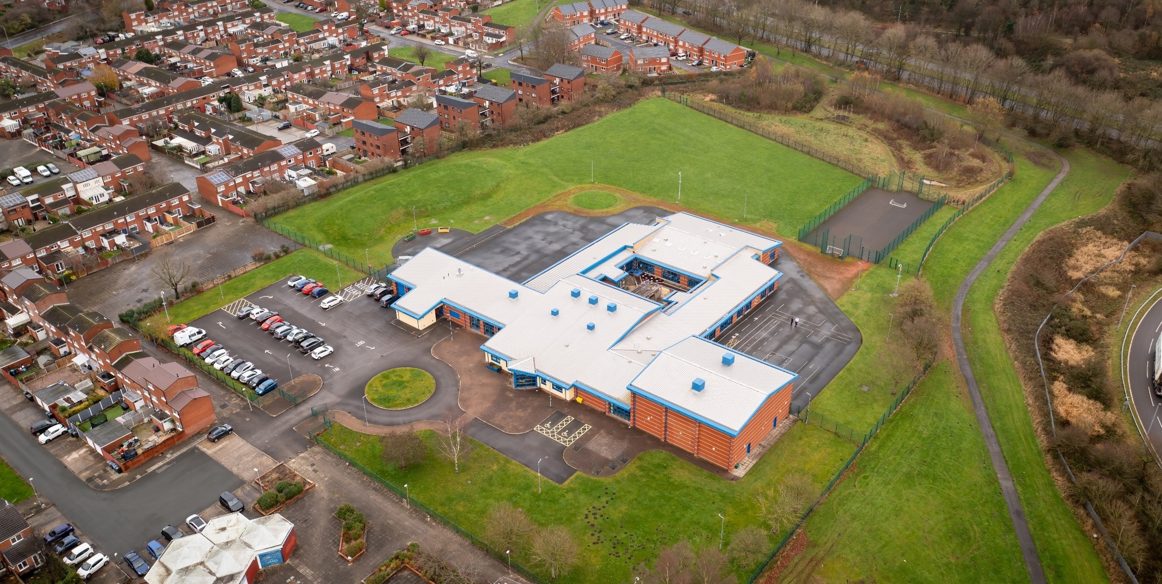
examf

governor meeting Attendance 2023-2024

  - Document Control

Document Name | Governor Meeting Attendance 2023-2024
Academic Year | 2023/2024
Term | Autumn / Spring / Summer 2023/2024
Category | Governor Meetings
Owner of Document | Headteacher | Helen Dunbavin
Publish Date | Live Document

Hope High School
Carfield
Skelmersdale
Lancashire
WN8 9DP
Tel: 01695 721066

Table of Contents
Full Governors Meeting – Standards & Curriculum 4
Autumn Term 2023 – Date of Meeting: Wednesday 18th October 2023 4
Full Governors Meeting – Resources 4
Autumn Term 2023 – Date of Meeting: Wednesday 13th December 2023 4
Full Governors Meeting – Standards & Curriculum 5
Spring Term 2024 – Date of Meeting: Wednesday 7th February 2024 5
Full Governors Meeting – Resources 5
Spring Term 2024 – Date of Meeting: Wednesday 20th March 2024 5

Full Governors Meeting – Standards & Curriculum

Autumn Term 2023 – Date of Meeting: Wednesday 18th October 2023

Present: | Apologies for absence were received and ACCEPTED from:
Mr A Brindle (Chair)  Mr A Argile  Mrs L Russell-Hayes  Mrs S Riley  Mr G Harrison  Mr A Alger  Mrs H Dunbavin (Headteacher)  Mrs H Parkinson (Governing Body Advisor)  Mrs L Fletcher (Deputy Headteacher)  Mr D Bird (School Improvement Advisor)  Mr S Jukes (Associate School Advisor)  Mr V Welch (Senior HR Manager) | Mr M Walker  Mr R Farbon  Mr W Hodgson  Mrs E Davies

Full Governors Meeting – Resources

Autumn Term 2023 – Date of Meeting: Wednesday 13th December 2023

Present: | Apologies for absence were received and ACCEPTED from:
Mr R Farbon (Chair)  Mr A Argile  Mrs L Russell-Hayes  Mrs S Riley  Mrs E Davies  Mrs H Dunbavin (Headteacher)  Mrs H Parkinson (Governing Body Advisor) | Mr M Walker  Mr W Hodgson  Mr A Alger  Mrs J Anderson  Mr A Brindle

Full Governors Meeting – Standards & Curriculum

Spring Term 2024 – Date of Meeting: Wednesday 7th February 2024

Present: | Apologies for absence were received and ACCEPTED from:
Mr M Walker (Chair)  Mrs L Russell-Hayes  Mr R Farbon  Mr W Hodgson  Mr A Brindle  Mr A Argile  Mr G Harrison  Mrs S Riley  Mrs H Dunbavin (Executive Headteacher)  Mrs H Parkinson (Governing Body Adviser)  Mrs L Fletcher (Head of School) | Mr A Alger  Mrs J Anderson  Mrs E Davies

Full Governors Meeting – Resources

Spring Term 2024 – Date of Meeting: Wednesday 20th March 2024

Present: | Apologies for absence were received and ACCEPTED from:
Mr M Walker (Chair)  Mrs S Riley  Mr R Farbon  Mrs L Russell-Hayes  Mr A Brindle  Mr W Hodgson  Mr G Harrison  Mr A Argile  Mrs E Davies  Mrs H Dunbavin (Executive Headteacher)  Mrs H Parkinson (Governing Body Adviser)  Mrs L Fletcher (Head of School) | Mr A Alger  Mrs J Anderson

