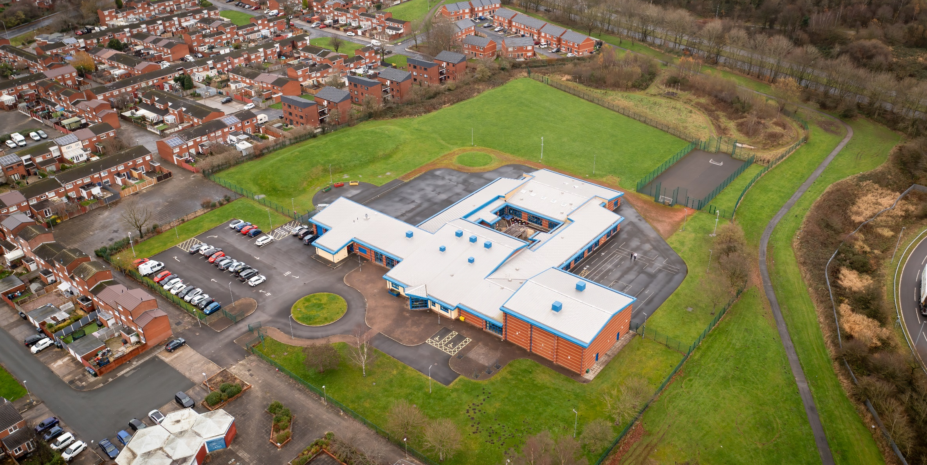

01 April 2023

Hope High School HISTORY CURRICULUM POLICY

History Curriculum Policy
Hope High School
Carfield
Skelmersdale
Lancashire
WN8 9DP
Tel: 01695 721066

Curriculum Purpose. “Learning for Life”
Our curriculum should allow all learners to have parity of opportunity, be life ready, harness their potential, promote creativity, have rich experiences, and broaden their life choices. ​
At Hope High School the Curriculum is ambitious and tailored to meet the needs of ALL pupils. Pupils study a broad and balanced range of subjects up to Functional Skills within Entry Level 1 & 2, BTEC Level 1 & 2, and GCSE. At Key Stage 3 pupils have the opportunity to follow a knowledge rich curriculum in a wide range of subjects. At Key Stage 4 pupils will follow a Core Curriculum and follow 2 pathways in an area of interest to them. This will allow them to flourish and develop their knowledge and skills in subjects that will provide opportunities for college courses and apprenticeships in the future.

Purpose
Our policy is intended to:
- Introduce the aims and objectives of the History Department.
- Outline the key components within History.
- Outline the knowledge skills and understanding for all Key Stages
- Explain the effective Teaching and Learning strategies utilised in History
- Provide the formative and summative assessment strategies used within History

Aims:
Through History we want the pupils at Hope High School to be:
- know and understand the history of these islands as a coherent, chronological narrative, from the earliest times to the present day: how people’s lives have shaped this nation and how Britain has influenced and been influenced by the wider world
- know and understand significant aspects of the history of the wider world: the nature of ancient civilisations; the expansion and dissolution of empires; characteristic features of past non-European societies; achievements and follies of mankind.
- Gain and deploy a historically grounded understanding of abstract terms such as ‘empire’, ‘civilisation’, ‘parliament’ and ‘peasantry’.
- Understand historical concepts such as continuity and change, cause and consequence, similarity, difference and significance, and use them to make connections, draw contrasts, analyse trends, frame historically valid questions and create their own structured accounts, including written narratives and analysis.
- Understand the methods of historical enquiry, including how evidence is used rigorously to make historical claims, and discern how and why contrasting arguments and interpretations of the past have been constructed History – key stage 3 2.
- Gain historical perspective by placing their growing knowledge into different contexts, understanding the connections between local, regional, national and international history; between cultural, economic, military, political, religious and social history; and between short- and long-term timescales.

Objectives:
To help meet the Aims of the History Curriculum the department will:
- Provide opportunities for pupils to gain knowledge of a high-quality education, to foster in children a curiosity and understanding of events, places and people in a variety of times and environments.
- To develop an interest in the past and an appreciation of human achievements and aspirations
- To learn about the major issues and events in the history of our own country and of the world and how these events may have influenced one another.
- To develop a sense of chronology within which the children can organise their understanding of the past.
- To understand how the past was different from the present and that people of other times and places may have had different values and attitudes from ours.
- To understand the nature of evidence by emphasising the process of enquiry and by developing the range of skills required to interpret primary and secondary source materials.
- To distinguish between historical facts and the interpretation of those facts.
- To understand that events have a multiplicity of causes, and that historical explanation is provisional, debatable and sometimes controversial.
- To help children understand society and their place within it, so that they develop a sense of their cultural heritage.
- Ensure through quality teaching that pupils receive a knowledge rich curriculum where they acquire the technical knowledge to support future applications to colleges and apprenticeships.
- Will work alongside other Targeted areas of the curriculum.
- Develop Schemes of Work that are tailored to the individual needs of the learners.
- Support pupils in achieving an Entry Level 1 and GCSE qualification that contributes to them progressing onto a college course of their choice.

Subject Content

Key Stage 3
Pupils should extend and deepen their chronologically secure knowledge and understanding of British, local and world history, so that it provides a well-informed context for wider learning. Pupils should identify significant events, make connections, draw contrasts, and analyse trends within periods and over long arcs of time. They should use historical terms and concepts in increasingly sophisticated ways. They should pursue historically valid enquiries including some they have framed themselves, and create relevant, structured and evidentially supported accounts in response. They should understand how different types of historical sources are used rigorously to make historical claims and discern how and why contrasting arguments and interpretations of the past have been constructed. In planning to ensure the progression described above through teaching the British, local and world history outlined below, teachers should combine overview and depth studies to help pupils understand both the long arc of development and the complexity of specific aspects of the content.
When designing and making, pupils should be taught to:

The Curriculum will include:
- The development of Church, state and society in Medieval Britain 1066-1509
- The development of Church, state and society in Britain 1509-1745
- Ideas, political power, industry and empire: Britain, 1745-1901
- Challenges for Britain, Europe and the wider world 1901 to the present day in addition to studying the Holocaust.
- A local history study.
- The study of an aspect or theme in British history that consolidates and extends pupils’ chronological knowledge from before 1066.
- At least one study of a significant society or issue in world history and its interconnections with other world developments [for example, Mughal India 1526-1857; China’s Qing dynasty 1644-1911; Changing Russian empires c.1800-1989; USA in the 20th Century].

Key Stage 4 – Entry Level 1 History

Qualification Overview
The OCR Entry Level 1 History qualification is designed around Exam and Coursework completion. The qualifications give learners the opportunity to acquire and develop generic, transferable and sector-specific skills in order to complete tasks and demonstrate a level of achievement that enables them to progress to further learning. The Award offers a basic introduction to the History and this programme can be co-taught alongside GCSE (9-1). The qualification prepares learners to have basic knowledge and understanding to build on this when accessing further education.

Thematic Study (Mandatory Unit)

Purpose
Our Entry Level Certificate in History will inspire and engage students by providing a broad, coherent, satisfying and worthwhile course of study within the Thematic study area, the students will focus on one area, they will have the chance to study key features and characteristics of periods studied and the relationship between them.

Learning aims:
In this area of study pupils will cover in depth one area of choice below:
- Crime and punishment.
- People’s health.
- Migration.
- War and British society.
- Power, monarchy and democracy.

Depth Study

Purpose

Within the Depth study area, the students will focus on one area, they will be taught chronological and key information of how History has made the world the way it is today.

Learning Aims
In this area of study pupils will cover in depth one area of choice below:
- Germany 1925–55.
- The USA 1919–74.
- Normans 1065–1087.
- Elizabethans 1580–1603.
- The Making of America 1789–1900.
- The Viking Age c. 750–c. 1050.
- Britain: Peace and war 1900–18.
- International relations 1918–2001.

Study of a site or individual

Purpose
Aiming to encourage students to become responsible for their own learning, confident in discussing ideas, innovative and engaged in an independent task, choosing their own individual or site.

Learning Aims
Students choose either a site or an individual to study and complete two pieces of work:
- A 150-word biography (of the person) or guide (to the site).
- A 250-word explanation of the importance and impact of their site or individual over time.

Teaching and Learning
Good quality teaching and learning is at the heart of improved life chances for the pupils at Hope High School. Our pupils benefit from consistency in their lives. Hope High has adopted the teaching and learning model of Rosenshein’s 10 principles of Instruction. These principles will be evident in classrooms daily.
In History the principles are:
- Daily review. Lessons will begin with a review of learning from previous lessons. This is to support our pupil’s cognitive load. This could be a review of new tools used or a re-cap on a new process.
- Present new material using small steps. Teacher demonstration is an integral part of the delivery of the subject. New concepts and skills will be introduced in small steps using live or video demonstration.
- Ask questions. A range of interactive questioning techniques will be used to check pupil understanding. Direct questioning, use of interactive whiteboards and Visualiser are just a few of the techniques used to check pupil understanding.
- Scaffold and model learning expectations and practices and embed routine formative assessment strategies with starters and plenaries as well as whiteboard check points.
- Guide Student practice. Teachers and TA’s will be used to help and support pupils in lessons with an emphasis on encouraging pupil independence.
- Check for student understanding. Formative assessment techniques such as direct questioning of individual pupils and observation of skills and techniques will be used to check knowledge and understanding.
- Obtain a high success rate, with confidence in depth knowledge of subjects, questioning, creating chronological times frames and
- Provide scaffolds for difficult tasks. In History the support of the teacher, TA is one of the main scaffolds that can support our students in barriers to learning and recoding work. Teacher to model with the visualiser, sentence starters and worksheets for support with all needs.
- Independent practice. Opportunities will be provided to pupils for them to apply their knowledge, skills and understanding to different design scenarios. Independence will be supported and encouraged in all our pupils in a safe and calm environment.

Assessment
At Hope High we firmly believe that assessment should be used as a tool to help move pupil learning forward. The day to day, lesson by lesson, formative assessment that takes place with pupils will help them make progress. This will inform teachers of areas of mastery and support them in the development of scaffolding materials to help pupils who need that extra support to achieve mastery.
This formative assessment coupled with end of topic summative assessments will provide the teacher with a holistic overview of a pupil progress and inform the grade for termly reports that are sent to parents/carers.
In history, assessment is ongoing and continuous through formative teacher assessment. Informal, diagnostic judgements allow teachers to give meaningful feedback to children about the success of their learning by identifying each child’s progress in each aspect of the curriculum, determining what each child has learned and what should therefore be the next step in their learning. Formative assessment through starters, whiteboards tasks, Kagan strategies within the lesson and using methods such as Kahoot. Peer and self-assessment are encouraged when completing work enabling pupils to be involved in their own assessment. Class teachers keep records of work carried out by pupils so that progress against key objectives can be accurately tracked. They are assessed on their ability to use this knowledge.
Assessments are made clear to learners to develop their independence and evaluation of their work. This will inform future target setting. Self-evaluation is key in getting learners to understand what they can do well and what they need to improve on further.

Monitoring

The Head of School and leadership team will:
Monitor the subject through the Hope High self-evaluation schedule and monitoring schedule which are reviewed annually

Departmental leader will:
- Monitor learners work and quality of teaching and learning
- Review Curriculum Maps and Schemes of Work based on suitability of use
- Review and monitor risk assessments for practical lessons
- Analyse pupil performance data
- Attend link meetings

Links to other policies:
• Teaching and Learning
• Behaviour for Learning
• Monitoring
• Assessment for Learning
• Health and Safety
• Marking and Feedback
Date Approved:
Review date:
Signed subject Lead:
Signed Headteacher:

