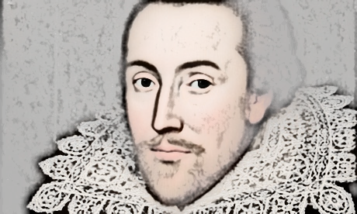
The Life and Times of William Shakespeare

Lesson 1:
- Read through the accompanying PowerPoint presentation.
- Answer the questions in full sentences below.

- Where was Shakespeare born?

- What date did he die?

- What was the name for primary school in Shakespeare’s time?

- How many brothers and sisters did Shakespeare have?

- What were their names?

- How old was he when he died?

- What was the name of the house he retired to in Stratford-Upon-Avon?

- What were the names of his 3 children?

