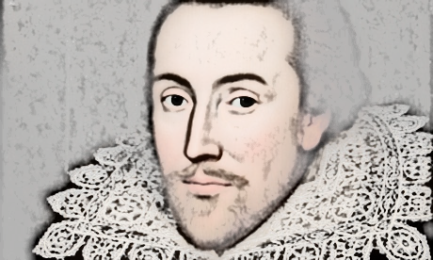
The Life and Times of William Shakespeare
Elizabethan England
Lesson 2:
- Read through the accompanying PowerPoint presentation, Elizabethan England.
- Answer the questions in full sentences below.

- What was the population of Stratford –Upon-Avon in Shakespeare’s time?

- Name 3 types of shops or stalls you would have found in an Elizabethan Town?
1.
2.
3.

- What is ‘Rother’ the old English word for?

- What were buildings made out of in towns in Elizabethan England?

- Where did Elizabethan people throw away their toilet waste?

- Which offences in Elizabethan England were dealt with by the Church Courts?

- What are Cheat and Manchet?
Cheat:
Manchet:
- Apart from bread, what could you have for breakfast in Elizabethan England?

