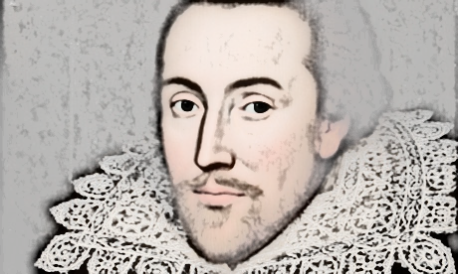
The Life and Times of William Shakespeare
Elizabethan Theatre
Lesson 3:
- Read through the accompanying PowerPoint presentation, Elizabethan Theatre.
- Answer the questions in full sentences below.

- What were the cruel animal sports that the Elizabethans liked to watch called?

- What were the other kinds of street theatre that you could see in Elizabethan times?

- How many people could the Globe Theatre hold?

- What was Shakespeare’s theatre company originally called?

- When King James I was on the throne, what was Shakespeare’s theatre company called?

- What did Elizabethans actors use to recreate the effect of someone being stabbed?

- What did audiences do if they did not like a play?

- What were the people called who stood in the area at the front of the stage?

- How much did a ticket cost for a groundling?

