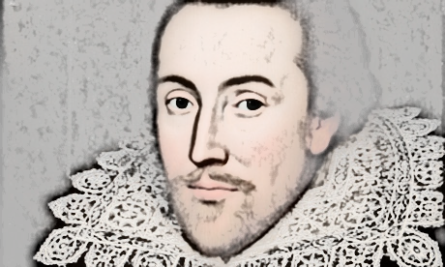
The Life and Times of William Shakespeare
Shakespeare’s Works
Lesson 4:
- Read through the accompanying PowerPoint presentation, Shakespeare’s Works.
- Answer the questions in full sentences below.

- How many plays did Shakespeare write?

- What is his longest play?

- What are the names of the feuding families in Romeo and Juliet?

- What is the name of the Merchant of Venice?

- How do Romeo and Juliet die?

- What types of poems did Shakespeare write?

- What is the name of the money lender in the Merchant of Venice?

- What does he want in return for lending money to Antonio?

- What play is the famous Seven Ages of Man speech from?

- How was thunder created?

