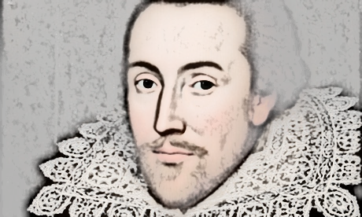
The Life and Times of William Shakespeare

Lesson 5 Quiz:
- Read through the accompanying PowerPoint quiz presentation.
- Answer the end of topic quiz questions in full sentences below.

- How old would William Shakespeare be on 23rd April 2020?

- Where was he born?

- How did THE PLAGUE spread?

- What was his wife’s first name?

- How much did it cost to watch one of his plays in the Globe Theatre?

- How many witches perform in Macbeth?

- What was Nick’s surname in Midsummer Night’s Dream?

- How many plays did William Shakespeare write?

