Managing Own Money Part 2
Answer Sheet
How will you pay 1?
How will I pay for my shopping? It costs £78.85
I have £80.00 in cash.
How much change will I receive from the cashier?
Answer:

How will you pay 2?
My shopping comes to £102.86 today!
I decide to pay with my debit card because it is quite a lot of money.
Explain each step on how you will pay with your debit card and pin number.
Step 1:

Step 2:

Step 3:

Step 4:

How will you pay 3?
My shopping bill comes to £26.38 on this occasion.
I decide to pay contactless with my debit card because it is a smaller amount of money and under the limit of £30.00
Explain each step on how you will pay using contactless payment.
Step 1:

How will you pay 4?
My shopping bill comes to £43.97 today.
I decide to pay with my chequebook.
Complete the cheque below:
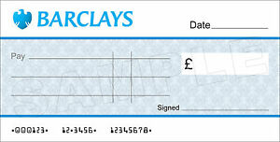

How will I pay 5?
My Gas bill has come for the first three months of the year. It is a whopping £268.00
I decide to pay the bill by cheque because it is a larger amount of money.
To avoid getting big bills like this again, you decide to set up a direct debit with your bank.
Explain what steps you will take to set up a direct debit.
Step 1:
Step 2:
Step 3:

How will I pay for larger items?
Items to be bought | How will I pay?
Holiday to Spain
Coffee and cake with my friends at Costa
My first home
My shiny new car

