HOMEWORK BOOKLET
Biology
Microbes

Name: _______________________________ Group: ______________
Date Given: ______________ Date to Hand in:___________

Parent / Guardian Comment:

WWW:

NS/Target for next piece of work:

Guidelines
Within this booklet there are a series of tasks.
Parents/Guardians are encouraged to support their children in the completion of this booklet. Each task should last for approximately 30 minutes.
Marks will be awarded for:
- High quality presentation of work
- Correct spelling, punctuation and grammar
- Use of key terms
Extra Help
Consider doing the following to help you find information to complete the tasks.
- Useful Website: http://www.bbc.co.uk/bitesize/science
- Use a search engine e.g. google.com or bing.com
- Use key words in your google searches e.g. ‘punnet squares’. Even better if you add ‘bitesize punnet squares’ which normally finds the exact page on bitesize which Is easily understandable with examples.
- Use ask.com to find a fact out.
- Avoid Wikipedia.

Homework tasks
The following section is levelled from task 1 to task 5. These tasks will get progressively more difficult but try them all and stretch your knowledge
Dispatches will be awarded for each section completed correctly and for excellent presentation. You may need to research the answers using books or the internet.
Microbes true or false?

1 Decide if each of the statements below is true or false. If a statement is false, change some of the words to make it correct.
2 Now look at your pairs of corrected statements, and decide if the second statement is an explanation for the first one.
True False
A Viruses are living things.
________________________________________________________________
B Viruses cannot live unless they are inside another cell.
________________________________________________________________
Does B explain A? Yes or no? __________________________
C Bread dough has to be kneaded to trap air in it.
________________________________________________________________
D Yeast makes carbon dioxide by aerobic respiration.
________________________________________________________________
Does D explain C? Yes or no? __________________________
E Cheese contains some fat.
________________________________________________________________
F Cheese is made using bacteria.
________________________________________________________________
Does F explain E? Yes or no? __________________________
G Yeast cells make alcohol by aerobic respiration.
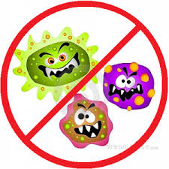
________________________________________________________________
H Beer is made from grapes.
________________________________________________________________
Does H explain G? Yes or no? __________________________

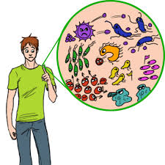
Recall so

me uses of microbes
Recognize different kinds of microbes.

1 Number the boxes and draw arrows around the body to show where they work.
Natural Defences

2 Use the words in the box to complete the information boxes.

ciliated gullet microbes mucus scab skin stomach white windpipe
I CAN...

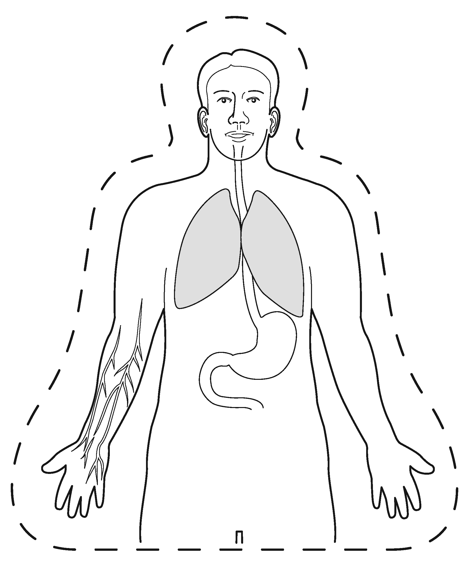

A chemical in your tears kills .  ___________________________ | Your nose produces ___________________________, which traps microbes.
Cells in your ___________________________ also produce mucus. ___________________________ epithelial cells sweep the mucus to the top of your ___________________________ to be swallowed. | ___________________________ covers your whole body. It stop microbes getting in. If you get a cut, a ___________________________ forms.
___________________________ blood cells destroy microbes. | Your ___________________________ contains acid that kills microbes.

Ebola disease

Ebola disease is caused by a virus. The first cases of it were discovered in 1976 along the Ebola river, in The Democratic Republic of Congo, Africa. The disease causes a fever, muscle aching, vomiting, very bad diarrhoea, a rash, and eventually bleeding inside and outside the body. Unless treated, it causes death in about 90% of cases, and even if treated, one in four people die. There are no medicines that can cure the disease, but if the people are looked after in hospital their bodies can often fight off the infection.
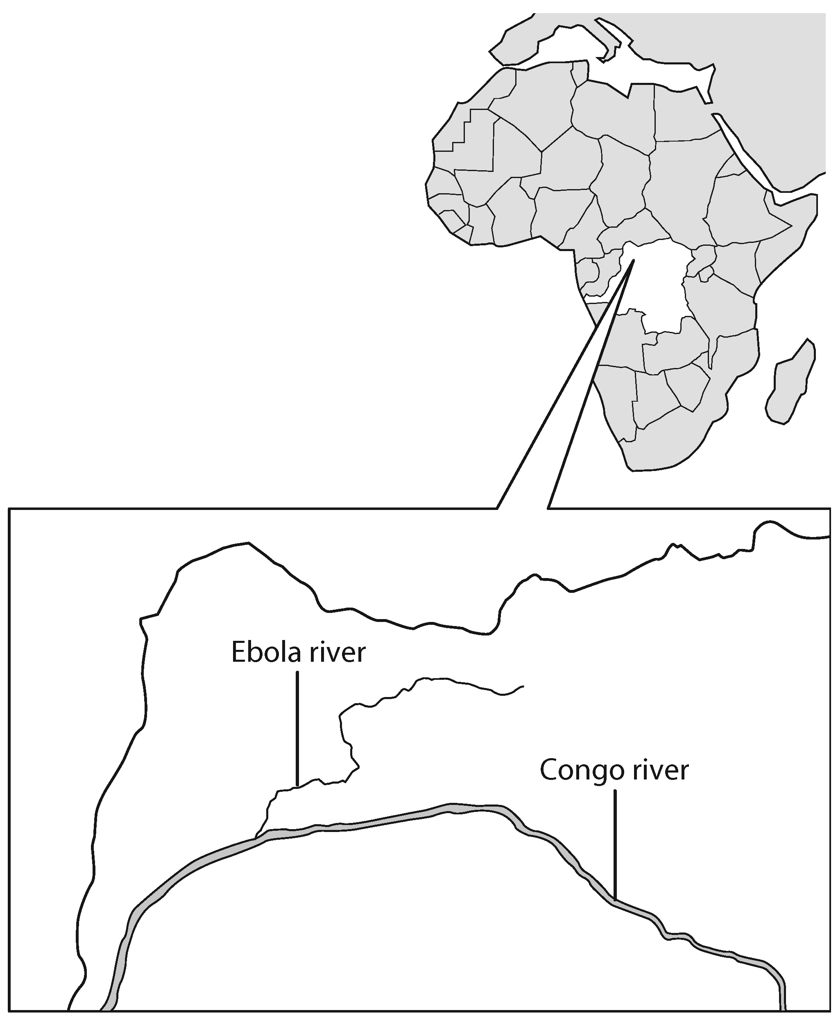
The disease is spread by touch and it easily spreads from person to person. People can also become infected by touching the dead bodies or by coming into contact
with blood, urine, faeces, vomit or saliva from an infected person. In one area of Uganda, the virus spread quickly because the people who had
died of the disease were given traditional burials. This involved many people washing the dead body and then washing their hands together
in a large basin as a sign of unity.
When a local doctor first suspects that someone is suffering from Ebola
disease, he or she will immediately get in touch with the government
health department. In most cases a team of people is then quickly sent from the World Health Organisation. The team consists of doctors, nurses, scientists and teachers. The doctors and nurses are specially trained to look after the patients without getting infected themselves. The scientists try to work out where the disease originally came from in the area, to try to stop it spreading. The teachers tell the local people about the disease and how they can avoid catching it.

  - What sort of microbe causes Ebola disease?
________________________________________________________________________________________________________________________________________________________________________________________________________________________________________________________________________________________________
  - How do you think the disease got its name?
________________________________________________________________________________________________________________________________________________________________________________________________________________________________________________________________________________________________

  - What are the symptoms of the disease?
________________________________________________________________________________________________________________________________________________________________________________________________________________________________________________________________________________________________

  - How is the disease spread?
________________________________________________________________________________________________________________________________________________________________________________________________________________________________________________________________________________________________

5 a Which organisation usually sends a team of people to areas where Ebola disease occurs?
b Describe what you think the doctors and nurses do to help people to get better.
c How do you think the medical team might protect themselves from getting the disease?
d Imagine you were one of the teachers sent to an area like this. What would you advise the people to do to avoid catching the disease?
________________________________________________________________________________________________________________________________________________________________________________________________________________________________________________________________________________________________________________________________________________________________________________________________________________________________________________________________________________________________________________________

6 One of the World Health Organisation team members has suggested using radio advertising to warn people about the disease. Write the script for a 20 second radio advert. ________________________________________________________________________________________________________________________________________________________________________________________________________________________________________________________________________________________________________________________________________________________________________________________________________________________________________________________________________________________________________________________________________________________________________________________________________________________________________________________________________
I CAN...
obtain relevant information from a text
describe how diseases caused by microbes can be spread.
White Blood Cells

7 Some white blood cells produce antibodies. These can tag microbes, pointing them out to other white blood cells that engulf (surround and digest) the microbes and kill them. Sometimes the antibodies make microbes burst open, and sometimes they make them stick together. For each drawing explain what is happening.
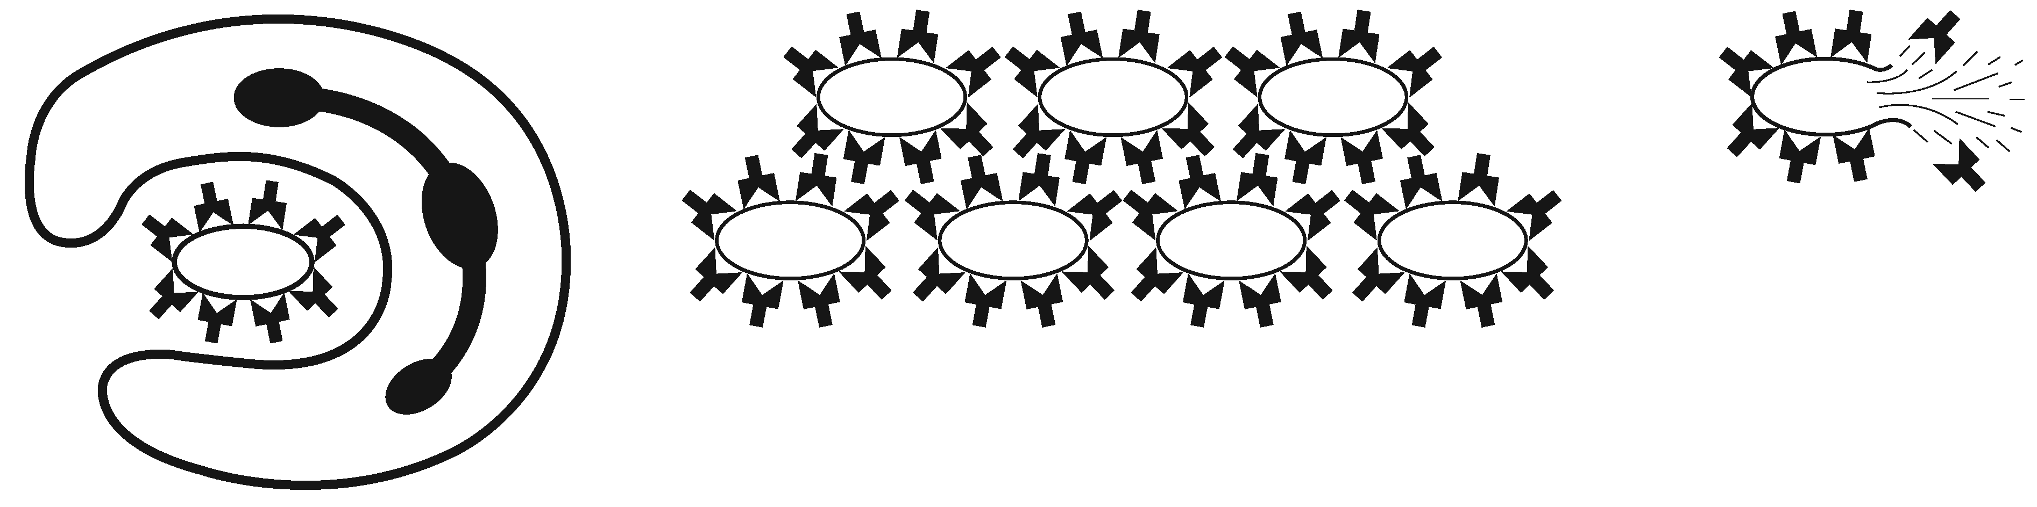
a b c
c_____________________________________________________________________________________________________________________________________________________________________________________________________________________________________________________________
b______________________________________________________________________________________________________________________________________________________________________________________________________________________________________________________________
a_____________________________________________________________________________________________________________________________________________________________________________________________________________________________________________________________

8. When the white blood cells identify a microbe, the microbes do not get covered in antibodies immediately. It is some time before this happens, during which time the microbes can reproduce and cause a disease. Why don’t microbes immediately become covered in antibodies as soon as they are found?

---------------------------------------------------------------------------------------------------------------------------------------------------------------------------------------------------------------------------------------------------------------------------------------------------------------------------------------------------------------------------------------------------------------------------------------------------------------------------------------------------

