Mince Pies |  | 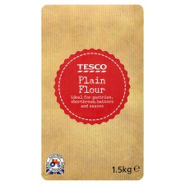
 | 110g  Margarine | 22g  Plain Flour | 200g Mincemeat
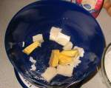

1. Add the margarine to a large bowl and sieve in the flour.

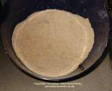

2. Mix the flour and margarine until it looks like small crumbs.

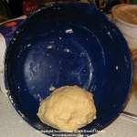

3. Add 3 tablespoons of water and mix together into a ball.

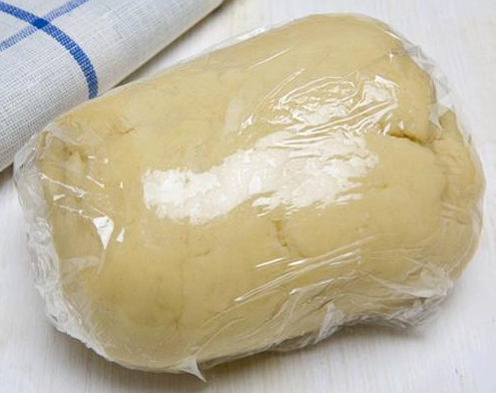

4. Wrap the pastry in cling film and place in the fridge for 30 minutes.

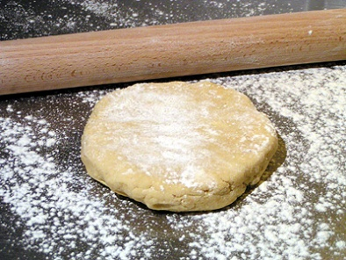
5. Roll out the pastry with a rolling pin. Turn the oven on to 200°C.

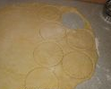
6. Use a large pastry cutter to cut out the base for 12 mince pies and put them in the tin.

7. Add a teaspoon of the Mincemeat to each mince pie base.

8. Brush the edge of the mince pie bases with some milk.

9. Cut out the tops with a smaller pastry cutter. Place over the mince pies and press down the edges. Brush with milk.

10. Make a small hole in the top of each mince pie to stop the filling from oozing out of the edges.

11. Cook in oven for 25 minutes. Put on wire rack to cool and sprinkle with icing sugar.

