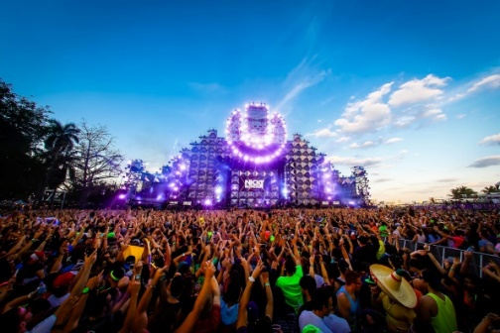
Planning your own Music Festival

Your task: Plan and create your own Music Festival using either a computer or coloured pens and paper.

- What type of music will your own Music Festival showcase? Bands, solo performers, DJ’s?

- What is your festival called? Create a “name” and design a logo.

- You’ll be working on the “Set Times & Line-Up” of your Music Festival shortly, but for now, think of the bands, artists or DJ’s you would like to perform and make a brainstorm of these. Circle your “headline” act (the most well-known or important act that will ‘bring in the crowds’!)

- How many days will your Music Festival last? Do you have enough performers to fill this time? Will it last for one evening, a weekend or an entire week?

- Where will your Music Festival be located? Will it be local or even abroad?

- Accommodation for guests and performers – Where will they stay? Will there be camping (or “glamping!”) or nearby hotels?

- Catering – Where will your festival-goers go to eat? Will you be offering a range of “street food” stalls? What type of stalls will you offer? Where will these be located within your Music Festival? What about Bars? What type of drinks will you offer?

- Toilets – How many? Where?

- Emergency Services – First Aid? St. John Ambulance? Fresh Water point?

- Security – Entrance? Security guards around the site? Security Hub?

- Attractions – Will you have “Fun Fair” or “Rides”? Where?

- Tickets – How much will they cost? What will your tickets look like?

- Advertising – Design an eye/catching leaflet/poster or Facebook® banner.
- VIP – Will you have a “VIP” area? What “extras” will VIP Festival-goers get?

- How will your Music Festival be laid out?

  - Will you have a “Main Stage”?

  - Will you have other stages, marquees or performance areas?
  - Most Music Festivals have a “Site Plan” for festival-goers so they know their way around.

- Create a 3D “Site Plan” of your Music Festival using colour, like the one shown below, illustrating where you will place and locate your facilities and “performance areas”.

